Plant Roots
Students’ Sheet

Introduction
Roots are responsible for providing a plant with all the water and minerals it needs to grow. Understanding how they work can help scientists breed crops that use fertiliser more efficiently, and which can cope with either drought or water-logging.
‘Particles’
In science ‘particles’ are the smallest building blocks of matter. They might be atoms, molecules or ions.
These particles are not the same, for example, as visible grains as in rocks or flecks of dust.
A grain of salt is made from 5 x 10¹⁷ atoms of sodium and 5 x 10¹⁷ atoms of chlorine. In total that’s 1 x 10¹⁸ atoms, or
1 000 000 000 000 000 000 atoms.
For most of us that’s an unimaginable huge number!
Groundwater is water held below Earth’s surface. When it rains, water soaks into the ground and some gets trapped in cracks in rock formations and between particles of rocks.
Soil is a mixture of humus (decayed organic matter), small pieces and grains of rock and minerals, and water. It also contains countless micro-organisms. The groundwater in soil is called soil water. It is trapped in the spaces between the small pieces and grains of rock and minerals.

pieces of rock and mineral
humus (decayed organic material)
pore containing soil water
root pushing its way through the gaps

The roots of a plant force their way through the spaces and absorb soil water containing dissolved minerals essential for healthy pant growth.
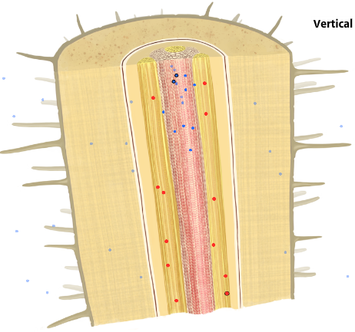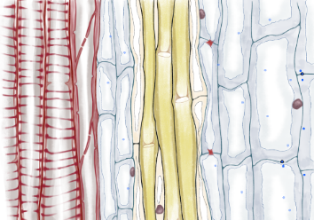
open-ended xylem cell
xylem tube
A cross-section through a root: the orange area is the xylem (blue dots represent water particles)

Activities

Activity 1: Germinating seeds

1. You will be given a petri dish that has a piece of wet filter paper in its lid and some seeds (your teacher will tell you what kind they are).
2. Draw a pencil line across the filter paper about one-third from the top. Now draw four small crosses on the line about 1 cm apart.
x
x
x
x
Top of filter paper
Bottom of filter paper
⅓
⅔
3. Lay the filter paper in the lid of the petri dish. Cover the filter paper with water and gently press it against the lid.
4. Pour off the excess water. Make sure there are no air bubbles under the filter paper.
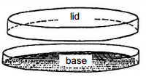
5. Place a seed on each of the crosses (press them on gently) and put the bottom of the petri dish into the lid. Leave the dish flat on the table for at least 10 minutes. (This gives the seed time to produce a secretion that helps the seed stick to the filter paper.)
6. Gently pick up the dish and place it upright in a reservoir of water (your teacher will provide this). The bottom of the filter paper should be in the reservoir of water.
Note: Any seeds that fall in the water will not germinate and grow successfully. You may replace these if you wish.
7. Place the reservoir with the petri dishes in a light, warm place in the classroom. Don’t put them too near a radiator as excessive heat may kill the young seedlings.
Question
Over the following week make a note of when these changes happen:
(a) The seed swells and the seed coat splits.
(b) The root emerges and grows.
(c) Shoot and green seed leaves grow.

Activity 2: Examining plant roots

1. Using tweezers, very carefully pick up one of the seedlings and lay it on a microscope slide so that roots are about in the middle of the slide. Place a coverslip over the roots.

2. Describe the appearance of the seedling’s roots. If you have a digital camera you could try taking a photograph of them.

3. Now place the slide on the stage of a microscope and focus on low power until you can visualise the root hairs on the root. You could then focus using the medium power lens. You may be able to observe trapped water vapour amongst the root hairs.

4. Sketch a diagram of what you see with the microscope. (If you have a digital camera you could try taking a photograph through the microscope eyepiece).
Questions
1. Whereabouts on the root are root hairs found?
2. Does the length of the root hair cell vary along the root?
3. Water gets in through a plant’s hair cells. What is it used for in the plant?

Activity 3: Examining water movement in plant roots

1. Place approximately 200 cm³ water into a 250 cm³ beaker, add 2-3 drops of food dye and mix to ensure an even colour.

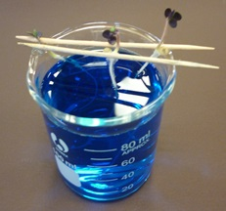
2. Set up 2 cocktail sticks parallel to each other over the beaker of dyed water, resting on the edge of the beaker.
Seedling with its roots dipping into coloured water

3. Using tweezers, carefully pick up one of the seedlings and suspend the seedling between the 2 cocktail sticks. Make sure the root hairs are in the coloured water. Leave the seedling for 24 hours.

4. Using tweezers, very carefully pick up one of the seedlings and lay it on a microscope slide so that roots are about in the middle of the slide. Place a coverslip over the roots.

5. As in part 2, examines the the root. You could then focus using the medium power lens. You may be able to observe trapped water vapour amongst the root hairs.

6. Sketch a diagram of what you see with the microscope. (If you have a digital camera you could try taking a photograph through the microscope eyepiece).
Questions
1. Describe where the coloured water is being taken up into the seedling.
2. Through which type of cell does water pass when it moves up a plant and into its leaves?

