Plant Roots
Technical & Teaching Notes

Related sheets

Plant cells and water; About water; Moving water through plants; Plant leaves and water; Water and plant structure

Introduction and context
Roots are responsible for providing a plant with all the water and minerals it needs to grow. Understanding how they work can help scientists breed crops that use fertiliser more efficiently, and which can cope with either drought or water-logging.
Groundwater is water held below Earth’s surface. When it rains, water soaks into the ground and some gets trapped in cracks in rock formations and between particles of rocks.

Soil is a mixture of humus (decayed organic matter), small pieces and grains of rock and minerals, and water. It also contains countless micro-organisms. The groundwater in soil is called soil water. It is trapped in the spaces between the small pieces and grains of rock and minerals.

Possible barriers to learning

The following are misconceptions that some students may have and which may be a hindrance to further learning:
- The nucleus of a cell is like the nucleus of an atom
- Living things are made of cells, which are as small as atoms
- Microbes, cells and particles are much the same
- Fertilisers are plant food

Plants get their food from the soil

Links to National curriculum for science in England at key stage 3

In biology pupils should be taught about cells and organisation, and nutrition and digestion which include:
- cells as the fundamental unit of living organisms, including how to observe, interpret and record cell structure using a light microscope
- the functions of the cell wall, cell membrane, cytoplasm, nucleus, vacuole, mitochondria and chloroplasts
- the role of diffusion in the movement of materials in and between cells
- the hierarchical organisation of multicellular organisms: from cells to tissues to organs to systems to organisms
- plants making carbohydrates in their leaves by photosynthesis and gaining mineral nutrients and water from the soil via their roots

In chemistry pupils should be taught about the particulate nature of matter, and pure and impure substances. This includes:
- the properties of the different states of matter (solid, liquid and gas) in terms of the particle model
- mixtures, including dissolving
- diffusion in terms of the particle model

Safety Notes

All materials used are low hazards and should produce minimum risks.

Apparatus

Activity 1: Germinating seeds

Each student or pair will need:

petri dish

4 mustard seeds (other seeds could be tried, e.g. tomato, radish, pansy)

filter paper to fit petri dish top (the filter paper may need to be cut to size)

They will also need a water reservoir – this can be made from a 1 litre plastic bottle (see below) – and this may be used to hold the petri dishes of several students. Make sure students label their dishes.

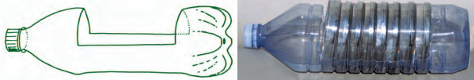

Activity 2: Examining plant roots

Each student or pair will need:

light microscope

microscope slide and coverslip

pencil and paper

Optional: digital camera or smartphone

Activity 3: Examining water movement in plant roots

Each student or pair will need:

250 cm³ beaker

food dye (any colour, but blue works best)

2 cocktail sticks (or similar)

tweezers

light microscope

microscope slide and coverslip

pencil and paper

Optional: digital camera or smartphone

Teaching Notes

Part 1: Germinating seeds

This activity uses information from SAPS teacher guidance for Growing Seedlings.

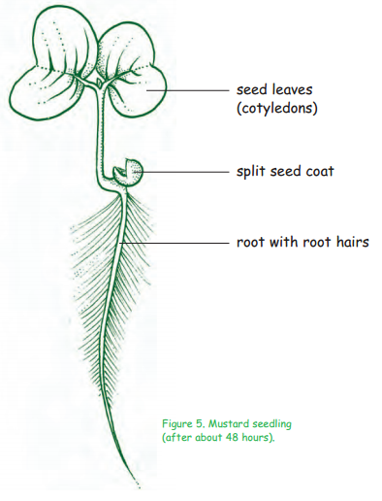
Answer
seed leaves (cotyledons)
split seed coat
root with root hairs

Normally, a mustard seed swells and its seed coat splits open within 24 hours.

The root emerges and grows within 48 hours (see diagram on the right).

By the end of the first week shoot and green seed leaves grow.

Activity 2: Examining plant roots

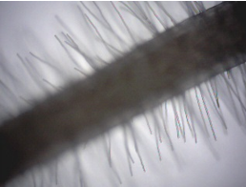
Preparing plant roots for examination under a microscope requires care, especially transferring seedlings to a microscope using tweezers.
Root hairs under the microscope

Answers
1. Root hairs are found on the upper two-thirds of the main root.
2. The root hairs are longest at the top of the root and get progressively smaller down the root.
3. Water is used:
- to dissolves nutrients from the soil and carry them around the plant
- as one of the reactants in photosynthesis (the other is carbon dioxide)
- to keep stems, leaves and shoots rigid (plants wilt if they have insufficient water)
- to cool leaves when it evaporates from them.

Activity 3: Examining water movement in plant roots
This activity is an extension of activities 1 and 2, based on the SAPS resource Gravitropism at post-16 - the Role of Roots.
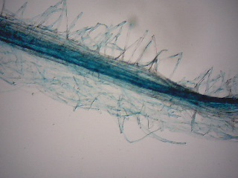
The root hair cells need to be below the level of the water. Leave the seedling for 24 hours. Remove the seedling and place onto a microscope slide and focus on low or medium power to reveal the xylem which will be coloured with the food dye. The water is taken up by osmosis by the root hair cells to enter the xylem.
Root and root hairs with xylem dyed blue after water uptake by osmosis
Answers
1. The coloured water is taken up by the root hairs and into the root.
2. Xylem cells.

