Why does pondweed bubble?
The bubbling pondweed practical is slightly counterintuitive. Often, students will have learned about photosynthesis in a terrestrial plant where gas exchange happens via stomata but they are then observing it in a piece of upturned aquatic plant releasing bubbles of gas from its stem.
This practical is only possible because of the adaptive features that pondweeds have that enable them to survive underwater. Pondweeds like the ones used in this practical have a specialised tissue called aerenchyma which is filled with gas. This gas enables the pondweed fronds to float, bringing them closer to the surface of the water where there is more light available for photosynthesis. Gases also diffuse through the air spaces in the aerenchyma, allowing oxygen produced by photosynthesis to diffuse down to the roots which are buried in anoxic soil. This allows cells in the roots to respire. Gases produced in the roots will also diffuse up through the air spaces in the aerenchyma.
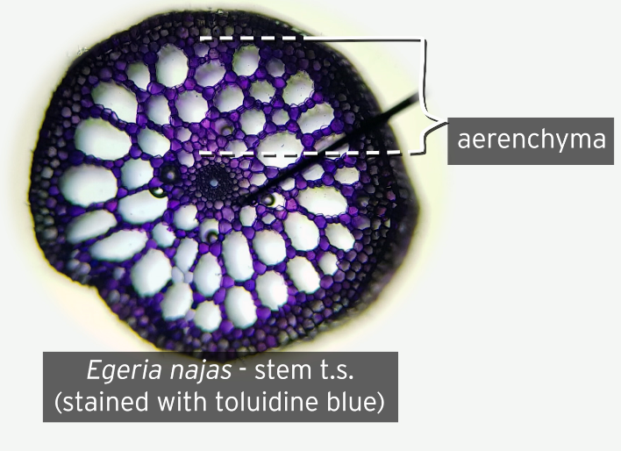
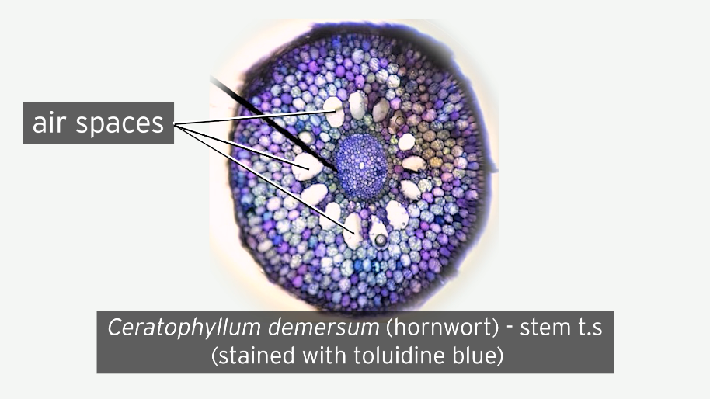
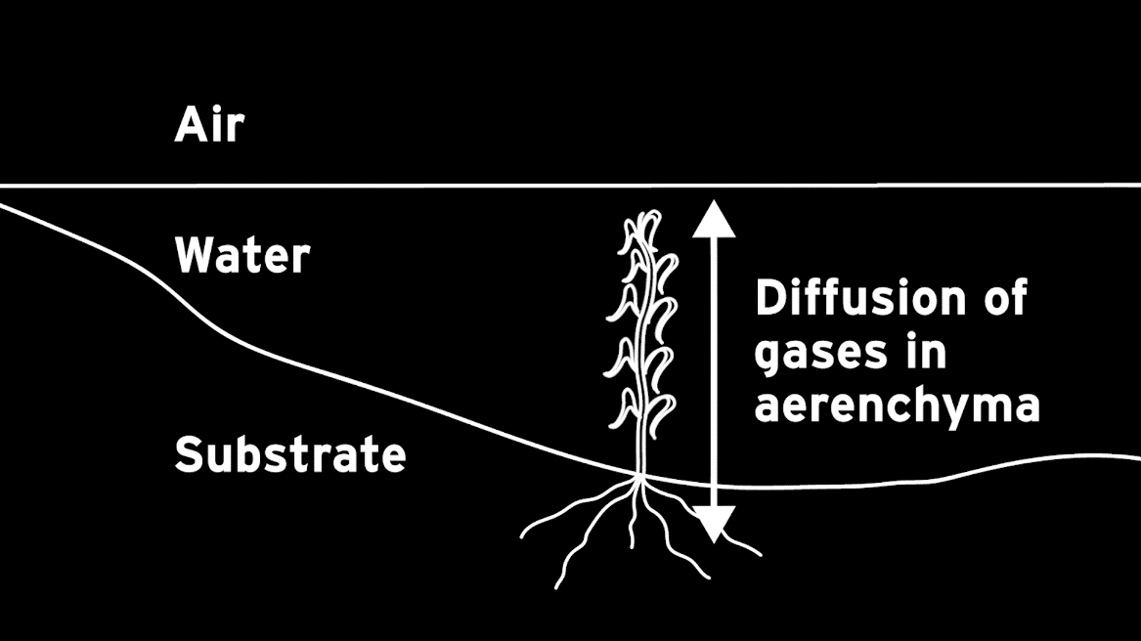

When the pondweed stem is turned upside down and cut under the level of the water, gas can escape from the air spaces and bubbles up to the surface.

When transverse sections of different species of pondweed are made and stained with 0.5% toluidine blue solution, we can see that the structure of the aerenchyma differs for each species. The air spaces differ in shape, size and number. This may well explain why the species bubble in different ways. The aerenchyma is the tissue with the air large spaces visible on each of the slides.
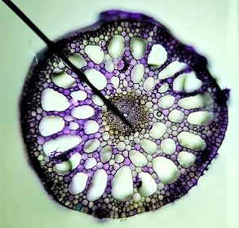 | Elodea/Egeria densa
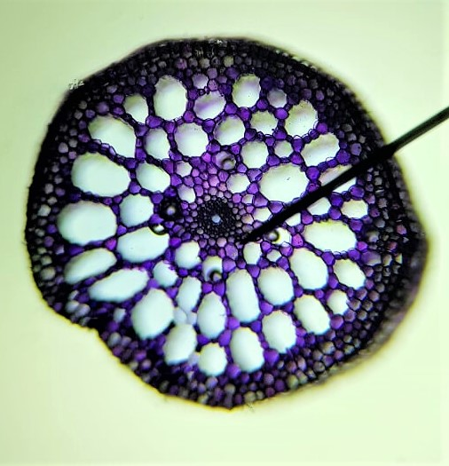 | Egeria najas
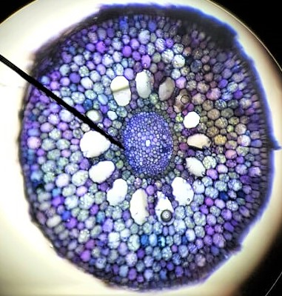 | Ceratophyllum demersum (hornwort)
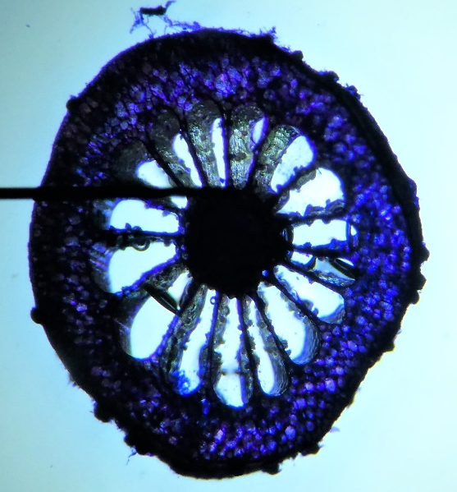 | Myriophyllum scabratum
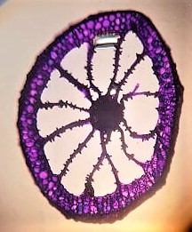 | Cabomba piauhyensis / furcata (red cabomba)
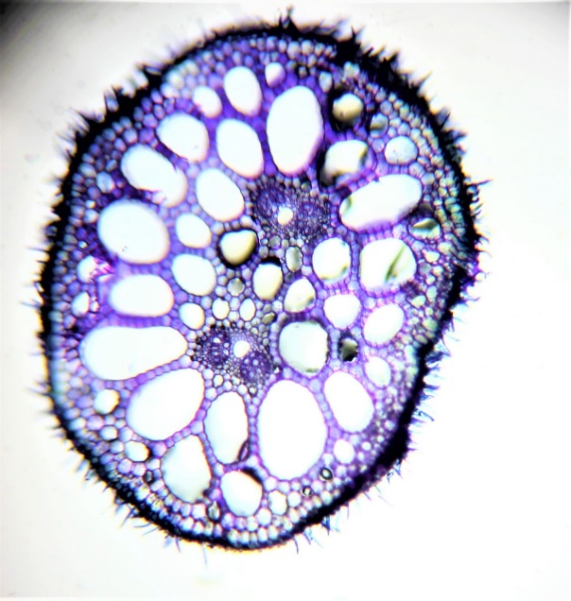 | Cabomba aquatica (yellow cabomba)

