From the booklet: Living processes and what plants need to grow

*Teaching Notes*

**Design a seed packet**

This activity involves designing a seed packet for seeds that have come from a newly discovered plant. It stimulates discussion on what the seeds need to grow and how to care for the young growing plant. It gives the children an opportunity to write instructional texts and requires some creative thinking in the design of the packet. This provides useful opportunities for developing literacy and presentation skills as well as being a good end-of-topic activity.

You will need some A4 envelopes to be the basis of their seed packets.

***The activity***

Allow the children, perhaps for a homework task, to research different types of plants and note some of their features and the type of habitat they are found. They should be encouraged to use a variety of sources including reference books and search engines.

Tell the children that they are now going on an expedition to look for new plants. They will only be able to bring back seeds and not the whole plant. Ask the children to design a seed packet with instructions to help other people grow the seeds.

Here are some suggestions you can ask the children to include in this activity.

* Make a drawing of the plant they discover, as seen growing in the wild, and give its name.
* List the equipment that they will need for growing the seeds.
* Write instructions for sowing the seeds, including what sort of soil or compost should be used and where they should be grown.
* Say how much soil or compost would be used and how deep the seeds should be planted.
* Suggest a suitable temperature for the seeds to germinate, then for the young plants to grow.
* Give instructions about watering the seeds and growing the plants.
* Discuss important features for the design of the seed packet, to make other people want to buy the seeds and then grow them.

To make the seed packet, the children can attach the drawing of the flower to the front of a large A4 envelope. They can write their instructions for planting and care, then attach this to the back of the envelope, so that it becomes the seed packet.

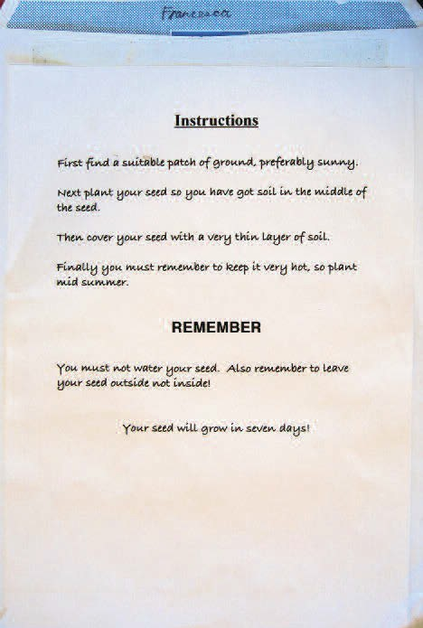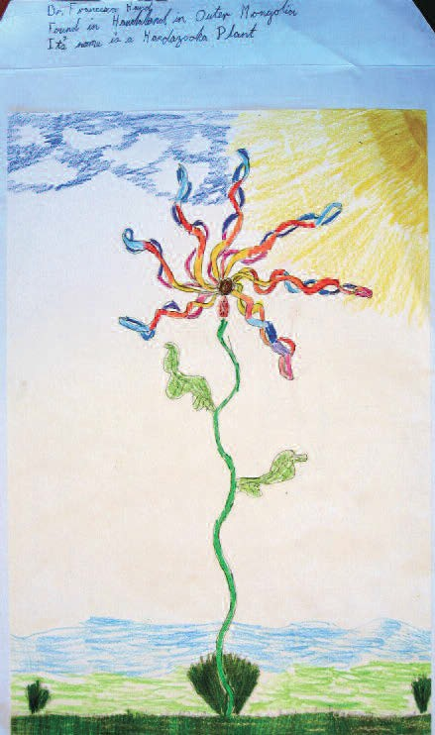

**Figure 1.** Two seeds packets created by children (in Year 4 at the Cavendish School in 2005).

