Investigating Flower Structure and Function in Primulas
Technical & Teaching Notes

Introduction

Charles Darwin was fascinated by the structure of primula flowers. In his autobiography, he wrote "I do not think anything in my scientific life has given me so much satisfaction as making out the meaning of the structure of heterostylous flowers." Some 150 years after Darwin did his research on these intriguing flowers, they continue to enable scientific insights.

In this activity, students follow in Darwin’s footsteps, investigating primulas. They will dissect and record primula flowers, which grow in two forms: ‘pin-eyed’ and ‘thrum-eyed’. Accompanying questions ask students to reflect on the genetics behind this adaptation. This can then be extended further, with students reading Darwin’s essay on the subject, and comparing it with a recently published research article.

This resource is designed to meet the specifications for the A-level practical endorsement in England (CPAC). However, given its focus on adaptation and evolution, it will make a valuable resource for those following a variety of different specifications, such as the Advanced Higher Biology Organisms and Evolution Unit.

These teaching notes, the student sheets and the accompanying PowerPoint include full guidance on how to carry out a dissection and a scientific drawing.

We recommend primula due to the extension activities that can be carried out on the topic, and its availability in garden centres through much of the year. However, our additional extension resources give information and example drawings of a range of other readily available flowers. These resources can be found on the SAPS website, www.saps.org.uk

Learning outcomes

The students will:

- Observe the structure of a flower
- Prepare a longitudinal section of a flower
- Produce an annotated scientific drawing of the longitudinal section of the flower
- Understand how the structure of the flower is adapted to its function.

Health and Safety

CLEAPSS Student Safety Sheet 74 provides information about assessing the risk posed by plant material

Many plants contain toxins. Good general advice is:
- Check before organising the practical whether any pupil is aware of allergies to a particular plant so that it can be avoided.
- Avoid using plants with latex. Latex can cause skin irritation and can be very dangerous if it gets onto the lips or into the eyes.
- The pollen of some lilies stains clothing and may produce hayfever symptoms in susceptible students.

Pupils will be using sharp and pointed tools for dissection. Make sure they know how to use these safely.

When drawing, it is important to take regular breaks to avoid eye strain and damage to the wrist and back. A short rest from drawing every half hour is a good idea.

Teaching Notes

The students will use one Primula flower to carry out this activity in 4 steps:

- Observation
- Cutting a longitudinal section
- Scientific drawing
- Labelling

The investigation could be completed in a single lesson.

You may wish to cover steps 1 as a demonstration or with students working in groups. Steps 3 and 4 should be carried out by students working individually.

Before students start their own dissection, advise them to take care with sharp and pointed instruments. Also advise them to work slowly and carefully - most flowers are quite fragile.

Students should have drawing tools and materials ready in advance, as the cut flower will not survive for long.

Once students have completed their drawing, they should undertake the questions in the student support sheet.

You may also wish to ask the students to read Darwin’s article ‘On the Two Forms, or Dimorphic Condition, in the Species of Primula, and on their remarkable Sexual Relations’ in John van Wyhe, editor. 2002-. The Complete Work of Charles Darwin Online. http://darwin-online.org.uk/converted/published/1862_primula_F1717.html. Students can compare their observations and drawings with those of Darwin. Are Darwin’s hypotheses about the adaptive function of primula’s dimorphism similar to their own thoughts?

Students can then read this very short editorial by two contemporary scientists, reflecting on advances in the genetic understanding of heterostyly in flowers: ‘Plant reproduction: Long story short’, John R Pannell and Guillaume Cossard, eLife 2016, 5

: http://dx.doi.org/10.7554/eLife.20314

How to use this resource

The accompanying PowerPoint presentation ‘Investigating Flower Structure and Function’’ contains slides that can be used together with the Student’s Support Sheet and the Student’s Sheet.

Guidance on how to dissect the Primula flower is given in the Student’s Sheet and the PowerPoint.

An example of a labelled drawing of a Primula flower is given in the PowerPoint.

The Student Support Sheet also asks the students to consider how the Primula flower is adapted for pollination. This section of the resource can be completed after the flower dissection and drawing and will allow the students to spend time reflecting on the function of the different parts of the flower, and on how they assist pollination.

Students will tend to see pollination from an animal-focused point of view, e.g. a bee searching out sources of nectar. They may benefit from a brief discussion of pollination and the evolution of flower morphology from a plant standpoint, focusing on how a sessile organism is able to manipulate animals to achieve its goals.

Examples of labelled scientific drawings of other flowers are given in the extension file ‘Examples of scientific drawings of flowers’.

The Powerpoint ‘Understanding the parts of a flower in detail’, in the Extension Activites collection on the SAPS website, gives a detailed look at flower parts and their role in pollination. You may wish to use this to refresh your own understanding of the topic, or to address any specific student queries.

The value of scientific drawing
Drawing and modern photographic techniques both have an important role to play in biological illustration and are often used together in recording observations.

Drawing may be slower than taking a photograph. The advantage however is that it requires constant reference back to the specimen, looking carefully at detail and working out of how structures fit together. This has the value of leading to a greater understanding of the overall structure of the specimen and how it works. If students can draw a flower, they will understand it!

Before starting, pupils should get as much information about the flower they are studying as possible. Knowledge of its geographical distribution habitat, how it’s pollinated, and what structure might be expected can all be very helpful in understanding what they see in the dissection. This information is given for Primula in the fact file below. Fact files for other flowers are given in the Extension Activities collection.

Students should always draw what they see. Anything unexpected should be described in the labels.

Getting learning value from the practical
Practical skill development | Developing the student’s ability to accurately observe, dissect and record biological specimens.
Maths skill development | Calculation of scale of the drawing
Associated subject knowledge development | Understanding of floral structure  Appreciation of adaptation of floral structure to floral function  Monohybrid inheritance
Recording evidence of student’s work | Completion of student support sheet, including biological drawing of longitudinal section of flower and dissection and arrangement of floral parts.  Answering questions about inheritance of alleles that control flower morphology
Meeting aspects of the use of apparatus and techniques | https://www.gov.uk/government/uploads/system/uploads/attachment_data/file/447147/2015-07-20-gce-subject-level-conditions-and-requirements-for-science-and-certificate-requirements.pdf  - produce scientific drawing from observation with annotations  - safely use instruments for dissection of an animal organ, or plant organ
Meeting aspects of the CPAC | https://www.gov.uk/government/uploads/system/uploads/attachment_data/file/447147/2015-07-20-gce-subject-level-conditions-and-requirements-for-science-and-certificate-requirements.pdf  Use and apply scientific methods and practices  - safely and correctly use a range of practical equipment and materials  - follow written instructions  - make and record observations

Technical notes

Equipment
Per student

For observing and dissecting flowers
- At least one per student. The flowers should have stems at least 1cm long
- Tile or cutting mat
- Single-edged (safety) razor blade
- Dissecting needle or seeker for separating parts
- Fine (pointed) forceps
- Small pointed sharp dissecting scissors
- Hand lens x10

Single-edged blades are available from school suppliers, e.g.
- Timstar £12.54 for 100 in dispensers, code DI 140150; £6.30 without dispensers, code DI140145
- Breckland Scientific £2.22 for 10, code DIN-350-100

For drawing
- A4 white paper
- HB pencil. A soft pencil (e.g. 2B) will smudge too easily
- Access to a pencil sharpener.
- A clean good quality eraser.
- A ruler for measuring and label lines

Per class
- Also very useful if available: a dissecting microscope magnification x10-20

Selecting flowers for dissection

Decide which flowers will be studied well in advance and make sure they are in good condition.

Each pupil will need at least one flower.

We recommend Primula as a flower that provides opportunity for interesting scientific observation and is readily and cheaply available throughout the year.

A list of suitable flowers showing the season available and the most likely sources; garden, plant nursery, florist or supermarket is given in the list below. Fact files on these and other popular flowers for dissection are included in the Extension Activities collection.

When to collect material

It is often best to buy plants/flowers in bud or half open well before the practical session to ensure that you have fresh flowers when you need them. If it is left until the day of the practical, florists and supermarkets may have run out of stock, or weather conditions e.g. heavy rain may destroy flowers you were planning to collect from the garden! 24-48 hours at room temperature is usually sufficient for flowers in bud to open.

NB Primula plants that are in flower usually also have plenty of buds, so each plant can be used for a couple of weeks and a series of classes.

Care of plant material

If possible put the stems of your specimens straight into water. Use a sharp knife to cut off about 2 cm of stem below the surface of the water. This removes the lower part of the stem in which airlocks may have formed and makes sure that water can reach the upper parts of the specimen. Cut flowers also last better if the water is slightly acidic and contains a little sugar. The flowers may come with a sachet of powder to add. Alternatively adding a teaspoonful of lemonade to the water will do the trick. If the specimens are being kept for any length of time the water is best changed every two days.

Suitable plants

Key to Source column:
S supermarkets
F florists - NOTE: Florists may remove some floral parts e.g. stamens or leaves. Check that specimens are complete before buying
N plant nurseries/garden centres
G common garden plants

Season | Common name | Scientific Name | Source
All year-round | Peruvian Lily | Alstroemeria species or cultivars | SF
Spring  January-April | Daffodil | Narcissus species and cultivars | SFNG
 | Tulip | Tulipa species and cultivars | SFNG
 | Primrose | Primula species | NG
Summer  May-July | Daffodil | Narcissus species and cultivars | SFNG
 | Tulip | Tulipa species and cultivars | SFNG
 | Primrose | Primula species | NG
 | Geranium | Pelargonium species | N
 | Hardy Geraniums | Geranium species | G
 | Wallflower | Erysimum cheiri | NG
 | Fuchsia | Fuchsia species | NG
Late summer  August-Oct | Geranium | Pelargonium species | N
 | Hardy Geraniums | Geranium species | NG
 | Fuchsia | Fuchsia species | NG
 | Snapdragon | Antirrhinum majus | NG

Flowers to avoid

- Plants with copious latex (see Health and safety notes).
- Lilies: The pollen of these flowers may stain clothing and may produce hayfever symptoms in susceptible students (see Health and Safety notes).
- Exotic species such as orchids which are difficult to interpret.
- Double flowers: These are difficult both to interpret and draw.
- Fragile flowers: Flowers like the poppy which fall apart too readily.
- Flowerheads made up of large numbers of tiny flowers, the whole head resembling a single flower. This includes members of the daisy family such as dahlias, sunflowers and chrysanthemums commonly found in supermarkets and florists.

Further reading

Bebbington and Bebbington (1997) Describing Flowers. Field Studies Council Occasional Publication 42

Bebbington, ALD (2014) Understanding the Flowering Plants. The Crowood Press. ISBN 9781847977588 (paperback). Also available as an e-book, ISBN 9781847977595.

Royal Horticultural Society Eds. Ingram, Vince-Prue and Gregory (2016) Science and the Garden, 3rd edition. Wiley Blackwell. ISBN 9781118778432 (paperback)

Acknowledgements

This resource was created by Anne Bebbington and John Bebbington, formerly of the Field Studies Centre, and by Beverley Goodger, Educational consultant.
Fact File - Primrose (Primula vulgaris)

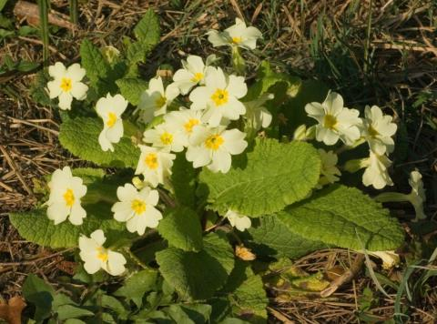
Primroses growing in a woodland habitat

Name
The common name is derived from the French name ‘Primevere’ derived from the Latin for first, primus and verna meaning spring.

Classification and distribution
The Primrose Family Primulaceae is predominantly a northern temperate family

Economic use
The genus Primula, and two other genera, Cyclamen and Lysimachia, are important horticultural plants.

Flower structure
Symmetry | Radially symmetrical (actinomorphic)
Perianth | Calyx – 5-toothed,formed of 5 fused sepals
 | Corolla – 5 fused yellow petals. A long corolla tube opens out into 5 showy lobes.
Androecium | 5 stamens attached to the corolla
Gynoecium | 5 fused carpels. Ovary superior with 1 chamber. The ovules are arranged around a single central placenta – free central placentation.

Flower morphology and pollination
The flowers are insect-pollinated by long-tongued insects such as Bee-flies (Bombylidae) or spring-flying moths.

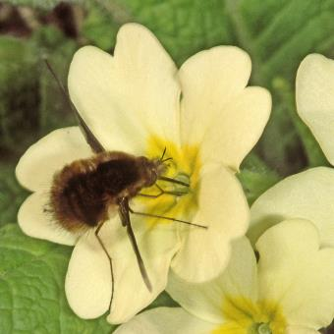

A Bee-fly (Bombylius sp.) visiting a pin-eyed Primrose flower.

The Primrose has two sorts of flower, pin-eyed and thrum-eyed.

Pin-eyed Primrose Thrum-eyed Primrose
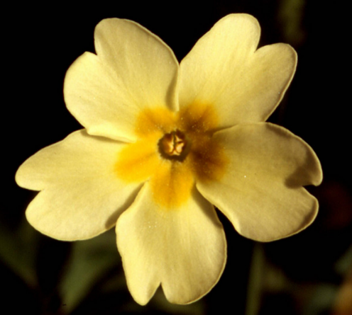
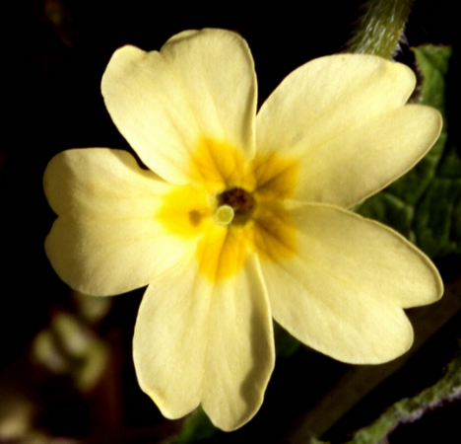

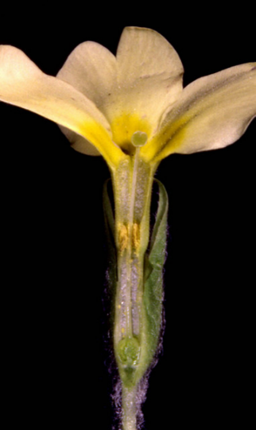
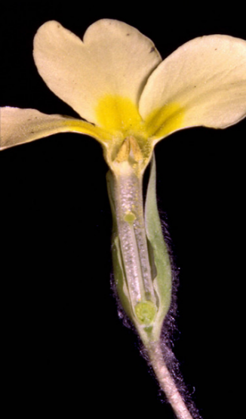
Longitudinal section through
a thrum-eyed Primrose

Longitudinal section through
a pin-eyed Primrose

When an insect visits a pin-eyed flower, its proboscis (tongue) acquires pollen from the stamens half-way down the flower tube. This position of the pollen on the insect’s tongue makes it more likely to be deposited on the stigma when the insect visits a thrum-eyed flower. In the same way, pollen collected from a thrum-eyed flower is in a position suited to be deposited on the stigma in a pin-eyed flower. About half the flowers in a population of Primroses will be thrum and half pin.

Successful pollination and fertilisation relies on the pollen being ‘accepted’ by the stigma and producing a tube which grows down the style into the ovary. Most species which have more than one flower type also have a self-incompatibility mechanism. The photographs show that in the primrose there is a mismatch in the size of the pollen grains and the stigmatic papillae (projections on the surface of the stigma). This may well limit self-fertilisation.at least in the thrum flowers where the large pollen grains produce a tube too large to penetrate the surface of the thrum stigma. It is also likely that if the small ‘pin’ pollen grains are transferred to the pin stigma they do not contain enough food reserves to allow them to grow all the way down the long pin style to the ovary.

Pin stigma (top) and pollen (bottom) Thrum stigma (top) and pollen (bottom)
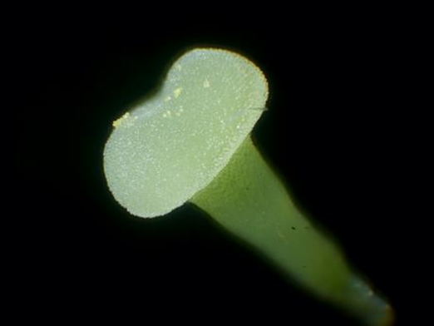
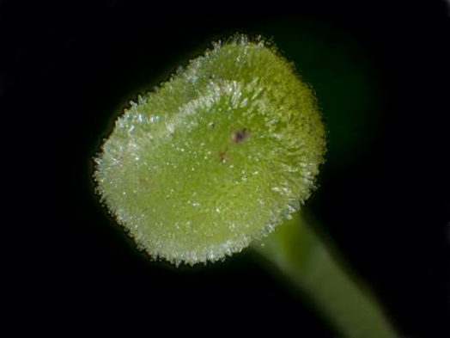

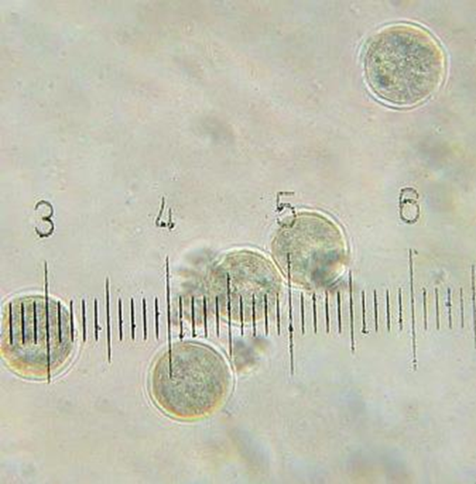
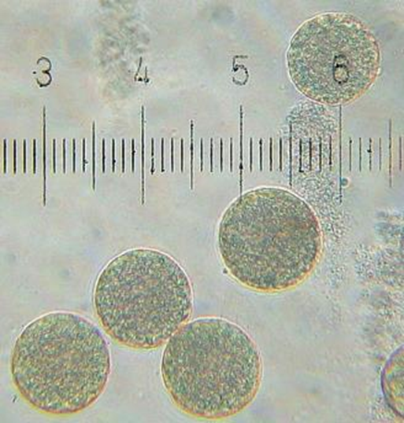

.
Answers to the questions on the Student Support Sheet

- What is the function of the Primula flower?
Plant reproductive organ adapted for pollination
- Which organisms are the pollinators of Primula in its native habitat?
Long-tongued insects such as moths, bees and bee-flies.
- About half the plants in a population of primroses will produce pin-eyed flowers and half will produce thrum-eyed flowers. Use your knowledge of the structure of primula flowers and information in the passage to explain how the presence of the two flower types within a Primula population ensures cross pollination.
When an insect visits a pin-eyed flower, its proboscis (tongue) acquires pollen from the stamens half-way down the flower tube. This position of the pollen on the insect’s tongue makes it more likely to be deposited on the stigma when the insect visits a thrum-eyed flower. In the same way, pollen collected from a thrum-eyed flower is in a position suited to be deposited on the stigma in a pin-eyed flower. About half the flowers in a population of Primroses will be thrum and half pin.
Successful pollination and fertilisation relies on the pollen being ‘accepted’ by the stigma and producing a tube which grows down the style into the ovary. Most species which have more than one flower type also have a self-incompatibility mechanism. The photographs show that in the primrose there is a mismatch in the size of the pollen grains and the stigmatic papillae (projections on the surface of the stigma). This may well limit self-fertilisation.at least in the thrum flowers where the large pollen grains produce a tube too large to penetrate the surface of the thrum stigma. It is also likely that if the small ‘pin’ pollen grains are transferred to the pin stigma they do not contain enough food reserves to allow them to grow all the way down the long pin style to the ovary.

- The genes responsible for pin-eyed and thrum-eyed Primula flowers are found on a part of the Primula genome called the S locus. Pin-eyed flowers have a homozygous recessive genotype, while thrum-eyed flowers are heterozygous at the S locus.
- (i) Use a Punnett square to show the genotypes and phenotypic ratios that will arise from a genetic cross between a pin-eyed and a thrum-eyed flower.
Parental phenotypes Pin-eyed X Thrum-eyed
Parental genotypes ss X Ss
Gametes s S s

Punnett square
 | S | s
s | Ss | ss
s | Ss | ss
Genotypes of progeny: Ss and ss
Phenotypic ratio: 1 : 1
Thrum-eyed : Pin_eyed

(ii) Does the result of this genetic cross agree with the phenotypic ratios observed in populations of primrose plants?
Yes: 50%-thrum-eyed, 50% pin-eyed.
- Explain why it is unlikely that populations of primrose plants will contain plants with the homozygous dominant genotype.
Dominant alleles are only present in heterozygous plants (Thrum-eyed). Homozygous dominant plants can only be produced if these heterozygous plants self-fertilise. Self-fertilisation is unlikely because of incompatibility of pollen and stigma from the same flower-type.

