From the booklet: Reproduction and Life Cycles part 2
Teaching Notes
The colours of flowers
This simple exercise concentrates on the role of the petals in attracting insects. The activity also provides an opportunity to go outside to do some fieldwork and learn the names of some wild flowers. Children can then make links between their outdoor and classroom activities. An alternative version is given for those who cannot find a suitable range of flowers close to the school.
At this stage it would be particularly useful to make a link to the PowerPoint presentation ‘Pollination’ included and let the children see the pictures of different flowers.

If possible, record only wild flowers. If you look at wild flowers in the UK, you will probably find only a few bright red flowers. You can prompt children to ask questions about this and then you can tell them that many insects do not see red well, so this is not a good colour for attracting insects. However, if you use garden flowers, you may find that more of these have bright red flowers. Many cultivated flowers have come from abroad where sometimes pollination can be by birds, and birds are able to see red well. Cultivated flowers have often had unusual colours bred into them to please gardeners.

The activity
Let the children think about ways in which the petals might help to attract insects. Encourage them to consider the following:
- colour
- size
- shape
- production of nectar
- scent
- nectar guides

Then the children can make some predictions. One possible prediction is that ‘most flowers are brightly coloured’.

This activity is based on fieldwork. Take the children outside on a short walk and ask them to record the colours and names (where possible) of the wild flowers that they see.

To help with the recording, give younger children square coloured tokens, made of card. They then write the flower names on the appropriate coloured token. Older children can fill in their own chart (see the Pupil Sheet). The Pupil Sheet could be printed on lightweight card allowing children to use paints.

Alternatively, children can make their own chart, using paint, colours or coloured paper. Make sure you keep close to the range of colours shown on the Pupil Sheet.

On return to the classroom
The information gathered can be presented in a graph to show the frequency of the different flower colours that they saw.
- Coloured tokens. Use these to form a simple block graph showing how many flowers of each colour were found
- From the chart. The information from the different charts can be collected together and children can draw their own graph or use their IT skills to generate a computer graph.
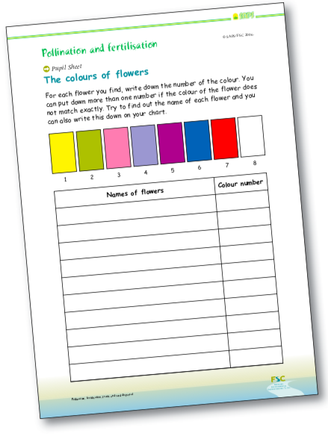
Figure 1. Reduced size version of Pupil Sheet for recording colours of flowers. A full-sized template is provided on the SAPS website.

Alternative version (in the classroom)
If it is impossible to go for a walk, you can find other ways to do this activity with the children by using pictures. You may have posters of wild flowers that you could use for pictures of flowers. Another useful source of pictures of wild flowers is one of the FSC fold-out charts (see reference list below).

Further information

For help with identification of wild flowers, you will find it useful to look at the FSC fold-out charts, obtainable from FSC Publications.

FSC Publications, Unit C1, Stafford Park 15, Telford TF3 3BB.
Telephone: 0845 345 4072
e-mail: publications@field-studies-council.org www.field-studies-council.org
Farley et al. Playing field plants (2005). OP97.
Bebbington A and Bebbington J Guide to grassland plants 2 (chalk and limestone) (2005). OP95. Gulliver et al. Grassland plants 1 (2002). OP68.
Gulliver et al. Woodland plants (1998). OP50.
More information about colour in the environment is given in
Bebbington A and Bebbington J Exploring colour in the environment (OP63) and the accompanying Teacher’s Guide (OP101).

