Vines and villains – a game (A3 coloured board)
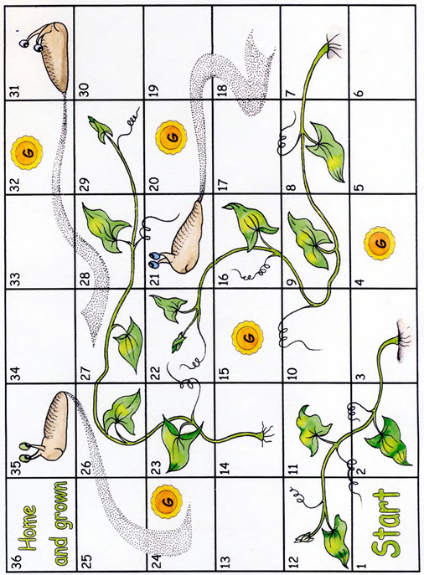

Vines and villains – a game (A3 board for colouring)

