Vines and villains – a game (Growth cards)
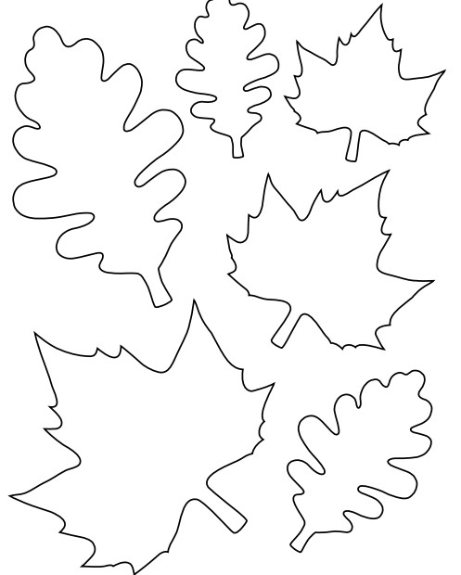

How does water get into the plant?
What three things does a plant need to make its food?
What is the process called that plants use to make their food?

What is dissolved in water, taken up by the roots and needed for plants to grow well?

To start germinating, a seed needs oxygen and a suitable temperature. What else does it need?

What sort of energy does the plant use to make its food?

Vines and villains – a game (Growth cards)

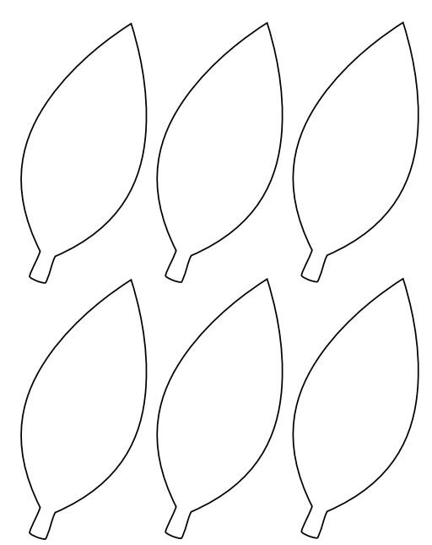

Which is the main part of the plant where the process for making food takes place?
Why do plants need mineral salts?
Which life process is to do with plants making food?

How do gases get into and out of the plant?
Which gas is produced in photosynthesis?

Which gas is used in photosynthesis?

To start germinating, a seed needs oxygen and a suitable temperature. What else does it need? (Water) | What is dissolved in water, taken up by the roots and needed for plants to grow well? (Mineral salts) | What three things does a plant need to make its food? (Water, carbon dioxide and light)
What sort of energy does the plant use to make its food? (Light) | Which gas is used in photosynthesis? (Carbon dioxide) | Which gas is produced in photosynthesis? (Oxygen)
How do gases get into and out of the plant? (Through holes on the leaves) | What is the process called that plants use to make their food? (Photosynthesis) | Which is the main part of the plant where the process for making food takes place? (The leaf)
How does water get into the plant? (Through the roots) | Why do plants need mineral salts? (For healthy growth) | Which life process is to do with plants making food? (Nutrition)
Vines and villains – a game (Answers)

