From the booklet: Living processes and what plants need to grow
Teaching Notes
Vines and villains – a game
This board game is a variation of snakes and ladders. It can be used to reinforce the children’s understanding about what seeds need to germinate and what plants need to grow well.

Preparation for the game
For the class, you will need the following:

- The game board
- A counter for each child
- Growth cards (with questions)
- A die
The game board (Figure 1) is available on the SAPS website for you to download. A black and white version is provided for the children to colour in themselves or you may prefer to use the coloured version. The templates can also be enlarged to A3 size if you wish. The templates can be printed onto card and laminated to make them more durable.
Prepare (or use those provided) twelve growth cards, each with a question written on one side. The cards can be any shape or size and made out of suitable card. Suggestions for questions (and their answers) are given below. Alternatively, the children could devise their own questions for the game as part of an end- of-topic activity. You may also wish to prepare a set of cards with the answers to the questions, so that the children can check their own answers while playing the game.
Playing the game
This is a game for two to four players. The aim is to reach ‘Home and grown’ first, but during the game, players may climb up the vines and slide down the slug trails.
- The growth cards are placed face downwards beside the board. Do the same with the answer cards, if you would like the children to check their own answers.
- To start the game, the child who throws the highest number with the die goes first.
- If a child’s counter lands on a growth square, they take the top card and try to answer the question. If they answer the question correctly, they advance four spaces, but if their answer is wrong, they go back four spaces.
- To end at square 36, the exact number must be thrown. The first child to reach this square is the winner. As an alternative, children may prefer to count forwards (as far as square 36) then backwards for the required number of squares to use up the numbers on the die. They then continue in this manner until they finally land on square 36 and become the winner.

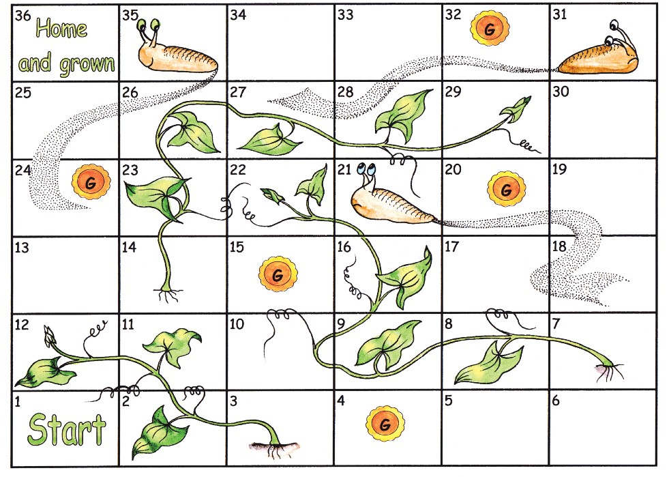
Vines and villains
Figure 1. Reduced size colour version of the board for playing Vines and villains.

Questions

To start germinating, a seed needs oxygen and a suitable temperature. What else does it need?(Water)

What is dissolved in water, taken up by the roots and needed for plants to grow well? (Mineral salts)

What three things does a plant need to make its food? (Water, carbon dioxide and light)

What sort of energy does the plant use to make its food? (Light)

Which gas is used in photosynthesis? (Carbon dioxide)

Which gas is produced in photosynthesis? (Oxygen)

How do gases get into and out of the plant? (Through holes on the leaves)

What is the process called that plants use to make their food? (Photosynthesis)

Which is the main part of the plant where the process for making food takes place? (The leaf)

How does water get into the plant? (Through the roots)

Why do plants need mineral salts? (For healthy growth)

Which life process is to do with plants making food? (Nutrition)

