A-level set practicals: Osmosis in bell pepper pericarp tissue
Technical & Teaching Notes

Introduction and context
Students studying A Level Biology 2015 specifications for England are required to demonstrate a specific set of practical skills and techniques by performing at least 12 practical investigations. The relevant skills and techniques covered in this practical are listed in the ‘Getting learning value from the practical’ section below.

In this practical, students will determine the water potential of cells in the pericarp of a bell pepper (Capsicum annum) by investigating the change in mass that is produced when water moves into or out of the cells by osmosis, down a water potential gradient. The investigation can be completed in one 60 minute lesson, and the changes in mass produced are easily detected using two-decimal-place top-pan balances (of the type widely used in school laboratories).

Students will prepare a dilution series of a 1 Molar sucrose solution and use this to produce a calibration curve with which to identify the water potential of cells in the pepper pericarp tissue.

The support and preparation sheet guides the students through a preliminary investigation into the cells present within the bell pepper pericarp tissues, and the importance of cell turgor to plants. It aims to reinforce the importance of the movement of water into and out of cells by osmosis to the survival of plants. The exercises on the support and preparation sheet could be carried out before this practical investigation, or could be completed during the thirty minutes when the pieces of pepper pericarp tissue are immersed in the sucrose solutions.

Learning outcomes
The students will:
- Use laboratory glassware to prepare a dilution series of a 1Molar sucrose solution
- Use a two decimal place balance to measure changes in mass in plant tissue samples that have been immersed in the solutions
- Calculate percentage change in mass of the plant tissue samples
- Use a calibration curve to find the water potential of the cells in the pepper tissues used in this investigation

Safety Notes
- Many plants contain toxins. Good general advice is:
Check before organising the practical whether any pupil is aware of allergies to a particular plant so that it can be avoided.
CLEAPSS Student Safety Sheet 74 provides information about assessing the risk posed by plant material.
- Care must be taken when using sharp instruments such as scalpels, scissors and mounted needles and students must be given clear instructions for their safe use.
- Care must be taken attaching or removing the pipette filler from the graduated pipette. The neck of the pipette is fragile and could easily snap.

Apparatus
Per student (or practical group)
- ¼ of a red pepper
- 50cm³ 1M sucrose solution
- 50cm³ Distilled water
- Test tubes x 11
- 10 cm3 Graduated pipettes x 2
- Pipette filler
- Cutting tile
- Kitchen knife or scalpel
- Petri dish with lid
- Paper towels
- Laminated graph paper
- Blunt forceps

Per class
- 2 decimal place top pan balance x2 or 3

Technical guidance
- If the peppers are fresh, wrapped in a plastic bag and kept in the fridge until the start of the experiment (so water potential of cells in the pericarp tissue is high), repeatable results for percentage change in mass can be obtained if the 1cm x 0.5cm pepper pericarp pieces are in the sucrose solution for 30 minutes (fitting nicely into a one hour lesson). This is probably the result of the cells of the pericarp being uniformly turgid.
- Peppers that have not been refrigerated or wrapped in plastic will give repeatable results if the pericarp pieces are left in the solutions for at least 60 minutes. Their tissues will not be uniformly turgid at the beginning of the experiment.
- Percentage change in mass produced more reliable data than percentage change in thickness or length of pepper pericarp pieces.
- It is possible for one pepper to provide sufficient 1cm x 0.5cm pieces for four to six experimental set-ups (depending on size of the pepper).
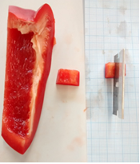
- 1M sucrose solution can be prepared using Tate and Lyle granulated sugar.
- Any colour of pepper could be used.
- Two decimal place top pan balances can be used to measure the changes in mass produced in this investigation.
- Laminated graph paper is suggested for use as a cutting grid if grids are not available within the school.

Suppliers

Bell peppers are widely available from any greengrocer or supermarket.

1Molar sucrose solution can be prepared using Tate and Lyle granulated sugar.

Teaching Notes
Preparation tasks

The accompanying Student Preparation Sheet can be used to prepare the students for the practical and to support their subject knowledge throughout the practical

Answers to questions on Student Preparation Sheet
1. The pepper giant cells are important in making the fruit succulent as they have a high cell volume, very elastic cell walls and water can enter and leave the giant cells rapidly. Use this information to suggest an explanation for the shape of the cell walls of the endocarp cells that cover the giant cells.
The endocarp cells may need to stretch when the giant cells are turgid. The many folds in the endocarp cell walls would allow for this expansion.

2. Explain what you observed when you pushed the mounted needle against the endocarp and giant cells.
When the mounted needle was pushed against the endocarp and giant cell, the cell walls and cell membranes of the endocarp cells and giant cell broke, reducing the turgor of the giant cell and releasing cell sap from its vacuole.

3. Suggest why the high pressures developed inside some turgid plant cells may be so important to the plants.
Plants rely on turgor pressure for transport and support.

Modelling changes in cell turgor (student preparation sheet extension idea)

Suggested apparatus that could be available:

- 10cm lengths of Visking tubing that have been softened by soaking in distilled water for 5 minutes.
- 1Molar sucrose solution
- Boiling tubes
- Distilled water
- Boiling tube racks
- Thread

Possible method for modelling changes in cell turgor
- Securely knot the piece of Visking tubing about 1cm from the end to make a Visking tubing bag (this simulates the cell).
- Fill two thirds of the Visking tubing bag with the 1Molar sucrose solution (the sucrose solution simulates the cell sap in the vacuole of the cell).
- Carefully squash out the air from the space above the sucrose solution in the Visking tubing bag, then securely tie the thread around top of the bag to close it.
- Place the Visking tubing bag (the model cell) into the boiling tube and fill the boiling tube with distilled water (the distilled water represents the water molecules that are able to diffuse into the model cell from surrounding cells).
- Make a drawing of the Visking tubing bag and describe its appearance.
- Place the boiling tube into the boiling tube rack and leave for 30 minutes.
- After 30minutes, describe the appearance of the Visking tubing bag and make a drawing that will allow you to compare its appearance at the start and at the end of the experiment.

Expected results
After 30 minutes, distilled water will have diffused, by osmosis, from the boiling tube, through the Visking tubing into the 1 molar sucrose solution down a water potential gradient. The volume of liquid inside the bag will have increased, increasing the pressure of the liquid inside the bag. This increased pressure simulates turgor pressure. The model cell is now much more rigid.

Changes in cell turgor: slow or fast

4. Pressure changes inside your Visking tubing model take place slowly. Suggest two ways in which the changes in pressure could be speeded up:
- Increase the temperature of the model system.
- Increase the steepness of the water potential gradient on either side of the semi-permeable membrane in the model.

5. The following images illustrate a variety of rapid plant responses that are brought about by changes in cell turgor. For each response, state its importance to the survival of the plant, carry out some research to find out how the rapid changes in cell turgidity are thought to be brought about and write a brief explanation in the table.
Plant response | Importance of response to the survival of plant | How the response is brought about.
Stomatal opening and closing  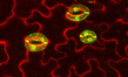 | Regulates gas exchange between the plant leaf and the atmosphere. | Stomata are formed by two guard cells that change shape to open or close the stomata. When K⁺ ions are actively pumped into the guard cells, the cells take up water by osmosis, become turgid and bend, opening the stomata. The stomata are shut when the guard cells lose K⁺ and become flaccid.
Closing of Venus fly trap when trigger hairs are touched.  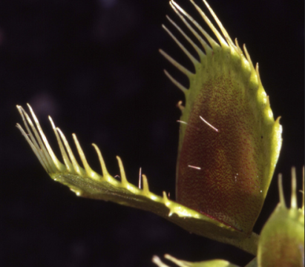 | Allows the venus fly trap to trap insects that land on the trap, providing the plant with a source of nutrients such as nitrogen. | Successive stimulation of a trigger hair on the inside of the trap causes ion channels to open in the cell membranes of the flaccid cells on the outside of the trap. These cells take up water by osmosis and become turgid, while the innermost cells become flaccid, flipping the curvature of the trap from concave to convex, rapidly closing the trap.
Movement of mimosa leaves when touched.  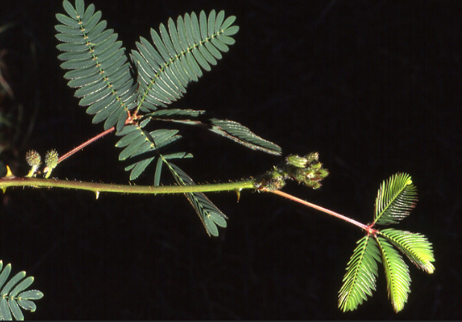 | Defense against leaf damage by grazing insects and larger animals | Changes in the turgor pressure of cells in structures called pulvini, found at the base of the leaflets, bring about this movement. When the cells in the pulvini are turgid, the leaflets are held out. When the leaflets are touched, ion channels in the membranes of the pulvini cells open, leading to movement of ions into the surrounding tissue. As a result, the cells in the pulvini lose water by osmosis, become flaccid and the leaflets fold downwards.

Answers to questions on Student Sheet
- Why are the pepper pieces stored in a covered dish until they are needed?
To reduce the amount of water that may evaporate from the cells. Without this, those pieces cut first could have a lower starting water potential than those cut later.

- Why are the discs washed in distilled water?
To remove any solute molecules that may have been released from the cells when the tissue pieces were cut. If not removed, these solutes could change the water potential of the solutions that the pepper pieces are placed into.

- Why are they dried very carefully?
To carefully remove surface water without rupturing any cells

- Explain why the pieces of pepper are left in the solution for 30 minutes. After 30 minutes, what happens to the net diffusion of water molecules?
To allow water molecules to diffuse, by osmosis, between the bathing solution and the cells of the pepper tissue, down a water potential gradient, until equilibrium is reached. At equilibrium, there is no further net movement of water into or out of the cell in the pepper pieces (although water molecules will continue to diffuse across the cell membranes, but diffusion of water into the cells is balanced by diffusion of water molecules out of the cells), because the water potentials on either side of the semipermeable membrane are the same.

- Why are the pieces of pepper tissue dried before they are re-weighed?
To remove surface water, which would contribute to the final mass of the pepper tissue, but would not represent water that had been taken up by osmosis.

- Why was change in mass data converted into percentage change in mass in this investigation?
Initial starting masses are variable. Converting to percentage change in mass allows comparisons to be made.

- Use your graph to find which molarity of sucrose solution has the same water potential as the pepper pericarp tissue. Explain how you got your answer.
The molarity of sucrose solution with the same water potential as the pepper pericarp tissue will produce a percentage change in mass of 0% (as there will be no net up take or loss of water by osmosis by the pepper tissue). Finding the intercept of the line on the graph with the x axis allows this molarity to be calculated.

- Explain fully the shape of the graph in terms of water potential (.i.e. why some pieces of pepper pericarp tissue discs gain mass, why some lose mass and why some may stay the same.) In your answer, use the following terms: Osmosis, water potential, water potential gradient, net movement of water molecules.
For tissue that gained mass:
- Water potential of sucrose solution is greater than water potential of cells in the pepper tissue (water potential solution>water potential cell)
- There is a net movement of water into cells of tissue by osmosis, down a water potential gradient from high water potential to low water potential until equilibrium is reached (water potential solution=water potential cell)
For tissue that lost mass:
- Water potential of cells in the pepper tissue is higher than water potential of the sucrose solution (water potential cell>water potential solution)
- There is a net movement of water out of the cells of the pepper tissue by osmosis, down a water potential gradient from high water potential to low water potential until equilibrium is reached (water potential solution=water potential cell).
For tissue whose mass was unchanged:
- Water potential of cells in the pepper tissue equals the water potential of the sucrose solution (water potential cell=water potential solution)
- Water molecules will diffuse across the membrane at an equal rate in both directions, so there is no net (overall) movement of water into or out of the cells of the pepper tissue by osmosis.

- What is your estimate of the water potential of the pepper pericarp tissue cells?

- Explain how you obtained a value for the water potential of the cells in the pepper pericarp tissue.

By creating a calibration curve from the data provided and reading off from the graph.
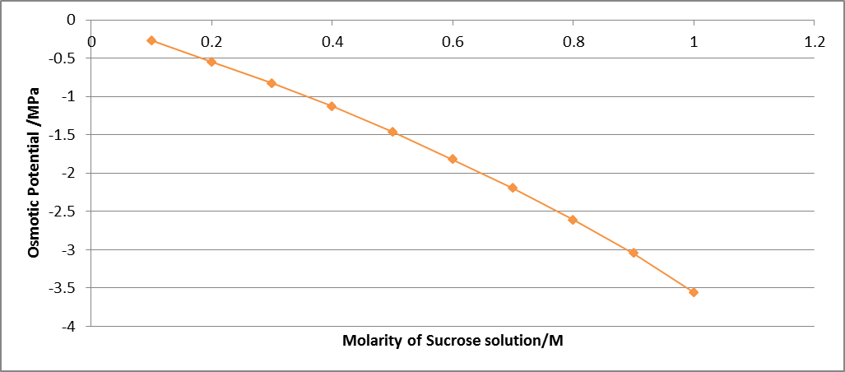
Molarity of sucrose solution/M | Osmotic potential/MPa
0.1 | -0.27
0.2 | -0.55
0.3 | -0.83
0.4 | -1.13
0.5 | -1.46
0.6 | -1.82
0.7 | -2.2
0.8 | -2.61
0.9 | -3.05
1 | -3.56

- How could you increase the accuracy of this
investigation?
- Set up replicates at each sucrose molarity and calculate a mean % change in mass.
- Pool class data
- Compare the value for water potential of pericarp cells that you obtained with that obtained by other students in your class, using different pieces of pepper pericarp tissue. Discuss the possible causes of similarities and differences within the class.
Variation in water potential of pericarp cells within a pepper
Variation in water potential of pericarp cells between different peppers
Human error: Inaccurate pipetting, inaccurate use of balance (reading display, not zeroing between weighings), inaccurate record keeping.
Getting learning value from the practical

Practical skill development | Developing knowledge and understanding of the techniques and procedures for finding the water potential of cells within a plant tissue using change in mass. Using laboratory glassware to prepare a dilution series. Use of electronic balance. Use of ICT to record or process data.
Extension to practical skill development | Investigating the use of other parameters of the tissue samples, such as length or depth, to determine water potential.
Maths skill development | Calculation of percentage change in mass  Plotting data in a suitable format  Using the intercept of a graph to find water potential
Associated subject knowledge development | The movement of water across membranes by osmosis and the effect that solutions of different water potential can have on plant cells. Osmosis to be explained in terms of a water potential gradient across a partially permeable membrane
Recording evidence of student’s work | Completion of student support sheet, including drawing of observed cells. Completion of tasks on student sheet, including drawing graphs from primary data, drawing a calibration curve from secondary data and using it to calculate water potential of the pepper tissue cells.
Meeting aspects of the use of apparatus and techniques | - use appropriate apparatus to record a range of quantitative measurements (to include mass, time, volume, temperature, length and pH)  - use laboratory glassware apparatus for a variety of experimental techniques to include serial dilutions  - use of light microscope at high power and low power, including use of a graticule  - produce scientific drawing from observation with annotations  - safely and ethically use organisms to measure plant or animal responses or physiological functions  - safely use instruments for dissection of an animal organ, or plant organ  - use ICT such as computer modelling, or a data logger to collect data, or use software to process data.
Meeting aspects of the CPAC | Use and apply scientific methods and practices  - safely and correctly use a range of practical equipment and materials  - follow written instructions  - make and record observations  - keep appropriate records of experimental activities  - present information and data in a scientific way  - use appropriate software and tools to process data, carry out research and report findings

Further Investigations

Students could plan their own investigation into water potential in other plant tissues (for potato tissue, see http://www.saps.org.uk/secondary/teaching-resources/286-measuring-the-water-potential-of-a-potato-cell)

Using Chardakov’s method to estimate water potential (see http://www.saps.org.uk/secondary/teaching-resources/286-measuring-the-water-potential-of-a-potato-cell)

Using incipient plasmolysis to investigate water potential of plant tissues (for an example see http://essentials.cambridge.org/media/COAS_B1_02_acts_pr5.pdf)

References

Ofqual/16/6013
GCE Subject Level Conditions and Requirements for Science (Biology, Chemistry, Physics) and Certificate Requirements May 2016
https://www.gov.uk/government/publications/gce-subject-level-conditions-and-requirements-for-science

CLEAPSS Hazcards
http://www.cleapss.org.uk/
Log-in required

Plants and Pressure: A PowerPoint presentation by Professor Jeremy Pritchard, University of Birmingham, UK.

RYGOL, J. and LÜTTGE, U. (1983), Water-relation parameters of giant and normal cells of Capsicum annuum pericarp. Plant, Cell & Environment, 6: 545–553. doi:10.1111/j.1365-3040.1983.tb01167.x (found on-line at http://onlinelibrary.wiley.com/doi/10.1111/j.1365-3040.1983.tb01167.x/abstract)

Acknowledgements

With thanks to:
Professor Jeremy Pritchard, School of Biosciences, University of Birmingham; Vicky Doronina, Jane Martindale and Pierre Grace, Manchester Metropolitan University Science Education Department, MMU, Manchester; pepper images taken by Bev Goodger;The resource was developed by Bev Goodger.

