Calibrating and measuring in microscopy:
a paper-based activity
Teaching Notes
Introduction
This activity aims to help students learn the skills of measuring using an eye piece graticule and calibrating a stage micrometer without the extra challenge of using a microscope.
Once students are successful at this activity they can then progress to using the skills with a microscope.
Challenges of teaching students to calibrate a microscope whilst using one include that it’s difficult for a teacher to demonstrate exactly what to do, difficult for students to point out exactly what they are talking about when asking questions, and difficult for teachers to identify the specific issues students are having when they struggle to grasp the skill. By transferring the activity onto paper these challenges are avoided.
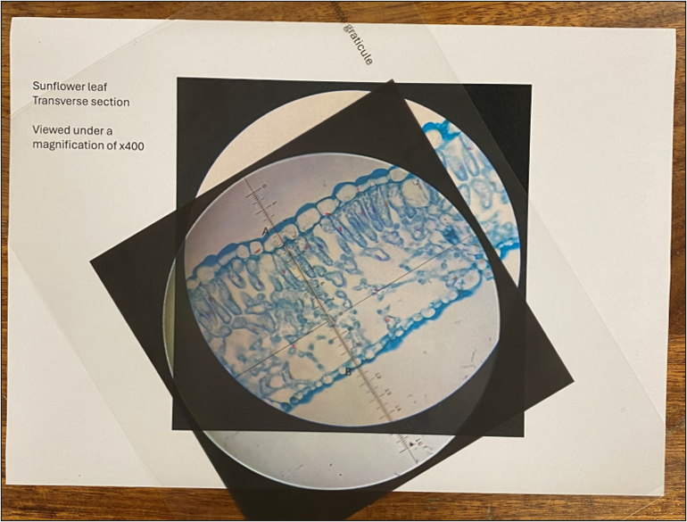
Figure 1: An image of an eye piece graticule on acetate lined up to measure the thickness of a leaf in eye piece units (EPUs) as viewed under a magnification of x400.

Apparatus
Paper copies of:
- Images of the transverse section of a sunflower (Helianthus annuus) leaf at x40, x100 and x400 (a set of 3 per group of 3 students)
- Images of a stage micrometer at x40, x100 and x400 (a set of 3 per group of 3 students)
Images of the view of an eye piece graticule printed on acetate. (one per student)
Note: ensure all images are printed to the same scale. The fields of view of all images should be the same size.
Eye pieces containing eye piece graticules (optional)
A microscope to demonstrate (optional)

Guidelines
The accompanying PowerPoint presentation can be used to lead students through this activity.
The following additional information may be useful:
- The activity is framed around working out how thick a leaf is. Slide 2 asks students to estimate how thick a leaf is in mm and then convert this to µm. It is useful to check whether students are comfortable using micrometres and support where necessary before moving onto calibrating and measuring since they will be working routinely in µm for this task.

- Slides 3 and 4 are stills from an animation about transport of water and sugar in plants (https://www.saps.org.uk/teaching-resources/resources/1274/transport-of-water-and-sugar-in-plants/). The images or the animation itself can be used to ensure students are familiar with what they are looking at before the activity begins.

- Slide 5 shows the images of the leaf that are going to be measured. There are images of the leaf at x40, x100 and x400. When measuring, students don’t have to start with the x40, so students could be put in groups of 3 and share the images between them. The distance to be measured is clearly marked so that all students are doing the same measurements. The same part of the leaf is marked on each image and so results should be similar regardless of which magnification is used.

- Slide 6 shows what an eye piece graticule looks like when you view it down the microscope. It might be useful for students to hold up a real eye piece containing an eye piece graticule and look through it so that they see one for real. You may also want to demonstrate, using a microscope, why an eye piece graticule is required when measuring specimens under a microscope (i.e. you can’t have the specimen and a measuring tool under the microscope, and in focus at the same time). So the specimen goes on the stage and the measuring tool goes in the eye piece). Students will need an image of the eye piece graticule printed on acetate each. The slide deck for printing images provides an image of a 0-10 eye piece graticule and a 0-16 one. The units on the eye piece graticule are the same regardless of which type is used. It’s best to choose ones most similar to the eye piece graticules you have.

- Slide 7 asks students to measure the thickness of the leaf (the distance between points A and B) in eye piece units (EPUs) for each of the 3 images of the leaf and put their results in a table as shown on the slide. Some teachers talk about an EPU as one of the smallest divisions and others use the numbered divisions to represent 1 EPU (and so the smallest divisions are 0.1EPU). The example answers at the end of the presentation use the numbered divisions to represent 1 EPU.

- Once the measurements of the leaf thickness in EPUs have been completed at all 3 magnifications, you can point out that the leaf thickness is a different number of EPUs each time. This is because an EPU is not a fixed distance. Its length varies with the magnification being used. This discussion can be used as a way to introduce the need to calibrate the eye piece graticule so that leaf thick can be determined in µm and not just left as meaningless EPUs.

- Slide 8 shows students how to calibrate their eye piece graticule for each magnification. Students keep their acetate of the eye piece graticule and now use it with images of a stage micrometer at each of the 3 magnifications used. The slide deck of images to print has ones for two different stage micrometers. Students could get experience with both types or you could just use the ones most similar to the stage micrometers you have. Each stage micrometer image contains a description of how many µm each division represents.

- When calibrating, students should line up their eye piece graticule with the stage micrometer and find two points where lines on the eye piece graticule line up with lines on the stage micrometer (the further apart, the greater accuracy).

You could use the image on the slide to explain how to calibrate:
- In the image on slide 8, the number 1 line on the eye piece graticule lines up with a line on the stage micrometer, as does the 14.2 line, a difference of 13.2 EPUs.
- There are 35 small divisions on the stage micrometer between the two lines identified.
- Since in this example each of the smallest divisions of the stage micrometer are 10µm, this is a distance of 350µm.
- Therefore 13.2 EPUs are equivalent to 350µm.
- This means that one EPU is 26.515µm (left with more decimal places so that rounding issues don’t cause a problem when measuring).

There is a table on slide 8 for students to copy and complete to show their values for what distance an EPU represents at each magnification.

- Slide 9 shows how students can use their ‘thickness of the leaf in EPUs’ measurements from earlier with their calibration values to calculate the thickness of the leaf in µm and add it to their first table.

- Slide 10 shows some possible answers. There is a note on the slide to say that values that students calculate may vary slightly due to choices made when measurements fall between two gradations on the eye piece graticule or if sections nearer the edges of the images of the eye piece graticule or stage micrometer have been used as there is some slight distortion of the images around their edges. It’s likely that final values of leaf thickness in the range of 200-260µm will have come about through correct maths but values at the extremes of that range may have been caused by the issues above and/or slightly sloppy measuring by the student.

- Students can then compare their estimate for leaf thickness at the start of the activity to the calculated one.

- To allow time to focus on supporting struggling students, those that finish first could be asked to do the task for real with a microscope. Alternatively, they could be asked to decide which value of the 3 they calculated for leaf thickness is likely to be the most accurate and to write an explanation of why. Their answer should be the value at the highest magnification since any measurement resolution issues (i.e. a measurement falling between the gradations of the eye piece graticule) will have the smallest effect on the final value. Another way of explaining this is that calculations at the highest magnification have the lowest percentage error associated with them.

If you’d like to find out more about ideas for helping students develop their understanding of, and skills in, microscopy you can explore a range of resources and articles on the Science and Plants for Schools website here: https://www.saps.org.uk/growth-hub/teaching-microscopy-using-plants/

