From the booklet: Grouping and Classification

*Teaching Notes*

**Copycats – a game**

This activity provides an enjoyable way of reinforcing the importance of accurate observation and recording. It encourages the children to understand why, when doing science work, they should draw what they see and not add anything or leave something out. The activity also helps to make the point that even though drawing living plants or animals is difficult, if you copy other people’s work, you copy any mistakes they have made. If an illustration is copied several times, mistakes add up!

The game is based on ‘Chinese whispers’, but in ‘Copycats’ an original drawing is copied by one child, then the different children, each in turn, copy the previous child’s drawing without seeing the original. It is more fun if you don’t explain the point of the activity beforehand. Make sure they only look at the drawing done by the child just before, but don’t let them see the earlier drawings (until the end of the activity).

The game can be played with as few as ten children, but the more children that copy the drawings made the more the copies are likely to change from the original. It is often a good idea to use this activity while the children are occupied on another task, such as drawing a living plant.

***Resources and preparations for the activity***

* *The picture to be copied, printed onto a piece of card*
* *Similar-sized blank cards, enough for each child in the class. Number these on the back, starting at number 1*
* *Some sharp pencils*

***The activity***

Explain to the children that you are going to give them a drawing, and you want them to copy it as accurately as they can within a time limit (we suggest two minutes).

* In a quiet corner of the room, give the first child the original drawing and the card numbered 1 (and give the child a sharp pencil). After two minutes, ask the child to stop and return to what they were doing with the rest of the class.
* Call another child into the corner. Give them the blank card number 2 and the drawing on card number 1 to copy.
* Continue in this way until all the children in turn have copied the preceding child’s drawing.
* Display the drawings in sequence, placing a copy of the original drawing at the beginning and end of the series.

The children can then see what has happened to the drawing as it has been copied, and you can discuss with them and emphasise the value of making careful observations on living material and recording these observations accurately.

***Questions***

* *In what circumstance is it important to draw what you see?*
* *What implications are there if a drawing doesn’t resemble what is seen in real-life?*
* *Why do you think the finished drawing doesn’t resemble the original?*
* *What could you do to help ensure the drawing is of what is actually there and what you can see?*
* *What could you do or use to help with that?*

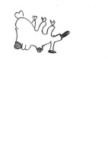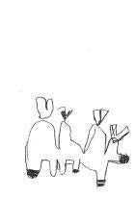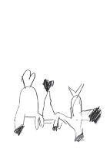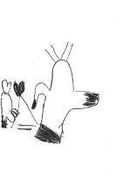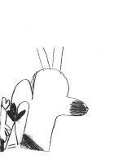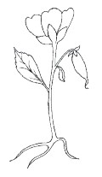

***Figure 2.*** A series of ‘Copycat’ drawings done by children (in Year 4 at The Cavendish School). This helps to show how mistakes add up and how features in the original picture are scarcely recognisable in the final drawing.

Original

Original

16

15

14

13

12

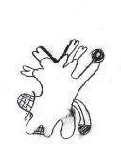

7

7

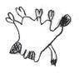

8

8

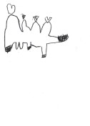

11

11

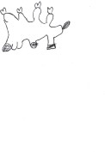

10

10

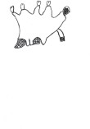

9

9

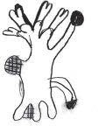

6

6

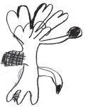

5

5

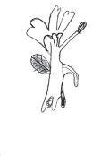

4

4

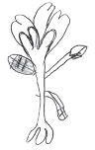

3

3

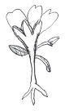

2

2

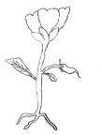

1

1

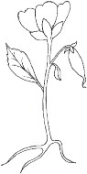

Original

Original

**Figure 1.** Copycats – original picture of a flower for the first child to draw. The rest of the children copy, in turn, the drawing done by the previous child.