From the booklet: Plants in their Natural Environment

*Teaching Notes*

**Design and make a plant suitable for a particular habitat**

This activity involves designing a plant, which the children have ‘discovered’ in a particular habitat. It encourages the children to reflect on what they have learned elsewhere about plant adaptations (see resource ‘How are plants suited to their habitat?). It requires some creative thinking and also gives opportunities for developing literacy and presentation skills.

**The activity**

Tell the children to choose a habitat which they are going to explore. While there, they discover a new plant.

* Ask the children to make detailed drawings of the new plant and show features that make it suitable for that habitat. This can be presented as a poster and the various features labelled. Any descriptions or explanations needed can be included in the poster
* Using various materials and from their design, let them make a model of their new plant

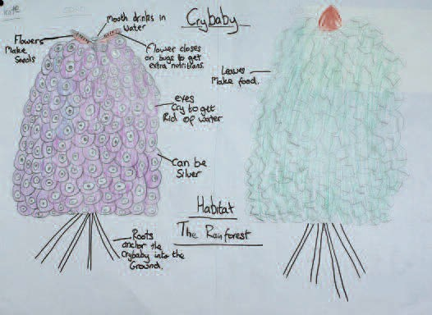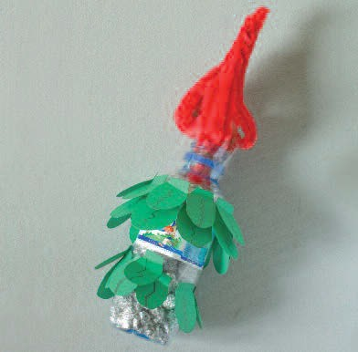

**Figure 1.** Plants ‘discovered’, then designed and created by children (in Year 4 at The Cavendish School). The plants show adaptations for their habitats, and this is explained in the accompanying posters: Crybaby model (top); Duckweed model (below).

