From the booklet: Plants in their Natural Environment

Soil, microorganisms and recycling

*Teaching Notes*

**Finding out about soil**

This starts with a blind exploration of what is in a box (which actually contains some soil) and leads on to taking a closer look at some of the different components. Children can use magnifying glasses, microscopes or some sort of visualiser or webcam if available, linking this for all to view on a whiteboard or equivalent.

***Resources and preparation for the activity***

* *A stout cardboard box. Make a hole in the top of the box, just large enough for a child’s hand to go through*
* *Some soil in a polythene bag, about half filling the box. The top of the bag comes out through the hole, allowing the children to put their hands inside without seeing what is in there. It is best to use soil from a garden as this is likely to contain a good variety of things for the children to feel and see. Store the soil in a cool, dark place and place it in the box just before the lesson.*
* *Plastic teaspoons, one for each child*
* *Petri dishes or other small containers with transparent lids, one for each child*
* *Magnifying glasses and, if available, a low-power microscope (magnification x 10 or x 20) and / or webcam*
* *Paper towels*
* *A measuring cylinder or tall jar (you can use a transparent drinks bottle or jam jar)*

**Make sure the soil is from a clean area of the garden and not used by cats or dogs. Cover all open wounds. Wash hands with hot water and soap after the activity.**

***The activity***

Tell the children that you have put something interesting in the box and you want them to find out what it is. Ask for a few volunteers, one at a time, to put their hands in the box and describe what is in there. They may realise there is some soil in the box, but probably dismiss it as they look for something they think is ‘interesting’. Encourage them to describe what they can feel and collect their words together, exploring their vocabulary (e.g. soil, mud, dirt, damp, gritty, rough).

After a few minutes, open the box. Let the whole class see what was in it. Ask them if they can think of any more words that could be added to the list, such as colours and other words for soil (e.g. dirt).

Now it is time to have a closer look. Give each child a small amount of soil – 2 teaspoons of soil in a dish with a lid should be sufficient. The children could use magnifying glasses or microscopes. Using a visualiser or webcam would give the class an opportunity to view the things in the soil together and share their discoveries.

At first, most children may not realise that soil contains water and air as well as the solid particles. Ask them to press a small amount of soil onto a sheet of absorbent paper (such as a paper towel). They should be able to see a damp patch, showing there is water in the soil. Then let the children put some soil into a measuring cylinder or tall jar and pour some water into the jar. As they watch, they are likely to see bubbles coming off as air is pushed out of the soil by the water.

To finish the activity, it is a good idea to introduce the Pupil Sheet ‘I spy in the soil’.

***Extension activities***

***For younger children***

Ask the children to imagine something that is happening in the bit of soil they have just been looking at. Ask them to draw a picture, or write a story or a poem about it. This gives a good opportunity to develop ideas for creative writing.

**Doug**

*Inside the soil there lived a bug*

*He had six legs, his name was Doug*

*In dirt and mud he scurried around*

*Until his favourite food he found*

*It wasn’t chips or even beef*

*Just a crunchy rotten leaf*

**For older children**

The Pupil Sheet ‘How soil is formed’ illustrates some of the processes involved in the formation of soil. You can use this to discuss the importance of soil to plants and animals and help you assess the children’s understanding of soil formation. Ask the children to write suitable words in the boxes to describe what is happening.

*Teaching Notes*

**How soil is formed**

In the diagram below you will see the answers to the ‘How soil is formed’ Pupil Sheet.

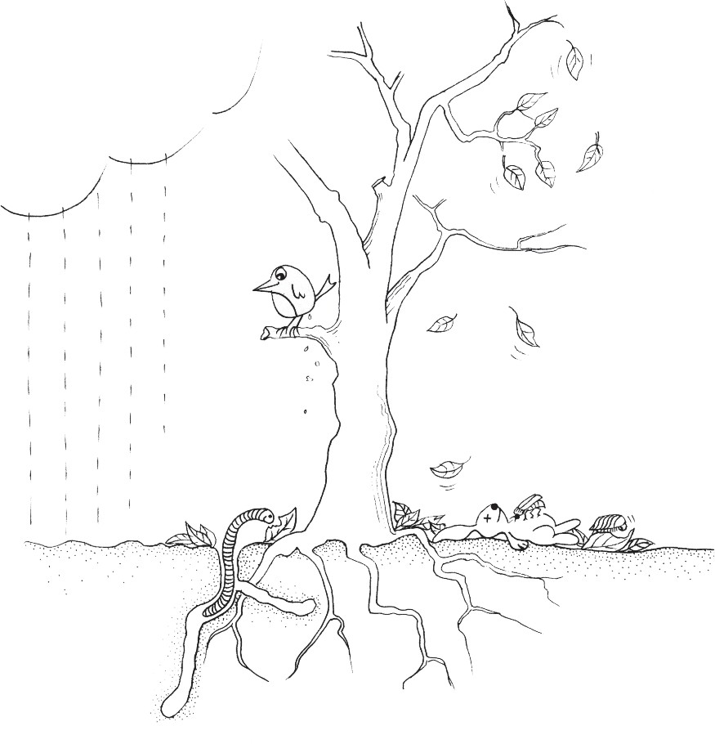

**How soil is formed**

**SOIL IS FORMED**

Animals in the soil and leaf litter help to break up this material into smaller pieces

Animal and plant material falls onto the soil surface

Rain water soaks into the soil

|  |  |
| --- | --- |
|  |  |
| Animals and plant roots burrow through the soil, mixing up all the ingredients | |

|  |  |
| --- | --- |
|  |  |
| Rocky material under the soil breaks up into smaller pieces | |

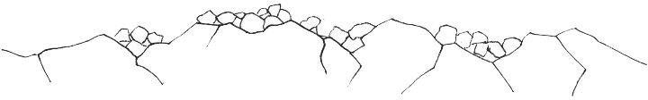

Bacteria and fungi (decomposers) in the soil release **mineral salts** from plant and animal material