From the booklet: Grouping and Classification

*Teaching Notes*

**Going on a treasure hunt**

The aims are to decide whether objects are living or have never been alive, using features that the children observe. The ‘Treasure hunt’ approach is probably familiar to many teachers but it is largely through the discussion, in groups and in the class, that children are able to develop and establish their ideas. As they do this, you can begin to elicit children’s existing understanding of groups of living things. Then, as they progress through these activities, children begin to become aware of the seven processes carried out by living things and can discuss what living things do.

These activities are likely to be used at two levels – firstly a relatively simple version for younger or less able children and secondly a more complex version that may be used even two years later with older children. The second version gives a useful approach for children ready to understand the differences between plants and animals. Teachers may wish to refer to the Background information for teachers (please see below).

**Going on a treasure hunt (1)**

This version is suitable for younger or less able children. The initial hunt can be carried out in the school grounds or playground. If this is not possible, the teacher can collect a suitable range of objects before the lesson and the children then carry out the sorting part of the activity. The game can easily be played in an urban school, with some objects being deliberately ‘planted’.

Choose objects that are readily available in the chosen area around the school. Here are some suggestions, but make sure that children understand that they should not collect whole plants or whole animals as part of the treasure hunt.

*Suggested objects*: a piece of paper; a stone; a fallen leaf; a piece of plastic; something made of metal; a twig; a fruit or seed; an artificial flower; something that the child can choose.

**The activity**

The children can work in groups of three or four. Give each group a bag or tray and a list of the objects they are going to hunt for in the chosen area. The activity can be timed to limit the time spent on the ‘hunt’. When time is up, the children bring the objects back to the classroom.

**In the classroom**

Ask the children to sort the objects into two groups, justifying their choice. Discuss as a class the different ways they have grouped the objects. Let them see that trying to sort things into groups can cause problems.

Whichever criteria they use, the activity is likely to start making them think about alternative ways of classifying objects (e.g. big or small, rough or smooth). Next focus on grouping them into ‘living’ and ‘have never been alive’. Discuss why certain objects have been put into the living group and what they all have in common.

**Figure 1b.** …and some things that have never been alive.

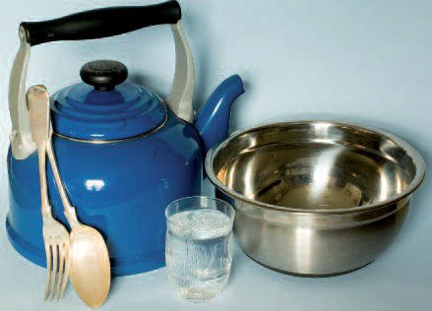

**Figure 1a.** Here are some things that have once been alive…

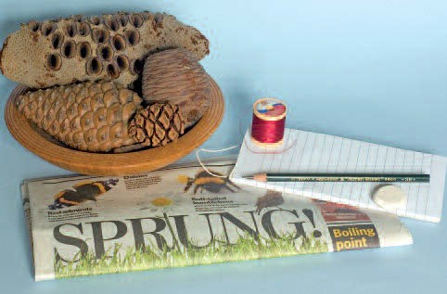

***Going on a treasure hunt (2)***

This version is suitable for older or more able children. Follow the instructions as given above, but provide a different list of objects (or the teacher collects them before the lesson). The emphasis now is to begin to sort living things into plants and animals and to use a more extended vocabulary.

*Suggested objects*: a piece of paper; a rough stone; a fallen leaf; a fallen petal; something from an animal (e.g. a bone, feather, shell, wool, fur); a piece of plastic; something made of metal; a small twig; a fruit or seed; a blade of grass; a pine cone; a smooth round stone; a silk or plastic flower; something that the child can choose.

**In the classroom**

As in (1), ask the children to sort the objects into groups, but discard the ‘never been alive’ group of objects. Then let the children focus on the living group and split them into two groups, giving reasons for their choice. Again, discuss as a class the different ways they have grouped the living objects. Within the living group, focus on how they have sorted the objects into ‘plant’ and ‘animal’ and the criteria they have used.

***Background information***

**Characteristics of living things**

In their own way, children are aware of most of these characteristics, but may find it difficult to understand them fully and express their ideas in suitable scientific terms. In particular, they often do not find it easy to apply the descriptions to plants. These notes attempt to give a basic understanding that teachers can use with children and which can be built on as children’s knowledge progresses and they become more familiar with the biological processes that occur in living things. Unfortunately, a number of words are used loosely in everyday language and so there are conflicts with correct biological use. As far as possible, teachers should try to establish the correct use of words to avoid misuse at a later stage.

The mnemonic **M R S G R E N** is a useful way of remembering the seven processes that are characteristic of living things and the name helps to give children a way of remembering them. Some teachers may prefer the mnemonic ‘MRS NERG’ or have other ways of reminding the children about the characteristics in the ‘list’.

For convenience, these notes are presented in the sequence **M R S G R E N**. For each characteristic, we make sure that suitable emphasis is given to how plants carry out the process. For most children, you are likely to deal with movement, nutrition, growth and reproduction, but with more able children you may wish to consider all of them. In discussions with children, remember that non-living organisms may show some of these characteristics, but never all of them.

**Movement**

All living things move in some way. Most animals are mobile and move their whole body from place to place (e.g. by swimming, walking or flying). In plants, movements are less obvious and usually involve parts of a plant rather than the whole plant. Examples are seen in the way leaves turn towards light and roots grow downwards into the soil. Tendrils on a sugar snap pea plant rotate (or move around) until they touch something they then cling to.

**Figure 12.** Movement of parts of plants – these images of a sugar snap pea show (1) young tendril, (2) the young tendril growing in a wide circle thus increasing its chance of making contact and finally (3) making contact with a stick and coiling round it.

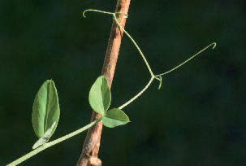

3

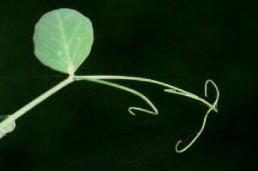

2

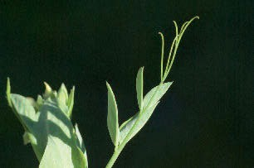

1

**Respiration**

In the cells of living things, respiration is the process by which energy is released from food. Oxygen is usually required to do this and carbon dioxide and water are produced. Remember, all living things carry out respiration all the time. If a living thing stops respiring it is no longer alive. Respiration should not be confused with breathing. Children should understand that, in humans (and many other animals), breathing is the way in which we get air into and out of our lungs, and so get oxygen into the body and remove carbon dioxide.

**Sensitivity**

Living things can react to what is happening around them. For example, humans can feel the difference between hot and cold, a person jumps in response to a loud noise and a plant shoot grows towards light (see Figure 14). In plants, response (sensitivity) is often linked to growth and movement.

300 mm

**Figure 14.** Response and sensitivity – the potato was left in the shoe box, with a lid on, for 12 weeks. The potato shoots grew round the two barriers in the box, towards the hole that was letting in some light. This illustrates response to light.

**Figure 13.** Touch a sensitive plant and watch its leaves collapse – a sensitive plant Mimosa pudica (1) before being touched and (2) after being touched.

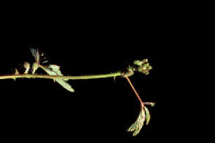

2

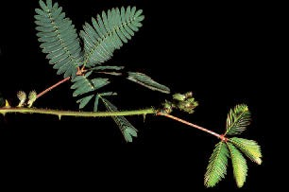

1

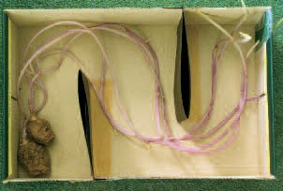

**Growth**

Over a period of time, living things make new materials and become larger and more complex. Damaged parts of both animals and plants can also be repaired by new growth. Living things use some of the energy released from their food for growing and food materials are incorporated into the new parts or increased size.

**Figure 15.** Compare the sizes of this beech seedling (about 4 cm high) and the mature beech tree (up to 40 m in height). A lot of new material has contributed to the growth of this tree.

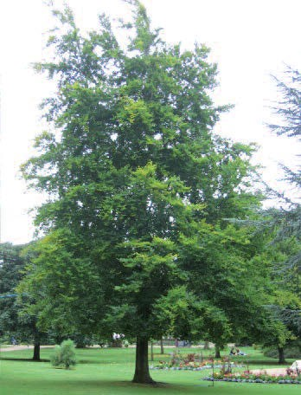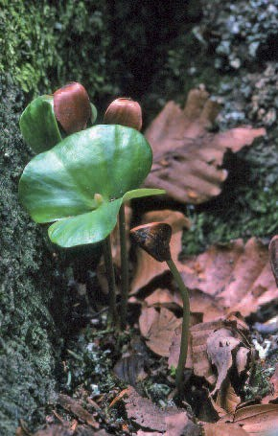

**Reproduction**

All living things can reproduce, making more living things like themselves. (See *Reproduction and life cycles – parts 1 and 2* for sexual reproduction in plants, and booklet 4 *Living processes and what plants need to grow*, for some information on asexual reproduction in plants.)

**Excretion**

All living things get rid of the waste materials produced from living processes. Both animals and plants give off carbon dioxide as a waste material from respiration. In humans, another example of an excreted material is contained in the liquid known as urine, and plants give off waste oxygen from photosynthesis. Children are likely to ask about faeces and whether this is part of excretion. You can explain that this is material that has been through the body but not actually taken part in the living processes inside cells. Biologists do not use the term ‘excretion’ for material contained in faeces.

**Nutrition**

Living things need energy for the various living processes they carry out. They get this energy from their food (see Respiration, above). Plants make their food from carbon dioxide and water, using energy from sunlight, in the process known as photosynthesis. Animals get their food by eating plants or other animals. (See also booklet 1 *Parts of a plant and their functions*, page 20, and booklet 4 *Living processes and what plants need to grow*, page 49.)