From the booklet: Plants in their Natural Environment

Soil, microorganisms and recycling

|  |  |
| --- | --- |
|  |  |
|  | |

*Pupil Sheet* **How soil is formed**

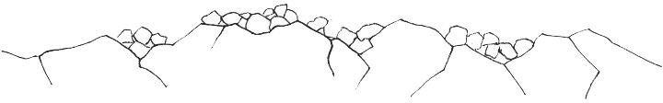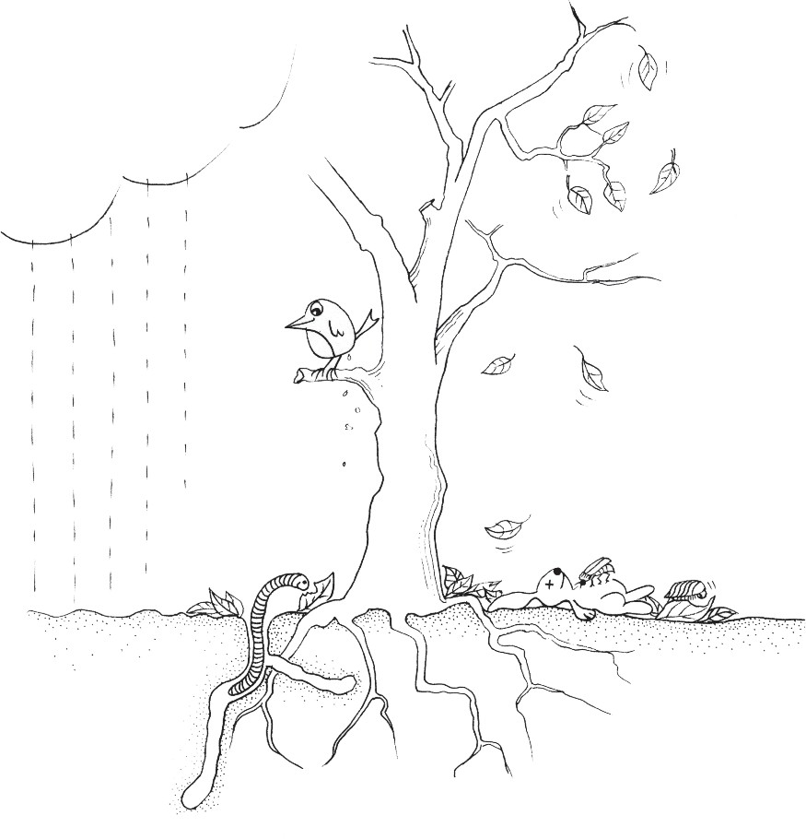

SOIL IS FORMED