From the booklet: Grouping and Classification

*Teaching Notes*

**Living things – what they need and what they can do**

This activity follows on naturally from the treasure hunt activities (at either level), in which children begin to become aware of whether things are living or non-living (never been alive). As they try to give reasons for their decisions (in the treasure hunt activity), the children begin to think about what living things do. It is usually easier for children to talk about what animals do (as living things) and harder for them to understand that plants show the same range of characteristics.

This activity can be used in different ways and is useful as a formative or a summative activity. The images (below) are a good way of introducing this activity and to stimulate discussion amongst the children in the class. It is a good idea for teachers to read the Background information below, so that you are well-prepared for the different questions that curious children are likely to ask. This version uses ‘MRS GREN’ as the guide, but you may adapt it for MRS NERG or whatever format you prefer.

***The activity***

Children may work in groups or individually. In the Pupil Sheet, three of the rows in the table have a greenish background. These rows are suitable for older or more able children, whereas most children should be familiar with the rest of the table (with a white background).

Ask the children to choose an ‘example’ of a plant, of an animal and of an object that has never been alive. The teacher may provide a selection for the children to choose from. Ask the children to write their chosen examples in the appropriate boxes on the Pupil Sheet. They use their own examples when trying to answer the questions.

Encourage discussion as the children try to write their answers in the boxes and use the images below to stimulate discussion. Statements the children might make include:

* *Look, this balloon is moving – it must be alive!*
* *It needs air*
* *It doesn’t need food or water though…*

(Image credit: Unsplash!)

(Image credit: Unsplash!)

***Background information***

**Characteristics of living things**

In their own way, children are aware of most of these characteristics, but may find it difficult to understand them fully and express their ideas in suitable scientific terms. In particular, they often do not find it easy to apply the descriptions to plants. These notes attempt to give a basic understanding that teachers can use with children and which can be built on as children’s knowledge progresses and they become more familiar with the biological processes that occur in living things. Unfortunately, a number of words are used loosely in everyday language and so there are conflicts with correct biological use. As far as possible, teachers should try to establish the correct use of words to avoid misuse at a later stage.

The mnemonic **M R S G R E N** is a useful way of remembering the seven processes that are characteristic of living things and the name helps to give children a way of remembering them. Some teachers may prefer the mnemonic ‘MRS NERG’ or have other ways of reminding the children about the characteristics in the ‘list’.

For convenience, these notes are presented in the sequence **M R S G R E N**. For each characteristic, we make sure that suitable emphasis is given to how plants carry out the process. For most children, you are likely to deal with movement, nutrition, growth and reproduction, but with more able children you may wish to consider all of them. In discussions with children, remember that non-living organisms may show some of these characteristics, but never all of them.

**Movement**

All living things move in some way. Most animals are mobile and move their whole body from place to place (e.g. by swimming, walking or flying). In plants, movements are less obvious and usually involve parts of a plant rather than the whole plant. Examples are seen in the way leaves turn towards light and roots grow downwards into the soil. Tendrils on a sugar snap pea plant rotate (or move around) until they touch something they then cling to.

**Figure 12.** Movement of parts of plants – these images of a sugar snap pea show (1) young tendril, (2) the young tendril growing in a wide circle thus increasing its chance of making contact and finally (3) making contact with a stick and coiling round it.

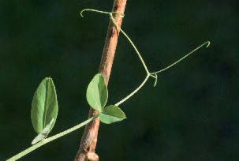

3

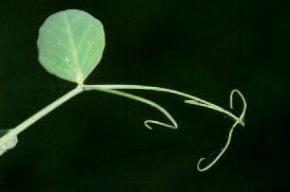

2

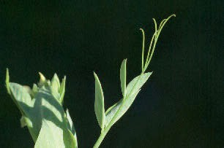

1

**Respiration**

In the cells of living things, respiration is the process by which energy is released from food. Oxygen is usually required to do this and carbon dioxide and water are produced. Remember, all living things carry out respiration all the time. If a living thing stops respiring it is no longer alive. Respiration should not be confused with breathing. Children should understand that, in humans (and many other animals), breathing is the way in which we get air into and out of our lungs, and so get oxygen into the body and remove carbon dioxide.

**Sensitivity**

Living things can react to what is happening around them. For example, humans can feel the difference between hot and cold, a person jumps in response to a loud noise and a plant shoot grows towards light (see Figure 14). In plants, response (sensitivity) is often linked to growth and movement.

300 mm

**Figure 14.** Response and sensitivity – the potato was left in the shoe box, with a lid on, for 12 weeks. The potato shoots grew round the two barriers in the box, towards the hole that was letting in some light. This illustrates response to light.

**Figure 13.** Touch a sensitive plant and watch its leaves collapse – a sensitive plant Mimosa pudica (1) before being touched and (2) after being touched.

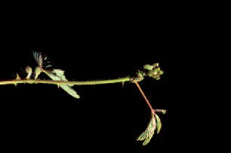

2

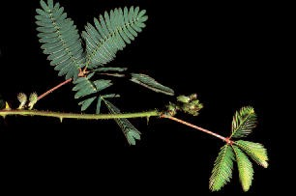

1

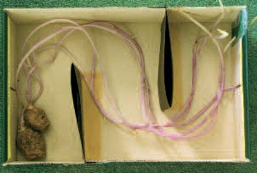

**Growth**

Over a period of time, living things make new materials and become larger and more complex. Damaged parts of both animals and plants can also be repaired by new growth. Living things use some of the energy released from their food for growing and food materials are incorporated into the new parts or increased size.

**Figure 15.** Compare the sizes of this beech seedling (about 4 cm high) and the mature beech tree (up to 40 m in height). A lot of new material has contributed to the growth of this tree.

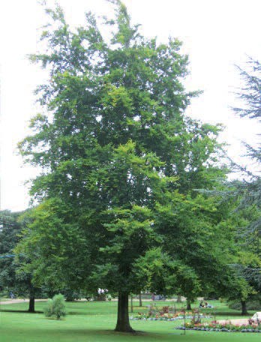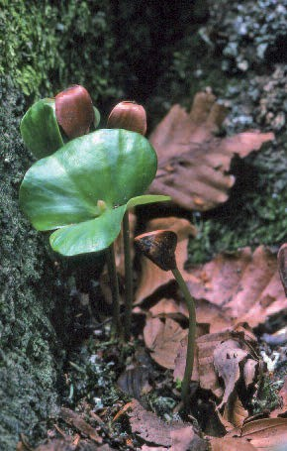

**Reproduction**

All living things can reproduce, making more living things like themselves. (See *Reproduction and life cycles – parts 1 and 2* for sexual reproduction in plants, and booklet 4 *Living processes and what plants need to grow*, for some information on asexual reproduction in plants.)

**Excretion**

All living things get rid of the waste materials produced from living processes. Both animals and plants give off carbon dioxide as a waste material from respiration. In humans, another example of an excreted material is contained in the liquid known as urine, and plants give off waste oxygen from photosynthesis. Children are likely to ask about faeces and whether this is part of excretion. You can explain that this is material that has been through the body but not actually taken part in the living processes inside cells. Biologists do not use the term ‘excretion’ for material contained in faeces.

**Nutrition**

Living things need energy for the various living processes they carry out. They get this energy from their food (see Respiration, above). Plants make their food from carbon dioxide and water, using energy from sunlight, in the process known as photosynthesis. Animals get their food by eating plants or other animals. (See also booklet 1 *Parts of a plant and their functions*, page 20, and booklet 4 *Living processes and what plants need to grow*, page 49.)