*Pupil Sheet -* **Making compost in a bottle** 

**You need:**

* Two 2-litre plastic bottles with their labels removed
* Scissors
* Small pieces of net (old tights)
* Elastic bands
* Labels and string
* Newspaper
* Dead plant material (see suggestions)

4. Add two tablespoons of soil or compost to the funnel. Fungi and small animals in this start the composting process

**How to make a compost column in a bottle**

8. Wrap the column in a sleeve of newspaper to keep the contents dark. Remove it when you want to observe the rotting process.

9. Spray the material inside the bottle about once a week to keep it just moist and record any changes that you see

**Notes**: discard the bottom half of the second bottle. You can recycle it. Once the columns have been filled, it is best to keep them out of direct sunlight and heat

3. Push this top half of the bottle into the bottom half to form a funnel

2. Cut a small piece of net and six it over the end of the bottle with an elastic band

5. On top of this add a layer of chopped leaves and other material to be composted

6. Take the second bottle and cut off the top. Push it onto the bottle that you have already assembled. Don’t worry if the middle section crumples a bit

7. Fix a piece of net over the top of the bottle with an elastic band. Write your name on a label and hang it round the neck

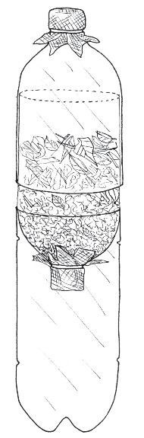

1. Carefully cut one bottle in half, keeping the line as level as possible. Trim the edge so that it is smooth.