From the booklet: Plants in their Natural Environment
Soil, microorganisms and recycling
Teaching Notes
Making compost in a bottle
This activity uses clear plastic bottles to make a compost column. The column is then filled with a variety of materials to illustrate the principles of composting. The children observe the changes that take place over time.
Some teachers may wish to let all the children make their own compost column, whereas others may prefer to make one or two only for the class and use them as demonstration columns. In the simple method described on the Pupil Sheet, the teacher MUST make the initial cut with sharp scissors, so that the children then continue safely and do the rest themselves. It is a good idea for you to make one yourself beforehand, so that you see where problems might arise.
Meat, fish and cheese must NOT be used in the bottle/column. The liquid that forms must be discarded safely. It could be a good idea to put it on a compost heap if available. Make sure you follow good hygiene practice, such as careful hand washing with soap and water after handling any of the solids or liquids. It is important that there is no transfer of such liquids from hands to mouth or eyes.
Resources and preparation for the activity

- Two 2-litre bottles for each compost column
- Scissors
- Small pieces of net (old tights) and some elastic bands
- Labels and some string
- Some newspaper
- Dead plant material to put into the column. Suitable materials include grass cuttings, lettuce leaves, carrot tops, apple cores, potato peelings, vegetables that are past their best

To make the compost bottle/column, follow the instructions on the Pupil Sheet. It is important that there is some flow of air through the bottle/column – hence the use of net or tights as a cover.
Activities with the compost column
Children should observe the bottle/column over a period of time and keep a record of the changes that take place. For the first week, they should make observations daily, but after that about once a week for about 6 weeks. Observations take only a few minutes each time. They could measure changes in height of the material, and describe any changes in texture or note the appearance of liquid at the bottom. It is also useful to take photographs and utilise ICT skills.
Discuss with the children what may be causing the changes. They should understand that the microorganisms that decompose waste plant material are beneficial. These microorganisms are too small to be seen with the naked eye. Other larger organisms are involved in the recycling process – these include springtails, woodlice and worms (see further information below.)
More extensive activities can be done with older children. See, for example, ‘taking temperatures in a compost heap’ on the SAPS website.
This can be an appropriate time to link in to a discussion about compost made from waste plant material, collected by local authorities all over the country.
Feeding relationships – food chains, food webs and energy transfer
Let’s start with the food on a plate for a typical meal. There is likely to be some vegetable (such as carrots, peas, lettuce, potatoes). Vegetables come from plants. There’s probably also some meat (or fish). The meat comes from an animal and the animal almost certainly ate plants. Even if the animal had been fed on artificial ‘feed’, the origin of this would have included plant material.
So we can write down a ‘food chain’ for some of the food on this plate.

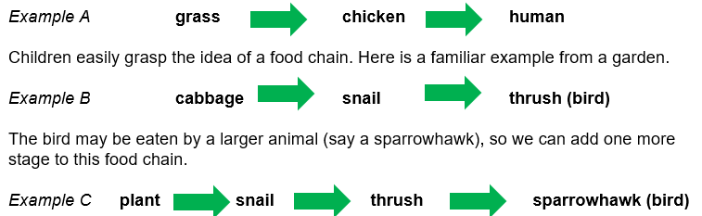
In the natural environment, there are many food chains, and these form the basis of feeding relationships of different organisms, plants and animals.
In the examples above, note the direction of the arrows. For the children, they understand that the arrows mean ‘is eaten by’, but it is important to understand that the arrows show the direction of energy flow.
Most food chains start either with a (green) plant or with dead plant material. We know that plants use energy from sunlight to build up food (starting with carbohydrate) (see booklet 4: Living processes and what plants need to grow). So when an animal feeds on a plant, some of the energy is transferred from the plant to the animal. Similarly, when an animal (e.g. a fox) eats another animal (e.g. a bird), energy is transferred from the bird to the fox. This energy came through the chain from the plant (and originally from sunlight).
At each stage along a food chain, some energy is lost and not transferred to the next animal in the chain. Energy is lost for various reasons – sometimes only part of the plant or animal is eaten (woody parts or bones cannot be digested), some energy is lost through movement or as heat, some is lost in excretory materials. This helps explain why food chains are rarely longer than four or five organisms – by the fifth organism, there would be very little energy to pass on to another one.
Sometimes a food chain does not start with a living plant, but with dead material (from plant or animal origin). It may be ‘eaten’ by animals, such as earthworms, which can digest the material and obtain energy from it. This energy then gets passed along a food chain when an animal eats the earthworm. Such organisms are described as detritivores and they play an important part in the stages of breakdown of material and formation of soil. Other examples of detritivores include woodlice and springtails.
This dead material may decay – i.e. be decomposed – by the feeding activities of, for example, fungi or bacteria. These microorganisms are known as decomposers and they play a very important part in releasing nutrients (including mineral salts) from the materials in the soil. The microorganisms can digest and absorb food materials from the dead remains, and so some energy is passed on, from the dead material to the microorganisms. The mineral salts then become available in the soil and can be taken up by plants and used for growth of the plant.
Let’s go back to example C and look at another similar example of a food chain. This time we arrange it vertically, as shown below. This helps us see the ‘feeding levels’ (also known as ‘trophic levels’) for the different organisms. The arrows again represent the direction of energy flow.
The diagram introduces other terms that can be used to describe the feeding relationships of particular organisms. Some of these are already familiar to children. They probably know the terms herbivores for animals that eat plants and carnivores for animals that eat other animals. Other less familiar terms are that plants are known as producers because they produce food (by photosynthesis); animals are known as consumers because they consume (eat) other organisms – either plants or other animals. These terms are summarised below.
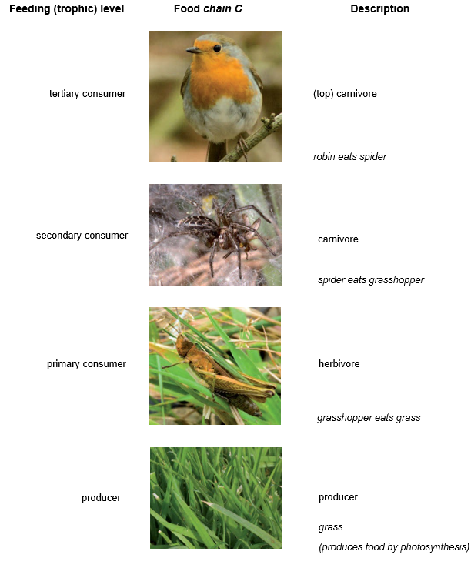

In the real world, a simple food chain gives only part of the story. Each animal may feed on more than one type of plant and each animal may also be eaten by several different animals. The food chains intermingle and link with each other. They can then be represented by what is known as a ‘food web’. An example of a simplified food web is shown below.

