**Measuring the speed of chloroplast movement in the pondweed *Egeria densa***

**Teaching Notes**

***Introduction***

This activity provides an opportunity for students to practise calibrating a microscope whilst exploring the dynamic nature of cells.

There are a variety of activities where students measure the dimensions of objects under a microscope (e.g. onion cells) or the density of a structure (e.g. stomata on a leaf epidermis) but this activity adds to this by asking students to measure how fast something is moving within a cell.

Cytoplasmic streaming occurs in many large plant cells. This is thought to be an adaptation to increase the rate of mixing the contents of the cytoplasm. In the pondweed *Egeria densa* the chloroplasts move along with this cytoplasmic streaming.

This allows the dynamic nature of living cells to be observed, for the speed of chloroplast movements (and therefore cytoplasmic streaming) to be calculated, and for students to get a sense of ‘what counts as fast’ at a subcellular level.

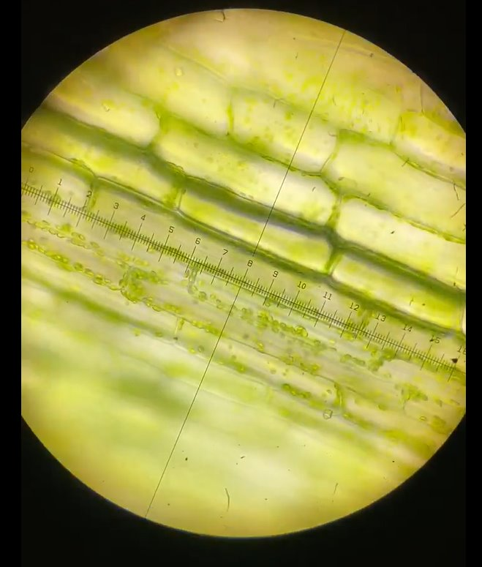

*Figure 1: Cells from the leaf of the pondweed* Egeria densa *viewed under x400 magnification (Field of view ≈450µm)*

***Apparatus***

Compound light microscopes with a magnification of at least x400 (x10 eyepiece and x40 objective lens) (per student or per pair of students)

An eyepiece containing an eyepiecegraticule per microscope

1 stage micrometer (per student or pair of students)

1 slide (per student or pair of students)

1 coverslip (per student or pair of students)

1 small beaker with tap water (per pair of students)

1 dropping pipette (per pair of students)

1 Pondweed leaf, from *Egeria densa* (per student or pair of students)

***Guidelines***

The accompanying PowerPoint presentation can be used to lead students through this activity.

The following additional information may be useful:

1. The best way to maintain pondweedfor any length of time is in a gently aerated tank (a simple aquarium pump is sufficient) filled with room temperature tap water. The plants do best near a window/or under constant illumination kept at a room temperature of between 10-21°C.

We recommend using lightbulbs with a rating of 1200 lumens (lm) or more to illuminate pondweed. You can buy LED lightbulbs to retrofit older laboratory desk lamps in most DIY stores or online. For tiptop pondweed we recommend using LED floodlights (sometimes called ‘task lights’) available from DIY stores. Using LED lamps also has an advantage in that they do not have a heating effect on the water tank.

1. Cells will undergo cytoplasmic streaming if they are not under stress and are actively photosynthesising. Cells under stress tend to clump their chloroplasts around the nucleus and it will take several minutes to start observing cytoplasmic streaming in some cells. This streaming will initially be slow. On the other hand, if the plant has been kept in favourable conditions as mentioned above then the chloroplasts will be more spread out on first observation and rapid cytoplasmic streaming can often be seen in many cells straight away. You can observe this phenomenon in this video on the SAPS YouTube channel: <https://youtu.be/Yssvybg7EAc>
2. Another activity using pondweed is described here: <https://www.saps.org.uk/teaching-resources/resources/6294/microscopy-of-a-pondweed-leaf-exploring-depth-of-field-and-focal-plane/>. It could be used as an introduction to the specimen before students do this activity.
3. **Slide 2** describes the concept of cytoplasmic streaming so that students have a sense of what they are looking at.
4. **Slide 5** describes the method of producing a slide for this activity and **slide 6** provides instructions of measuring the rate of chloroplast movement.
5. **Slide 6** asks students to estimate how long it would take a chloroplast to travel 1m without calculating the answer. Students often massively underestimate this since it appears that the chloroplasts are moving quite quickly. This part of the activity is there to ensure students consider what speeds are biologically useful speeds at a subcellular level and to realise that this is much slower than speeds we would consider biologically useful at the scale we engage with everyday with the naked eye.
6. **Slide 5** provides an example of the calculations required to calculate speed and how long it would take a chloroplast to travel 1m. This example could be talked through with all students for them to add in their own values afterwards or just used to support students who struggle with the calculations.

If you’d like to find out more about ideas for helping students develop their understanding of, and skills in, microscopy you can explore a range of resources and articles on the Science and Plants for Schools website here: <https://www.saps.org.uk/growth-hub/teaching-microscopy-using-plants/>