Measuring stomatal density in Tradescantia zebrina
Teaching Notes
Introduction
This activity asks students to explore what happens to stomatal density as leaves grow. Do the leaves make more stomatal as they grow? Do the stomatal that are present just spread out as other epidermal cells multiply and increase in size? Do the leaves retain the same stomatal density as they grow?
Answering these questions provides students with a purpose to developing their skills of being able to measure stomatal density.
Due to the colour of the lower epidermal cells and the cells associated with stomata in Tradescantia zebrina (see figure 1) no preparation is needed and leaf discs can be placed directly on a microscope slide for viewing without a coverslip.
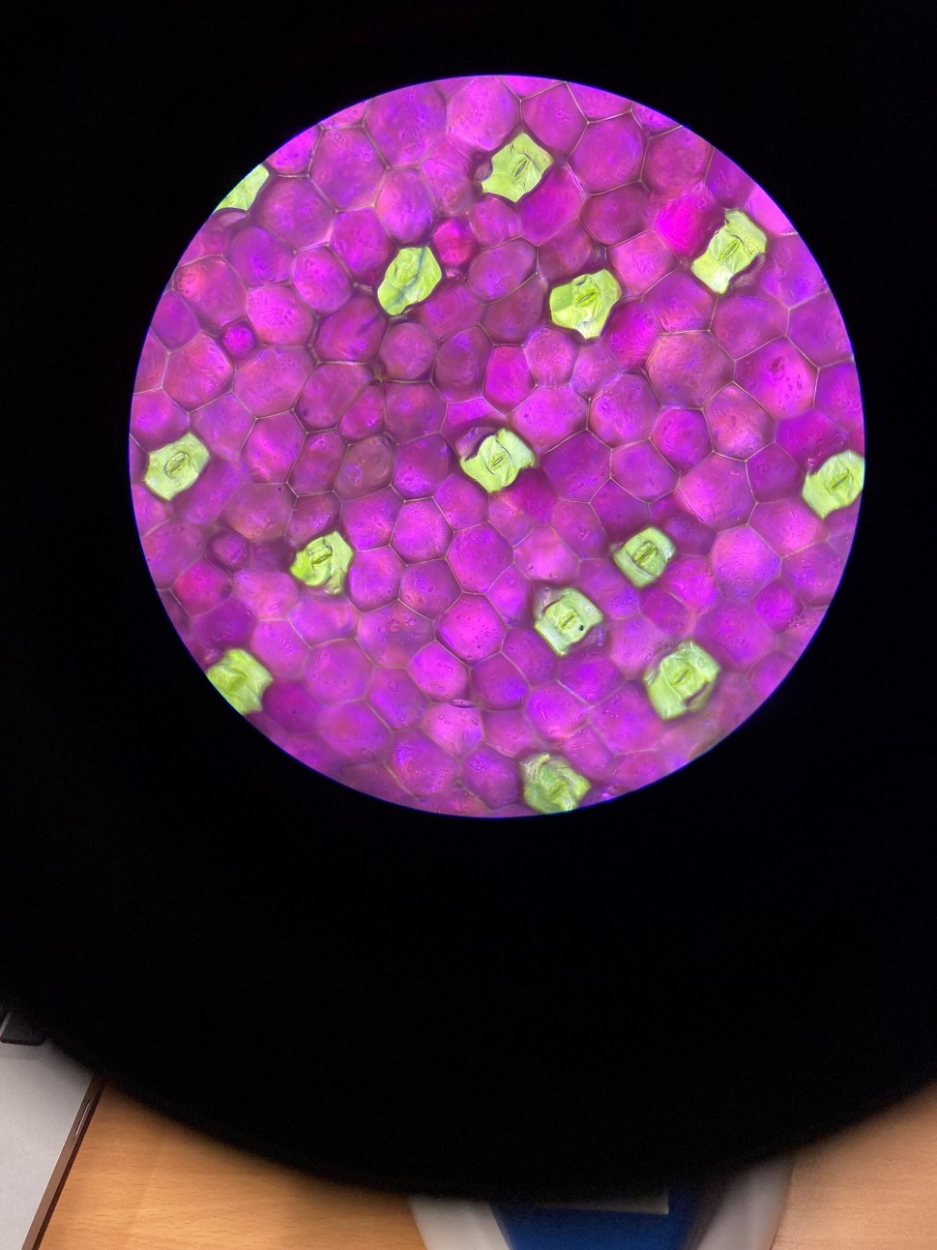
Figure 1: The lower epidermis of a large Tradescantia zebrina leaf viewed under x100 magnification. Field of view = 2.54mm²

Apparatus
Compound light microscopes with a magnification of at least x100 (x10 eye piece and x10 objective lens) (per student or per pair of students)
An eye piece containing an eyepiece graticule per microscope
1 stage micrometer (per student or pair of students)
1 slide (per student or per pair of students)
Smaller and larger leaves from Tradescantia zebrina (enough for one hole-punched disc of each leaf size per pair of students, aiming for the biggest difference in leaf size available)
A hole punch

Guidelines
The accompanying PowerPoint presentation can be used to lead students through this activity.
The following additional information may be useful:
- There is another resource that guides students through observations of the lower epidermis of Tradescantia zebrina leaves here: https://www.saps.org.uk/teaching-resources/resources/1434/observing-stomata-in-tradescantia-zebrina/
You may find this useful for introducing the specimen with students before they do this activity.

- For a more in-depth exploration of what happens as leaves grow, the mean length of a large leaf and the mean length of a short leaf are required in step 8. It may be useful for a technician of the teacher to measure the lengths of leaves in advance, before cutting out leaf discs, and just sharing these values with the students when they need them.

- Slide 3 shows students how to calculate the field of view. By using an eyepiece graticule to identify the centre of the field of view, students can line up the stage micrometer and measure an accurate radius.

- A magnification of x100 is most appropriate for measuring stomatal density and slide 6 shows views at x40 and x400 as well to point out that x100 is best.

- Slide 7 gives recommendations of how to count stomata in the field of view accurately. i.e. including stomata around the edge where the centre of the stoma is within view even if the rest of it isn’t but not including stomata where the centre of the stoma is not in the field of view.

- Slide 8 includes the equation for how to calculate stomatal density and slide 9 shows an example. You may wish to demonstrate the calculation used to achieve the results in the example.
For the large leaf this is 21stomata ÷ 2.54mm² = 8.3stomata per mm².
For the small leaf this is 13stomata ÷ 2.54mm² = 5.1stomata per mm².
- The statistical test that could be used (slide 10) is an unpaired t-test since we are looking for a difference between the means of two sets of values (large leaves vs small leaves) and the values in each data set are not paired together.
- Slide 11 asks some more in-depth questions about what happens when leaves grow. It would be possible just to show that there is a difference between large and small leaves and stop there but these questions allow for a deeper exploration of what happens during growth. For students to work out the answers to these questions they need to be provided with the answer to question 1: the mean leaf lengths for small and large leaves that were taken earlier in step 2. Depending on time available and the nature of your students you could ask these as a set of challenging questions for students to work out how to solve or you could take them through the example answers on slide 12 and then ask them to follow the process with their values.

If you’d like to find out more about ideas for helping students develop their understanding of, and skills in, microscopy you can explore a range of resources and articles on the Science and Plants for Schools website here: https://www.saps.org.uk/growth-hub/teaching-microscopy-using-plants/

