*Pupil Sheet*

**Observing and describing leaves**

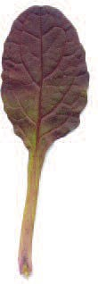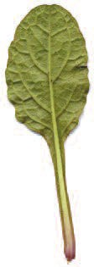

Images of leaves showing different features. The leaves were scanned ((U) upper side and (L) lower side) and are shown here at approximately two thirds life-size.

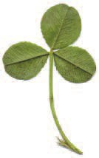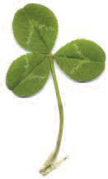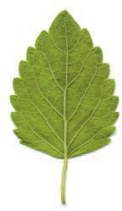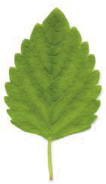

(L)

(U)

(L)

(U)

**Bugle**

**White clover**

**Lemon balm**

(L)

(U)

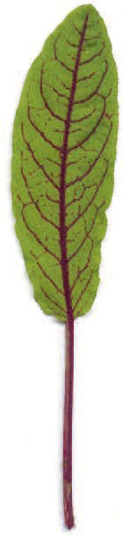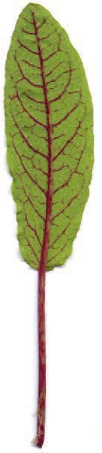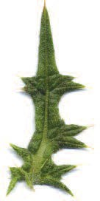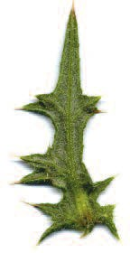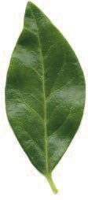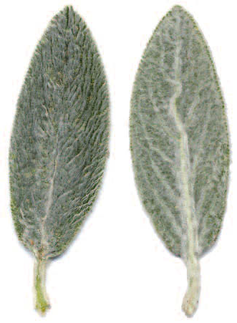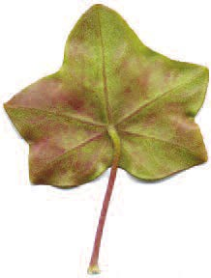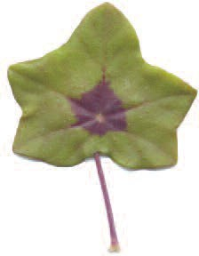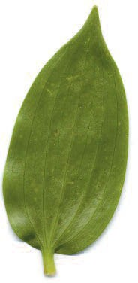

**Spear thistle**

**Sorrel**

(L)

(U)

(L)

(U)

**Periwinkle**

(L)

(U)

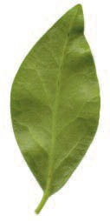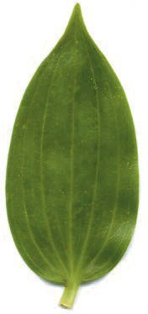

**Lamb’s tongue**

(L)

(U)

**Stargazer lily**

(L)

(U)

(L)

(U)

**Pelargonium**