From the booklet: Grouping and Classification

*Teaching Notes*

**Observing and describing leaves**

In this activity, children are encouraged to look closely at a leaf and its different features. It provides an opportunity to develop appropriate vocabulary in trying to describe the leaves and is a useful introduction to later activities in this booklet aimed at making or using a key for identification. The activity is suitable for older children, and helps them become aware of differences between leaves as well as features that are common to a range of leaves.

As a start, find out what the children already know. Almost certainly they are likely to say that leaves are green and know that they have different shapes. They may also give some other descriptions. The introductory part of the activity then helps children look closely at a selection of leaves and note obvious features. The main part of the activity gives opportunities for the children to use their listening and speaking skills as well as observations that they make and build up descriptions as a class activity. The children should be able to do reasonably accurate drawings of a leaf, perhaps using a hand lens to help with their observations. Some children may need a bit of help to get started.

***Resources***

**For the introductory activity**

* A class set of leaves without any particularly striking characteristics. All the children have a leaf of the same species. Useful examples include: hazel, fuchsia, privet, apple, pear, lilac (but there are plenty of others you could use). Consider potential allergens.

**For the main activity**

* A selection of leaves to give a different species of leaf to each child. These should not be too difficult for the children to draw. Useful examples include: oak, maple, dandelion, daisy, beech, lime, apple
* Hand lenses – one per pair of children
* Rulers
* Pencils, coloured pencils (you will need plenty of greens and browns)

***The activity***

For the **introductory activity**, give each child a leaf (they must all have a leaf from the same species of plant). Let them think about how to describe it accurately. Encourage them to consider the following: colour, shape, size, veins, leaf edge, surface, leaf tip, leaf stalk, comparison of upper and lower sides of leaf. Figure 2 gives you a guide to the features they can describe.

You may need 15 to 20 minutes for this stage. Then show the children images of a good range of leaves with very different features – or you may find it helpful to use the images provided on the Pupil Sheet. In their discussion of the features of the leaves, let the children develop a list of words to build up into a word bank, using the correct vocabulary and encourage them to use it when describing their leaves. A list of possible words children may use when discussing leaf characters is given in the table below.

**What is the shape of the leaf?**

**What colour is your leaf?**

Describe the leaf tip

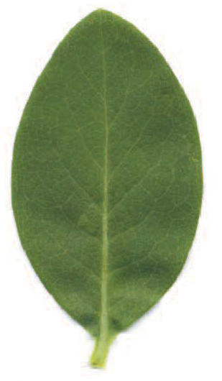

Describe the leaf edge

**Figure 2.** Describing a leaf – the lower side of a Privet leaf showing some of the things to consider when describing it.

Measure:

a – the widest point of the leaf

b – the length of the leaf

**Is the lower side different from the upper side?**

Describe the arrangement of the veins. Sometimes these are easier to see on the lower side of the leaf

Is there a leaf stalk?

If there is, measure its length

**What is the surface of the leaf like?**

**What size is the leaf?**

For the **main activity**, divide the class into groups of three. Send one child from the group into a part of the room where the others can’t see what they are doing. This child looks carefully at a leaf (say an oak leaf), then returns to the other two in the group and describes the leaf. The two who have not seen the leaf must listen and ask questions and then try to draw the leaf from the spoken description. They can refer to the word bank as they do this. The child who saw the original leaf can return as often as necessary, but it is important to have a time limit. Allow no more than about 10 minutes, then show them the leaf to see how well they managed.

Repeat with the other two children in the group, and each describes a different leaf. Encourage the children to use a hand lens for detailed observation and to use correct language in their descriptions.

The activity involves speaking, listening and measuring skills as well as giving an opportunity for the children to become familiar with appropriate vocabulary for describing leaves and you may wish to spend some time on it.

**Possible words to use in the word bank**

As the children talk about their leaves, they use different words to try and describe the leaf characters. Their ideas and vocabulary develop as they do this. Some of the children’s words are probably not standard botanical terms (e.g. ‘fluffy’, ‘furry’), but are the children’s words and represent their attempt to make descriptions that mean something to them. The list below includes ideas that the children may suggest and that could be incorporated into a word bank for your class. It is not intended to be used as a list to be learnt and children may not need to use all of the words listed here.

|  |  |
| --- | --- |
| Colour | green, brown, yellow, red here |
| Leaf edge | smooth, toothed, wavy, prickly |
| Leaf surface | smooth, rough, wrinkly dull, glossy  hairy, furry, not hairy |
| Leaf tip | pointed, rounded |
| Leaf stalk | present, absent |
| Veins | one main vein with branches  several veins starting from the bottom of the leaf and coming together again at the tip  several main veins spreading out from the bottom of the leaf |