From the booklet: Grouping and Classification

*Teaching Notes*

**Observing leaves and learning about their shapes**

In this activity, children are encouraged to look closely at a leaf and think carefully about its shape. The activity is particularly useful for young children as a way of helping them to make observations. It can also be used with older children to give them a chance to have some fun.

**Figure 1.** What can you turn your leaf into? …a mouse? …a cat? Some ideas of animals created from leaves – but these are for inspiration (not to be copied!)

***The activity***

Let the children choose a leaf. You can bring some into the classroom or they may find some leaves in the school grounds or wherever is convenient (see examples of commonly found leaves below). It doesn’t matter whether the leaves are all the same or different. Get the children to do a wax rubbing of the leaf or the teacher can do a photocopy or scan of each child’s leaf.

Show the children a leaf that you have collected. Discuss its shape with them and how you might turn it into an animal. Then ask them to do a drawing that turns their leaf shape into an animal or whatever they may choose to do! As they do the drawing encourage the children to talk about the different features of the leaf so that they become more familiar with appropriate vocabulary.

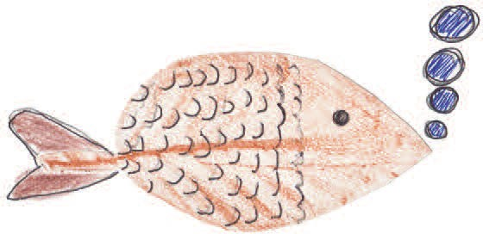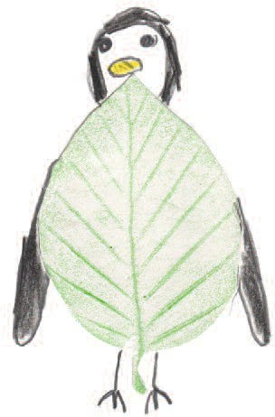Some ‘leaf animals’, drawn by Year 4 children, are given below. Let the children use their observations to develop their own ideas, but encourage them to draw from their leaf rather than copy a picture that someone else has done. Get them to do more than one if you can. These leaf rubbings can make delightful greeting cards.

**Figure 2**. Some ‘leaf animals’ created by children (in Year 4 at The Cavendish School).

Here are some examples of leaves from trees common to the UK.