From the booklet: Grouping and Classification
Teaching Notes
Sort it! – a game with cards
This activity is based on the card game ‘Happy families’. There are 24 cards in the pack, made up of six sets of four cards. The game takes further some of the ideas established in the activity ‘Sorting seeds into groups’. The game is most suitable for older children.
While playing the game, children have opportunities to:
- practise sorting objects into groups
- learn that there is usually more than one way of sorting objects into a group
- appreciate that it helps to have names for objects when trying to sort them

Preparation for the game
You will need one pack of cards for each group in the class. The master sheet (Figure 1 below) shows the complete set of cards (reduced size). You can use this page as a template to prepare your pack of cards. Enlarge the page by photocopying from A4 to A3 and this will give you suitable sized cards to use for your pack. Full-sized templates of each set of cards and a master sheet are given on the SAPS website. Download these and print sets of the 24 cards. You can print onto normal paper, then paste this onto card (e.g. use spray mount), or print straight onto a suitable weight of card. Don’t show the master sheet to the children until they have attempted to sort their own pack of cards into groups.

Playing the game
This game is best played with three to four players, but can be played with two. There are several stages as they progress through the game.
  - Give each group a pack of 24 cards. Ask them to spread the cards out (face upwards) and then sort them into groups in whatever way they like. Give them several minutes to discuss this. Then the children report back to the rest of the class saying how they have sorted their cards and their justification for doing so.
      - They should find lots of different ways of sorting the cards into groups. As they do this, make the point that most objects, including living things, can be sorted in different ways. Then tell them that the person who devised the game of ‘Sort it!’ actually divided the cards into six sets of four cards.
  - Ask the children if they can sort the cards into six sets of four cards. Again, let them discuss how they decided to group their cards.
  - The ‘master sheet’ (Figure 1) shows how the six sets of cards can be grouped into families, using certain characters. If the children haven’t grouped their cards in this way, you can then show them the master sheet. Discuss with the children the characters that were used to put the cards into the ‘families’ shown on the master sheet.
  - Next explain how to play ‘Sort it!’ with the cards and give each group a chance to play the game. (The game is based on ‘Happy families’ – see ‘Plant quartet’ on page 34 of Living processes and what plants need to grow for an outline of how to play).
  - After a few minutes of playing the game, ask if they are having any problems or discuss how they could make the game easier to play. Guide the discussion towards the value of using names for the families.
  - Let them give names to the families and then play the game again. Finally, the children can complete the activity by colouring the cards.

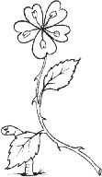 | 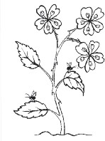 | 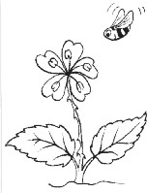 | 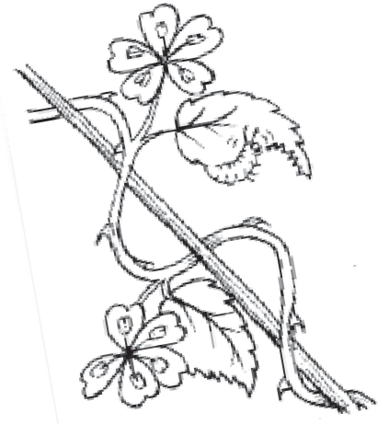
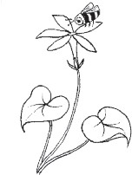 | 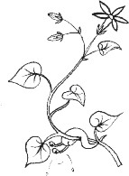 | 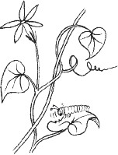 | 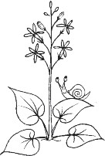
Sort it! Master sheet for the six families of cards
Family 1

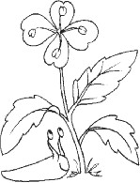 | 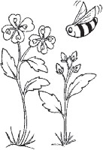 | 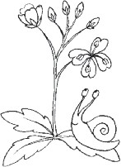 | 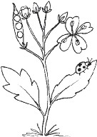
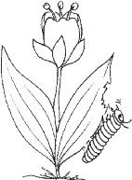 | 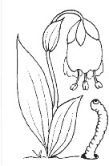 | 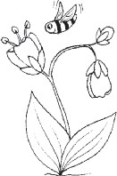 | 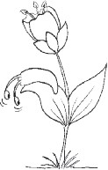
Family 2

Figure 1. Sort it! – master sheet. This master sheet shows the complete set of cards (reduced size), grouped into ‘families’, based on certain features shown by different plants on the cards. This page can be used as a template to make a pack of cards. Full-sized templates are available on the SAPS website.

Family 3

Family 4

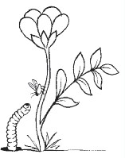 | 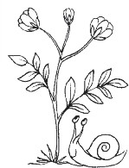 | 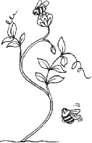 | 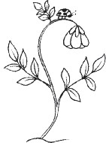
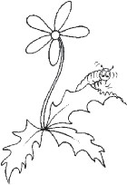 | 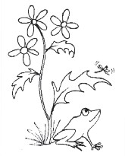 | 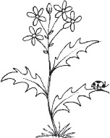 | 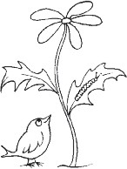
Figure 1

Family 6

Family 5

