From the booklet: Plants in their Natural Environment

*Teaching Notes*

**Why so many seeds?**

In this activity, children try to make a realistic estimate of the number of seeds produced by a single plant. It is suitable for older children and gives them an opportunity to think about the environmental hazards that seeds have to overcome to allow them to germinate, grow, produce flowers and more seed. In the activity, children have opportunities to do the following:

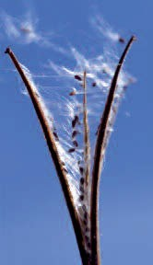

* apply numeracy skills of counting, addition and multiplication
* revise their knowledge of the requirements for growth of plants
* begin to understand some of the relationships between plants, animals and the environment

**Figure 1.** Rosebay willowherb – capsule with seeds

The activity follows on naturally from the activity ‘The fight for survival – will it grow?’. When they have made their estimate of the number of seeds produced, the children can discuss what happens to all those that never grow into mature plants. The two activities make useful links with work on dispersal of fruits and seeds and germination and growth of plants (see booklet 3, *Reproduction and life cycles, part 2: Pollination, fertilisation, fruits and seed dispersal* and booklet 4, *Living processes and what plants need to grow*).

***Preparation for the activity***

Once establishing any potential allergies, find a suitable plant at fruiting stage. Ideally you want a plant that the children can visit outside or which can easily be brought into the classroom. The children should be able to distinguish what makes up a single plant. Avoid plants that spread largely by vegetative means (such as runners or forming mats or large clumps). You may wish to grow plants specially for this activity.

***Suggested plants to use (images found below)***

* columbine, sweet william, love-in-the-mist, Rosebay willowherb and plants from the daisy family, such as marigolds and sunflowers – a good one to choose is the branched variety of sunflower known as ‘Hallo’. (Note here that what are often called seeds are small single-seeded fruits, produced in a head of tiny flowers.)

***The activity***

Divide the children into small groups. Take the seeds from a single fruit (e.g. a pod, capsule or single flower head if using sunflowers) and share these between the children in the groups. Make sure that the number of seeds for each group is within the counting ability of the children.

***Stage 1 – number of seeds in a single fruit or flower head***

* ask the children to count their seeds and write down the number
* one child in each group writes down the numbers counted by each member in the group
* each child then copies these and adds them up (more able members of the group can help other children with their adding up)
* when the group is confident that their addition is correct, they write this number on the board
* when all groups have completed this, the children can add up the group numbers The last step tells us how many seeds there were in the single fruit or flower head.

***Stage 2 – number of seeds in the whole plant***

* the children next examine the whole plant and count the number of fruits that have been produced
* they multiply the number of seeds in a single fruit by this number to estimate the number of seeds produced by a single plant.

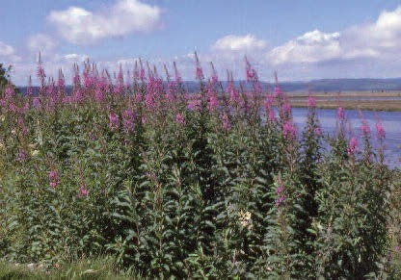

Ask the children why this is only an estimate. You can then discuss with them the fact that the plant may go on to produce more fruits. They also should understand that in many plants, fruits may contain different numbers of seeds. (They probably have evidence for this from the counts that they made.)

Discuss with the children reasons why many plants produce large numbers of seeds. How might this help make the plant successful? What might prevent a seed from germinating and growing and then producing more flowers and seeds? Some of the things you might discuss are listed in the boxes below.

**Figure 2.** Rosebay willowherb produces large numbers of seeds and can be found forming large stands on disturbed ground

Seeds may not germinate successfully because

* many seeds land where environmental conditions are unsuitable for germination
* seeds lying too close to the parent plant or other seeds may be affected by substances (from the parent plant) that inhibit germination
* seeds are an important source of food for birds and other animals so many of them are eaten

Seedlings may not grow into plants that flower and produce fruits because

* at any stage they may be eaten or damaged (trampled on) by animals
* they cannot compete successfully with other plants for water, light, nutrients or space
* they may not grow well or produce flowers because general environmental conditions are not right
* extreme weather conditions (such as cold, heat or drought) weaken or kill them
* pollination does not occur or fertilisation does not happen. (Remember that many plants rely on insects for pollination, so environmental conditions need to be right for the insects as well as the flowers.)

***Further activities***

1. For older children you could make a link to the ‘Seeds and chaffinches’ game (see booklet 4, *Living processes and what plants need to grow*). This makes the point that many seeds are eaten and that competition for water, light and mineral salts can affect survival.

***Images of suggested plants***

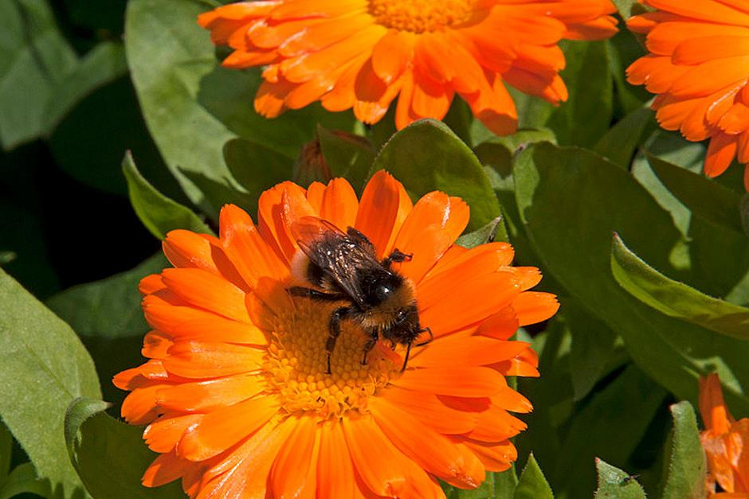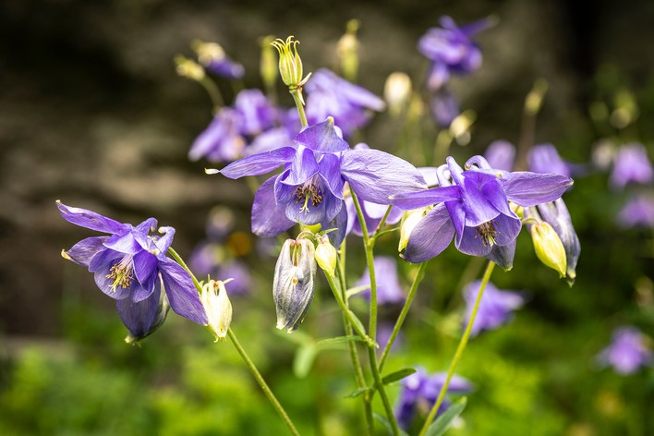Columbine (Image credit: Getty Images) Marigolds (Image credit: RHS)

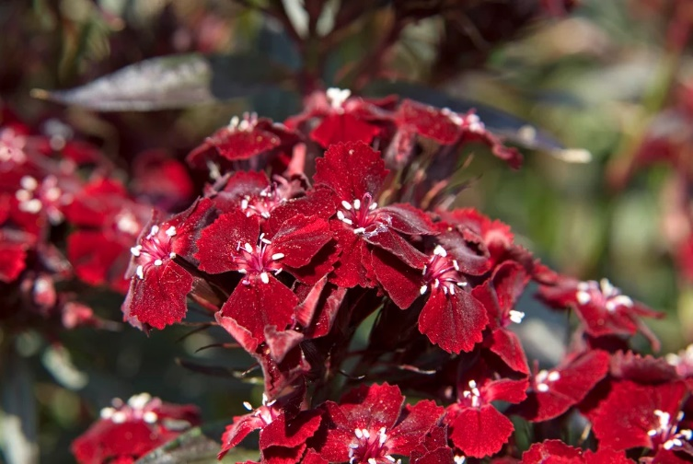Sweet William (Image credit: RHS) Common sunflower (Image credit: RHS)