7. Now cut off 2 seedlings and leave the strongest one to go on growing

*Pupil Sheet*

Stick a label on the pot with our name and the date

6. On each of the next 4 days, add 4 drops of water to your pot

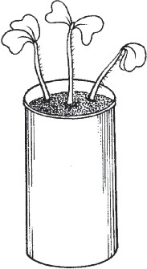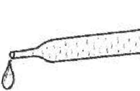

5. Ask your teacher to put the pot on a water box under the light bank



4. Add water with the dropper until water begins to drip off the wick

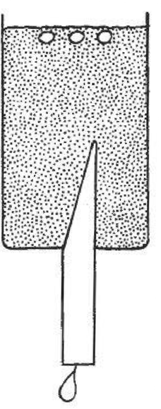

3. Just cover the seeds with soil mix and **gently** press the soil down with your finger

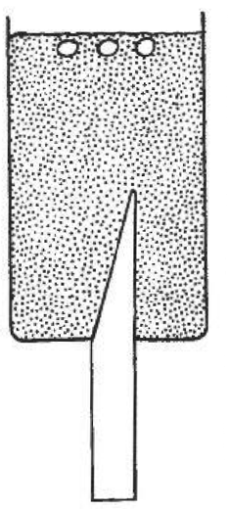

2. Add 3 seeds

1. Use the plastic spoon and fill your pot with soil mix

***You need:***

* a small pot with a wick
* some soil mix
* a plastic teaspoon
* seeds
* water and a dropper
* sticky label and pencil

**Growing plants in pots**