From the booklet: Living processes and what plants need to grow

*Teaching Notes*

**Adding mineral salts – do radishes grow better?**

As a start, discuss with the children why gardeners and farmers add ‘fertiliser’ to their plants and crops. The children may think that the plants are being ‘fed’. This is an opportunity to introduce the need for mineral salts. See notes below on ‘Food’ in plants.

In this investigation, radishes are grown in film pots containing different numbers of fertiliser pellets. The growth (or ‘crop’) is compared. You need to explain to the children that fertiliser pellets contain mineral salts. See further information on radishes and why they are good to use in this investigation below.

For details of the technique, see resource ‘Growing plants in pots’. If possible, you should use a light bank for growing the radishes in this investigation. The Pupil Sheet can be used to help the children see how to grow the radishes in film pots. A Word file is provided on the SAPS website for you to download and amend to suit your class.

***The activity***

Following on from the title, ask the question ‘Does adding mineral salts to radishes make them grow better?’ Discuss what ‘better’ might mean. Does it mean a bigger radish – in terms of weight, diameter or circumference? Ask the children to make a prediction and work with them to plan the investigation.

Each child has a film pot and it is suggested that children work in groups of five. They need to use black film pots and fill them with an inert material so that there is no source of mineral salts in the growing medium. For this activity, the best results are obtained with a soil mix with very low mineral salt content (e.g. moss peat). Mineral salts can be provided by using fertiliser pellets. So in a group of five children, each child adds a different number of fertiliser pellets – say 0, 5, 10, 15 and 25 pellets.

***Results***

Children can make observations on any differences in growth at 2 or 3 day intervals and record their observations. They can harvest their radishes after three to four weeks. Explore with the children the differences they can see in the radishes and how these differences could be measured. They may find that plants with more leaf growth may not have the biggest radishes.

Various features can then be ‘measured’ depending on the ability of the class. For example, you can trim the leaves and separate them from the radishes and other parts of the root. Different parts of the plants obtained in the different fertiliser pellet treatments can be weighed. A good way of showing the ‘yield’ of radish is to use a ‘radogram’ in which the radish roots obtained for each mineral salt treatment are lined up side by side, like drawing a bar chart (see Figure 1).

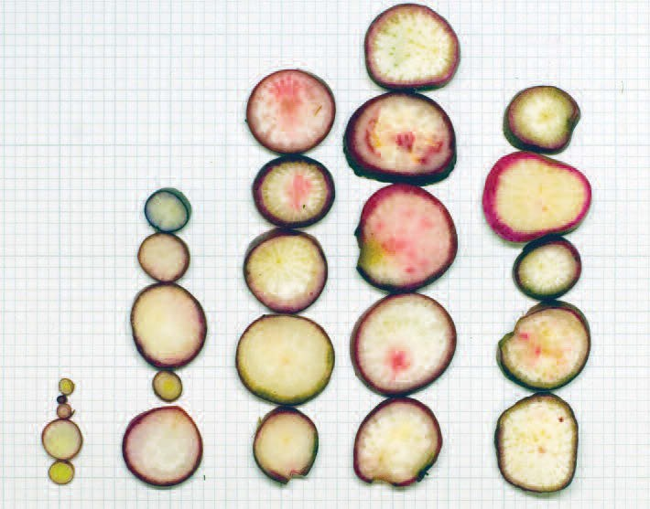

s0

s5

s10

s15

s25

**Figure 1.** A ‘radogram’ – a slice was cut across the widest part of each of the five radishes grown in pots, with the number of fertiliser pellets shown. These slices have been built up into a bar chart, known as a ‘radogram’.

***What we have discovered***

There is likely to be some variation in the results between the different groups. This provides an opportunity to discuss with the children the importance of doing replicates. The biggest radishes usually grow in the pots with 10 to 15 fertiliser pellets. With higher concentrations of mineral salts (25 fertiliser pellets), growth is inhibited. You may wish to discuss with the children whether the ‘biggest’ radish is necessarily the ‘best’ one. How important is taste and appearance?

***Evaluation***

Discuss with the children whether they think the test was fair. How might they improve it? Were all the fertiliser pellets the same size (or does that not matter)? What else could they investigate in relation to mineral salts and growth of the radishes?

Remember – you can use the ‘Planning Plant’ resource to help guide children in your class through the investigation.

***Food in plants***

Food provides a source of energy for living processes.

Animals are known as consumers and obtain their energy from the plants and animals that they consume.

Green plants are known as producers and are able to trap energy from the sun, using the green pigment chlorophyll. This energy is used to produce sugars, by the process of photosynthesis. The sugars are subsequently broken down to provide the source of energy for living processes in the plants. Plants are therefore said to make their own food.

In addition to obtaining energy, all animals and plants need other substances to build up their cells and grow successfully. These substances include mineral salts. Animals obtain their minerals from the plants and animals that they consume. Plants usually obtain their minerals from water taken up by the roots, and this water contains dissolved mineral salts.

Children are often confused by use of the term ‘food’ particularly when they know that ‘plant food’ can be purchased (say from a garden centre) and added to the soil to ‘feed’ plants. (This is mainly mineral salts.) They should understand that in science, we link ‘food’ primarily with it being a source of energy.

***Using radishes in investigations***

The radish (*Raphanus sativus*) is a useful plant for carrying out simple investigations. The seed is inexpensive and widely available. Seeds in a single packet show relatively little genetic variation, compared with some other plants. This means that when comparisons are made, differences are likely to be due to the experimental conditions rather than variations between the seeds. They can be grown successfully in film pots. Radish plants are small and compact and, if grown under a light bank, can give a ‘crop’ within three to four weeks. This crop can then be measured in a variety of ways.