From the booklet: Reproduction and Life Cycles part 2
Teaching Notes
Demonstrating pollination using model flowers
This activity lets you demonstrate pollination in the classroom.

Preparation for the activity

Make up two 3D flowers (you need at least two). Follow the instructions in on the Pupil Sheet (see the SAPS website). You can omit the ping pong balls that represent ovules but add these ‘extras’:
- get some rice grains that have been coloured yellow (or something similar) to attach to the anther part of the model. These represent pollen grains
- put double-sided sticky tape on the cap of the bottle that represents the stigma.

- Construct some bees.
For the body, you can use either a flat yellow household sponge, rolled into a tube and secured in place with black tape to represent stripes on the bee’s body, or a small stuffed yellow sock, again with black tape to represent stripes and give shape to the body.
For the head, use a ping pong ball and attach 2 pipe cleaners for the antennae. For the legs, use 6 pipe cleaners.
For the wings, cut out 4 ‘wings’ from clear acetate.
Attach a small piece of double-sided sticky tape to the underneath of each bee.

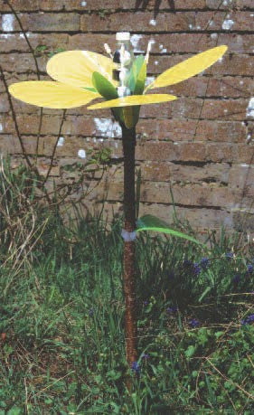
The activity

Place the model flowers on opposite sides of the classroom. The bee visits the first flower and collects some pollen grains (rice) from the anther of the stamen. It then flies to the second flower where it deposits the pollen on the stigma (sticky bottle top). This demonstrates the process of pollination.
Figure 2. A SAPS model Brassica flower created using instructions given on the SAPS website. The final model, supported on a stick (as shown in this photograph) reaches about 1m in height.

