From the booklet: Reproduction and Life Cycles part 2
Teaching Notes
Demonstrating pollination using role play
This activity lets you demonstrate pollination in the classroom through role play.

You need various items to represent the different parts of a flower and you also need props for a bee. You can follow some of the suggestions given in ‘Create a flower’ resource but here are some ideas that are particularly useful for this activity.
t

Parts of flower  (and bee!) | Suggested materials
sepals and petals | cut sepal and petal shapes out of card and fix to clothing or a headband
stamens | a pot (to act as a holder for the pollen grains) – use any container – e.g. ice cream tub, lemonade bottle, yoghurt pot
pollen grains | film pot lids, ping pong balls, card discs, paper balls*, fuzzy balls* - all these can have self-adhesive velcro hooks attached to them
stigma | a woolly hat on the head
bee | be imaginative! ideas could include a headband with antennae and a stripey body (made from an old T-shirt or tabard of stripey material)

*These can be purchased from a craft shop or sometimes from the local county suppliers

Preparing for the role play

You need two flowers and one bee. Adjust the number of flower parts according to the number of children in the class. For example, a flower with five sepals, five petals, five stamens and one stigma involves sixteen children.

The children dress up as the different flower parts using items as suggested in the table opposite. They are then organised into groups to form two flowers. One child dresses up as a bee.

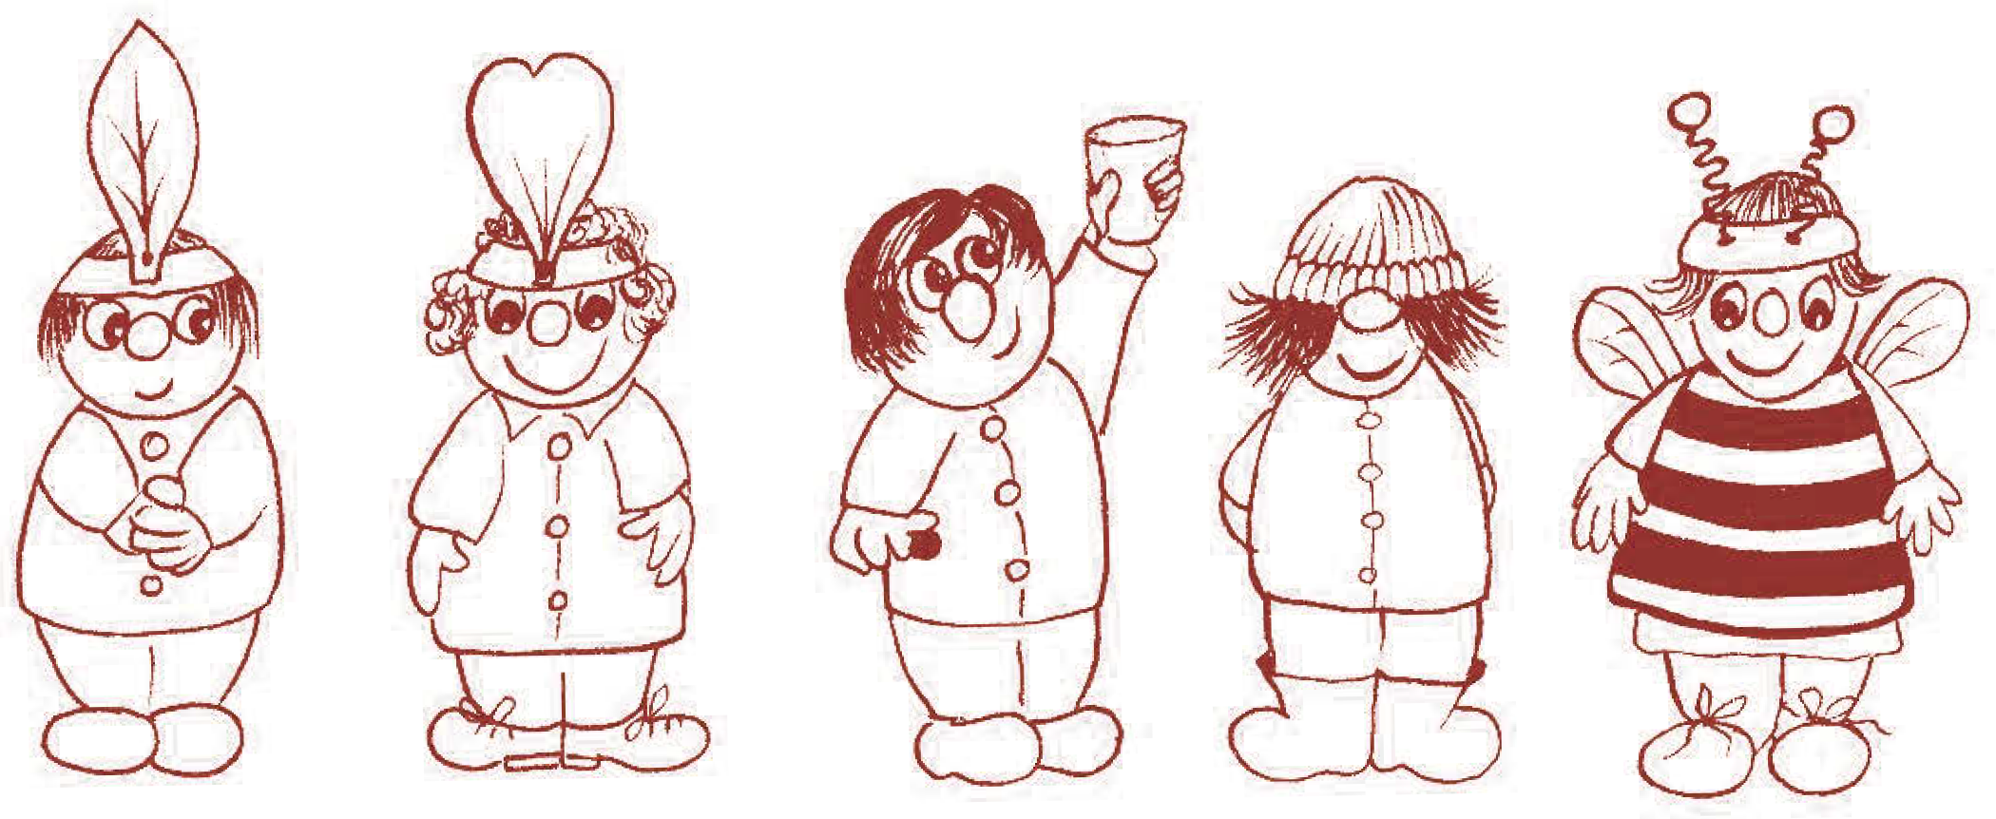
sepal petal stamen stigma bee

The activity
The bee visits the first flower making appropriate buzzing noises and collects pollen (by removing a pollen grain from the pot). It then ‘flies’ to the second flower, which is waving its petals to attract the bee. The bee deposits the pollen on the stigma (by brushing the velcro hooks against the woolly hat). This can be repeated several times with the children swapping the role they play. If you wish, at the beginning of the game both flowers can be in bud, i.e. with petals, stamens and stigma crouching down and the sepals bending over them. This helps the children to understand the protective role of the sepals.

