From the booklet: Reproduction and Life Cycles part 2

*Teaching Notes*

**Finding out about how fruits and seeds are dispersed**

This activity can be used to help children link special characteristics of fruits and seeds with the way in which they are dispersed.

**It is essential right at the beginning of the exercise to stress that fruits which birds and other animals enjoy eating may be very poisonous to humans. Nothing must be eaten without the permission of the adult in charge.**

###### **The activity**

As preparation for the activity, collect common local fruits, with a different one for each group and preferably each with a different dispersal mechanism (see below for more information). Spread out the fruits on chairs or stools in the garden or classroom. The [Field Studies Council](https://www.field-studies-council.org/shop/) have fold-out charts that can be used to help with identification.

Divide the children into small groups. Give each group a drawing of one of the fruits and ask the children to match the drawing with the correct fruit. There are four drawings included on the online resources that can be used as examples. Let the group examine the fruit carefully and, with help, fill in the questionnaire given in the pupil sheet. Each group tries to decide how the fruit or seed might be spread around.

Ask each group to explain how they think their fruit is dispersed, picking out important features – for example, the wind dispersed fruits are very tiny or have wings or parachutes. Let each group of children choose a name relevant to the dispersal mechanism of their fruit (e.g. the pepperpots), and which helps them remember the important features.

Take the children for a short walk and let them look for more fruits and seeds. If there are fields and woods close to the school, this is ideal, but there may be suitable places in the school grounds or in a nearby park. For each fruit or seed they find let them look at its characteristics, then with help from the teacher they can decide which dispersal group it should belong to.

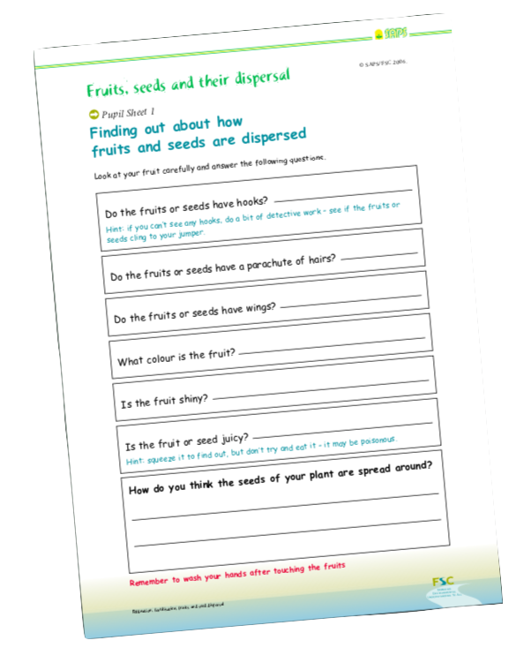A Pupil Sheet gives a set of questions for your children to answer when looking at their fruits and seeds. A full-sized template of the Pupil Sheet is provided on the SAPS website (with a reduced version in Figure 1). There is also a selection of images available to download within the resource pack illustrating different methods of fruit and seed dispersal. You can use these as examples to get your children started with this activity.

**Figure 1.** Reduced size version of Pupil Sheet for recording details about fruits and seeds. A full-sized template is provided on the SAPS website.

***Dispersal***

It is important for a plant to spread its seeds away from the parent plant and from each other, in other words to disperse them. This prevents overcrowding, reducing competition for light, water and mineral salts.

Seeds, or fruits contains seeds, are dispersed in four main ways:

1. Animal dispersal – these are moved by animals. Some are used as food sources (**juicy fruits and seeds** and **takeaways**) others have hooks and bristles that get caught in the animal’s coat (**hitch-hikers**)
2. Wind dispersal – some are tiny and float in the air like dust, others have special structures such as wings and parachutes to keep them airborne longer.
3. Water dispersal – this is important for plants growing in or by water, the seeds need to be buoyant to float.
4. Self dispersal – this group includes **exploders,** where the seeds are forcibly flung out of the pod when ripe and **pepperpot** types, where the seeds are shaken free.

###### The size, shape and colour of the fruit or seed, together with other features all help to give an indication of how they are dispersed.

###### **Further activities**

###### The FSC fold-out chart – A guide to fruits and seed dispersal (OP71) is a useful resource to support this activity. See the SAPS website for suggestions as to how to use it. All the illustrations on the FSC fruits and seeds chart are available on the SAPS website and can easily be made into more worksheets that you can use with your children.

###### In the autumn, adapt the activity ‘The colours of flowers’ (see resource) to look at colours of fruits and seeds.

###### Construct and use a key to dispersal mechanisms – this activity helps to highlight the characteristics of fruits and seeds with different dispersal mechanisms. It is particularly suitable for upper primary pupils or for use as an extension activity. Guidance on how to construct such a key is available on the SAPS website and is also included in booklet 5 of this series (Grouping and classification).