*Pupil Sheet*

**Finding out about how fruits and seeds are dispersed**

Look at your fruit carefully and answer the following questions.

Do the fruits or seeds have hooks?

Hint: if you can’t see any hooks, do a bit of detective work – see if the fruits or seeds cling to your jumper.

Do the fruits or seeds have a parachute of hairs?

Do the fruits or seeds have wings?

What colour is the fruit?

Is the fruit shiny?

Is the fruit or seed juicy?

Hint: squeeze it to find out, but don’t try and eat it – it may be poisonous.

**How do you think the seeds of your plant are spread around?**



**Remember to wash your hands after touching the fruits**

Look carefully at your fruit and see if you can answer the questions in the Pupil Sheet.

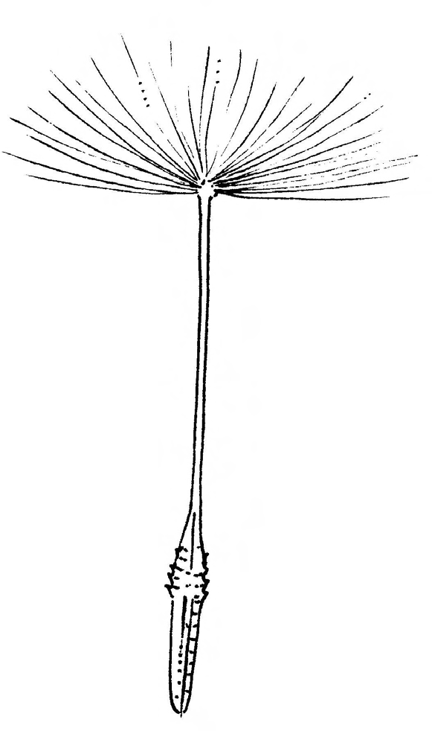

Dandelion