From the booklet: Grouping and Classification

*Teaching Notes*

**Introducing keys – and liquorice allsorts**

Several versions of ‘liquorice allsorts’ keys are already in circulation, and it is difficult to know where the idea originated. We include yet another version in the booklet ‘Grouping and Classification’, because liquorice allsorts are bright and appealing to children and also have enough different characters to enable children to sort and group them in different ways and then devise a simple key to ‘identify’ the particular one they have got. To make the exercise even more interesting, you may wish to give the children some information about the liquorice plant (please see below).

Liquorice allsorts have differences and similarities that are easy to see and observe and only a simple vocabulary is needed to describe them. The characters include shape, colour and arrangement of the layers. (Similar exercises can be devised with ‘Dolly mixtures’.) As a starter, this is a good way to establish the principles of making and using a key, before going ahead with more complex material using plants.

You need a packet of liquorice allsorts from which you can make selections of different kind of sweets. Always check for potential allergens before asking children to handle produce. It is best for the children to use the real thing in the activity, but you can use pictures if you have difficulty in obtaining liquorice allsorts. A set of photographs of the ‘standard’ kinds of liquorice allsorts can be seen below. You can use the pictures for the children in your class after cutting them out.

**The activity**

The children work in small groups. Choose four liquorice allsorts and give each group of children a set of these four sweets. Ask the children to look at the characteristics (features) of their four sweets, then begin to collect their descriptions on the ‘board’ (in whatever form is suitable).

**Figure 1.** Examples of liquorice allsorts sweets, selected to make a simple key.

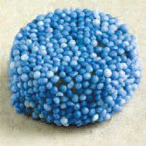

A

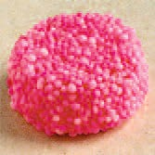

B

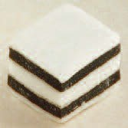

C

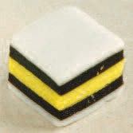

D

Next ask the children to sort the sweets into two groups. Then the children need to find a question that gives a reason for the separation into groups. An example could be “Is it round?”

If they use the four sweets shown on the previous page, the answer is YES for A and B, but NO for C and D. They can group the YES sweets together, separate from the NO sweets. They then find a question that can separate A and B, and another question that can separate C and D. Possible questions for A and B – “Is it blue?”, or for C and D – “Is it only black and white?”

Help the children build up a chart to summarise their questions. You can do this by using an interactive whiteboard or by writing the questions on ‘Post-it’ notes and sticking them on a board. Already they have created a very simple key. Here is how this could be laid out.

**Figure 2.** An example of a simple key to four liquorice allsort sweets, developed from a sorting exercise.

Is it only black and white?

No (D)

Yes (C)

No (B)

Yes (A)

Is it blue?

No (C or D)

Yes (A or B)

Is it round?

Let the children check the pathway through (to ‘identify’ a sweet). They pick one of the sweets, then start with the first question at the top.

You can extend the activity by using more sweets. Put the children into small groups and give six different sweets to each group. Soon they would see that this key works only for the four sweets used. If they want to add more sweets, they have to think of more questions. See if they can make their own key. They will probably find it helpful if they name each sweet, say with a letter or the name of a person. You can find an example of a key made with six liquorice allsorts below.

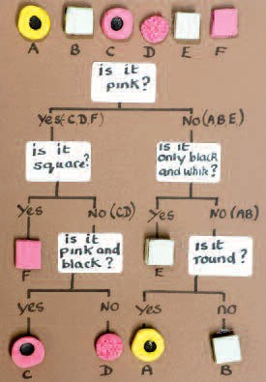

From this introductory exercise, the children should then be ready to move on to a more advanced exercise, such as ‘Making a key – using leaves’ or ‘Using a key – following the trail with buttercups’.

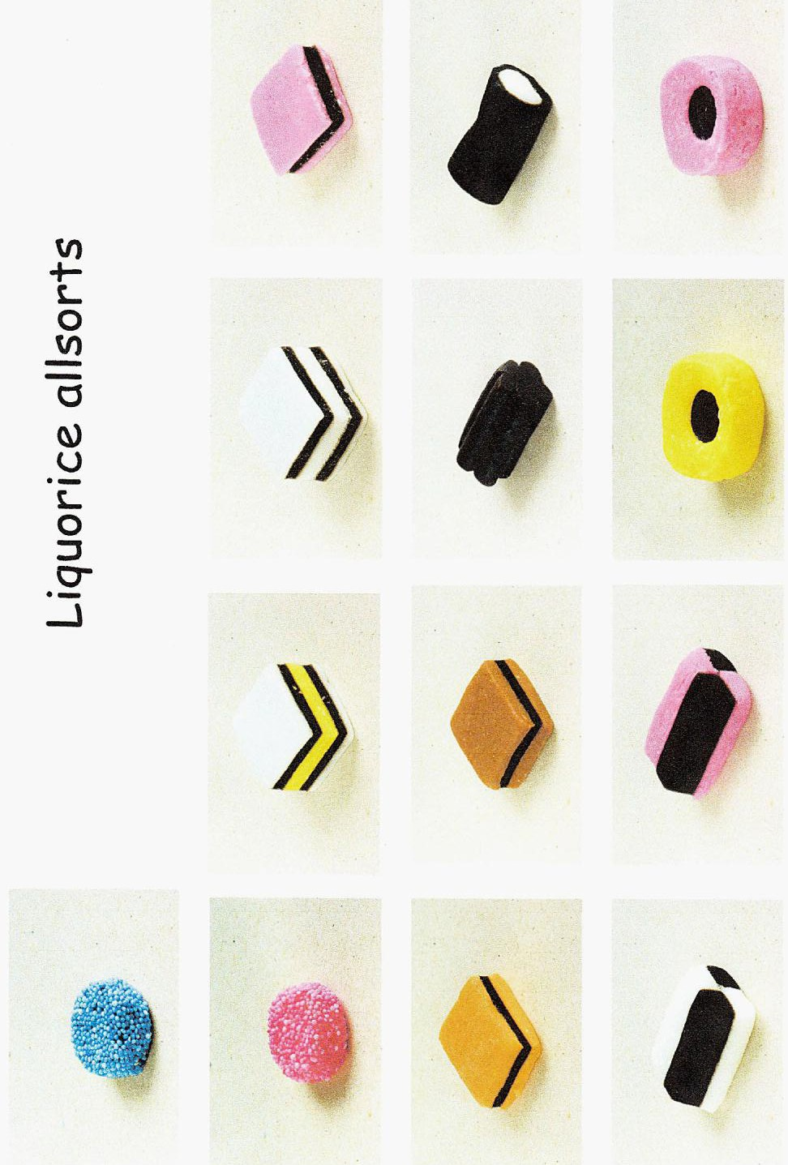These images show a range of typical sweets in a liquorice allsorts package. If you have difficulty in obtaining liquorice allsorts, you may wish to download the pictures given here and cut out a selection for children to use in making their key.

**The Liquorice plant *Glycyrrhiza glabra***

The Liquorice plant is in the same family as peas and beans (Fabaceaea). It grows as a wild

plant, for example in southern Europe, but in many countries it is also cultivated. Its underground stems and roots are used to provide flavouring in sweets and medicines. The dried sticks are also used for chewing. In England, the best place for growing Liquorice seemed to be Pontefract in Yorkshire.

In the 16th century, monks who lived there made small medicinal cakes called Pontefract cakes and these are still produced today.

