Making a key and using leaves

*Pupil Sheet*

**Leaf fact file**

Look at your leaf and write the answer **yes** or **no** beside each question

1. A picture containing linedrawing

   Description automatically generatedIs the leaf lobed?
2. Do the leaf edges have teeth or prickles?
3. Are the leaf edges smooth or slightly wavy?
4. Does the leaf have one main vein (running from the stalk to the leaf tip)?

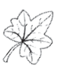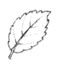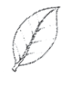

1. Does the leaf have more than one main vein (running from the leaf stalk to the leaf edges)?
2. Do the side veins mostly come off the main veins in pairs?
3. Do the side veins all come off the main vein one at a time?
4. Is the leaf stalk longer than 1 cm?

(You will need a ruler to answer this question)

1. Does the leaf stalk have small bumps on it? (These

are glands)

1. Is the leaf stalk red?
2. Is there anything else interesting about your leaf?

Draw a picture of your leaf here

|  |  |  |  |  |  |  |  |  |  |  |
| --- | --- | --- | --- | --- | --- | --- | --- | --- | --- | --- |
| Leaf stalk is red | Leaf stalk has small bumps on it (these are glands) | Leaf stalk is longer than 1cm | Side veins all come off the main vein one at a time | Side veins mostly come off the main veins in pairs | Leaf has more than one vein (running from the stalk to the leaf edges) | Leaf has one main vein (running from stalk to leaf tip) | Leaf edge is smooth or slightly wavy | Lead edge has teeth of prickles | Leaf is lobed | **Character** |
|  |  |  |  |  |  |  |  |  |  | **Leaf name** |
|  |  |  |  |  |  |  |  |  |  |
|  |  |  |  |  |  |  |  |  |  |
|  |  |  |  |  |  |  |  |  |  |
|  |  |  |  |  |  |  |  |  |  |
|  |  |  |  |  |  |  |  |  |  |

**Leaf character table**

Write the names of the leaves you are using in the class in the boxes under Leaf name.

Tick in the boxes below if your leaf has these characters.

You can use information from the leaf fact files from all the groups in the class to complete the table.

Suggested leaves to use for making a leaf key. Choose two leaves from each group to have a good selection. (These leaves are slightly smaller than life size).

Honeysuckle

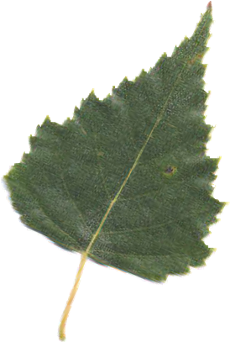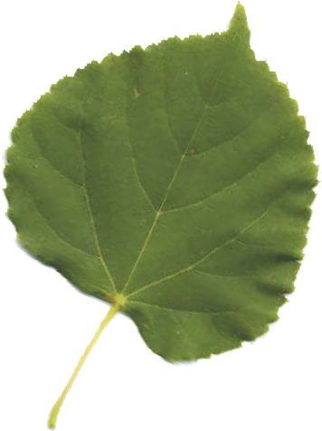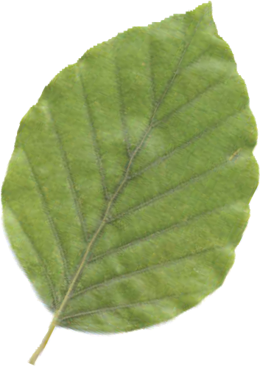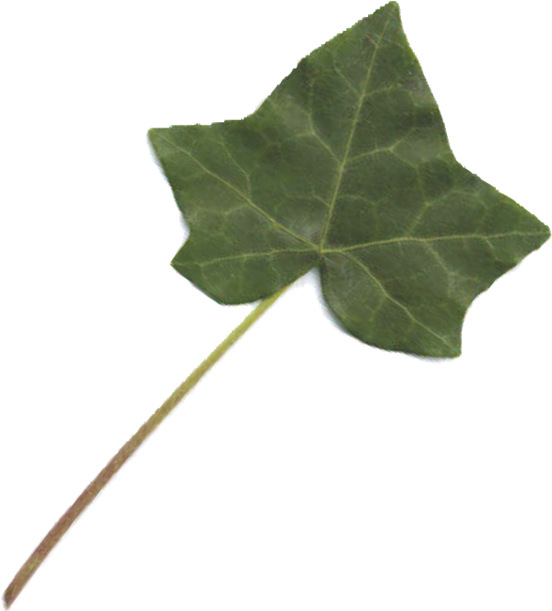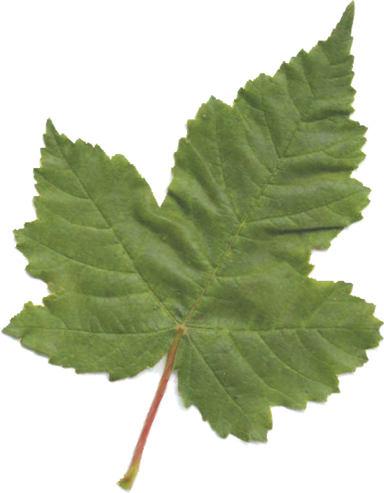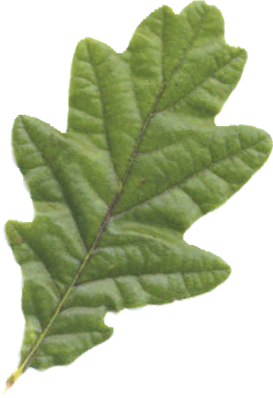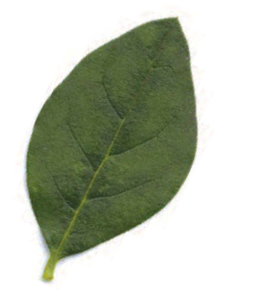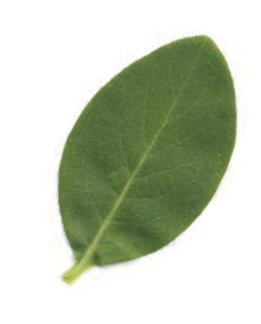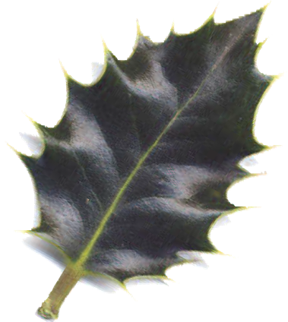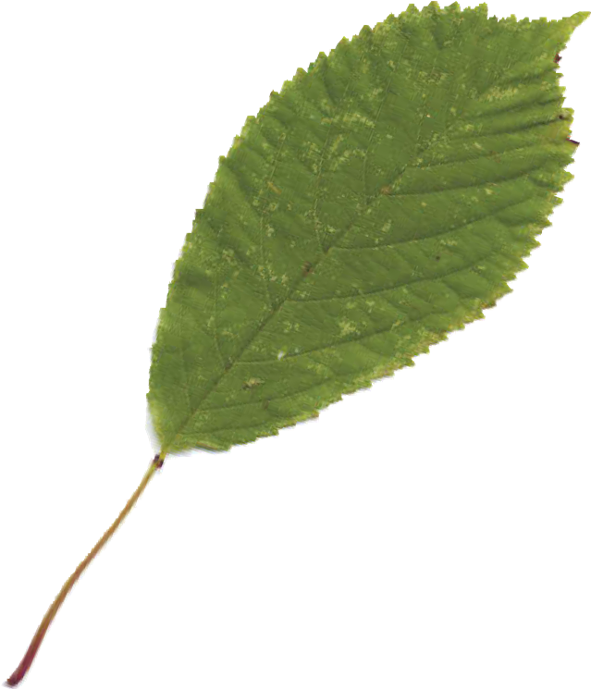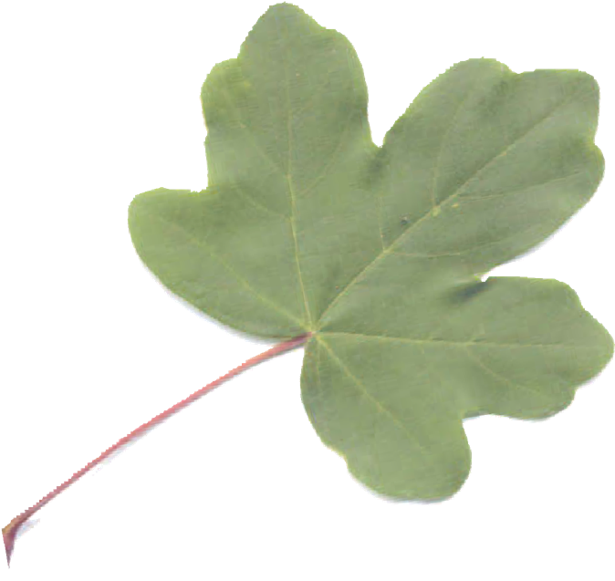

Field maple

Garden privet

Sycamore

Ivy

Beech

Oak

Cherry

Holly

Lime

Birch

**Group 3**

**Group 2**

**Group 1**