From the booklet: Living processes and what plants need to grow

*Teaching Notes*

**Plant quartet (Happy families)**

This is a version of the card game ‘Happy families’. There are 48 cards in the pack, made up of 12 sets of four cards (a quartet). Each set represents the plant of a wild flower with one card in each set for each of the things that it needs to grow well: water, air, light and mineral salts. Reduced size versions of the cards are illustrated in Figure 2. During the game, the children try to collect as many sets (of each wild flower) as they can.

The game can be used to help children reinforce their understanding of the requirements for successful growth of plants. It also provides a way of helping children to become familiar with some common wild flowers and their names.

***Preparation for the game***

First you need to make a pack of cards. Full-sized templates of the 12 wild flower cards are given on the SAPS website. Download these and print four copies of each of the two pages. You can print onto normal paper, then paste this onto card (e.g. using spray mount), or print straight onto a suitable weight of card. In the spaces for each of the pages, write the word for each of the four growth requirements. (See the example in Figure 1 below.) You may then wish to laminate the sheet to make the card sets more durable. Finally, cut out the individual cards to make the pack of 48.

***Playing the game***

This game is best played with three to six players, but can be played with two. The idea is for the players to complete as many sets of wild flower cards as they can.

* Deal five cards to each child (seven cards if only two are playing). Place the remaining cards face down in a pile on the table.
* The child to the left of the dealer starts. This child asks one of the other players for a specific card by saying, for example, ‘Please may I have mineral salts for foxglove’. The child must have at least one card of the set they are asking for.
* If the player asked has that card, they must give it up. The child receiving the card then has another turn.

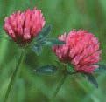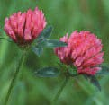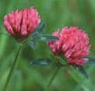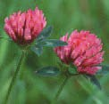

Red clover mineral salt

Red clover water

Red clover light

Red clover air

* If the player asked does not have the card, they reply ‘Go gardening’. The first child must then draw the top card from the pile. If this card happens to be the one they were asking for (unlikely, but possible), the child shows it and then has another turn. If it is not what they asked for, the turn then passes to the player who said ‘Go gardening’.

**Figure 1.** A ‘quartet’ of red clover cards.

* As soon as a child has a complete set of four cards, they must show this and place it on the table in front of them.

The game continues until one of the children has no cards left or the original pile runs out. The winner is the player with most sets (quartets) of wild flowers.

***Extension***

* Pupils could write a set of instructions on how to play the game. This cross-curricular link with literacy will promote their use of subject specific vocabulary.
* Features of the plant shown in the photo could be added to the cards or another set of cards. For example: petals, leaves, sepals, stem etc. This would reinforce knowledge of plant parts, develop observation skills and their vocabulary.

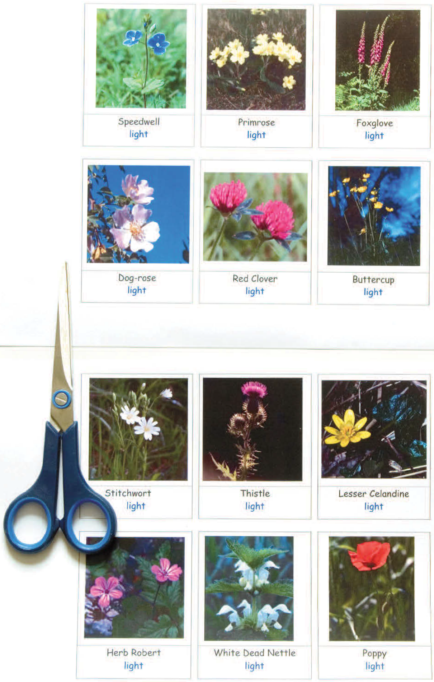

**Figure 2.** Reduced size versions of cards for Plant quartet. Full-size versions are provided on the SAPS website.