*Pupil Sheet*

**Buttercup fact file**

1. How many sepals are there? How many petals are there?

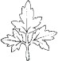

1. Are the leaf blades divided up

leaflet

into smaller leaflets or deeply lobed?

1. Are the sepals turned back?

wrap the leaf around your finger and use a magnifying glass to see the hairs

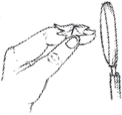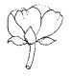

1. Are the leaves covered in tiny hairs?
2. Do the flower stalks have clear

grooves running along their length?

1. What sort of place was the plant growing in

(e.g. a grassy field, a woodland, the edge of a pond)?

1. Is there anything else interesting that you have noticed about your plant?

Draw a picture of the leaf here

Draw a picture of the flower here

**Now use the key to find out the name of your ‘buttercup’.**

**Celery-leaved buttercup**

**Lesser spearwort**

**A key to common buttercups**

Which buttercup have you found? Follow the trail to find out

Wrap the leaf around your finger and use a magnifying glass

The flowers on this plant often have petals missing

If your flower has missing and deformed petals it may be the Goldilocks buttercup. This sometimes has a few hairs on its leaves

**Meadow buttercup**

**Creeping buttercup**

**Goldilocks buttercup**

**Start here**

**Lesser celandine**

**Bulbous buttercup**

The open flower has its sepals turned back

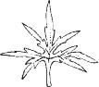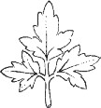

The flowers are less than 1cm across. A plant of wet places

The flowers are more than 1cm across. A woodland plant

The leaves are not hairy or have only a few hairs

The leaves have lots of tiny hairs

Most flowers have 5 sepals and 5 petals or fewer than 5 petals

Most flowers have 3 sepals and 7 to 12 petals

The leaves are deeply lobed or divided into smaller leaves (leaflets)

The open flower has

upright sepals

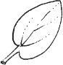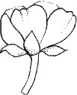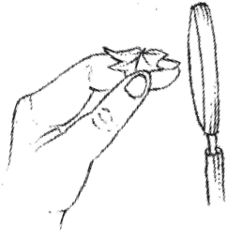

The leaves are not lobed

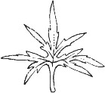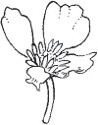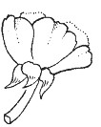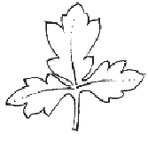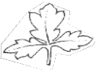

The stalks with flowers have clear grooves. The leaflets have stalks

The stalks with flowers do not have grooves. The leaflets have no stalks.



*Pupil Sheet*

**Goldilocks buttercup** Usually found in woodland. Flowers in April and May.

Leaf from flowering stem – notice it has no hairs.

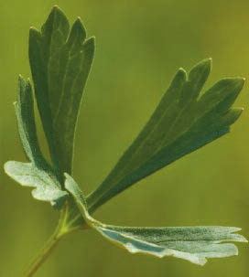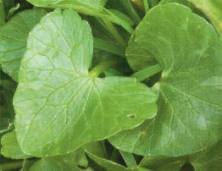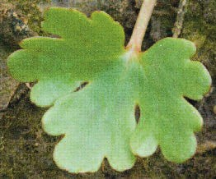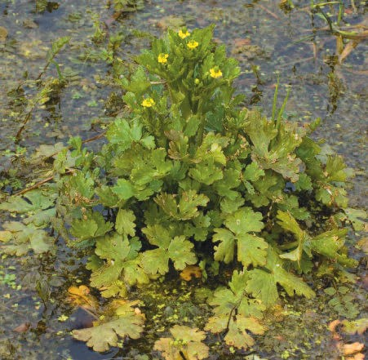

**Celery-leaved buttercup**

Common on damp mud at the edges of ponds. Flowers from May to September.

Goldilocks flower showing missing and deformed petals.

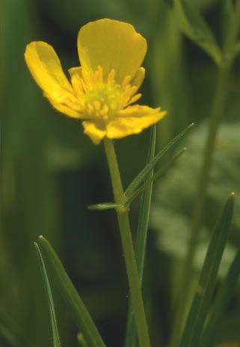

Leaf at bottom of plant.

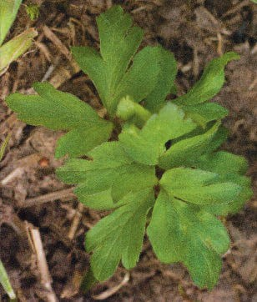

**Lesser celandine**

Common in woodland, grassland and on stream sides. Flowers in April and May.

Heart-shaped lesser celandine leaves.

Leaf from celery-leaved buttercup showing no hairs.

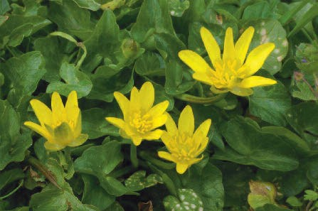

Most flowers of the lesser celandine have 3 sepals and 7 to 12 petals.

**Lesser spearwort** Common in wet places e.g. edges of ponds. Flowers from June to August.

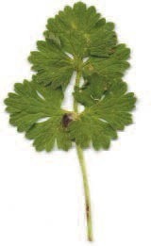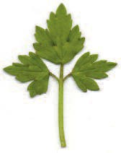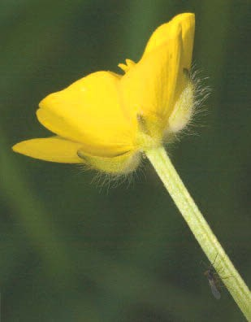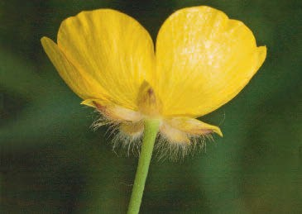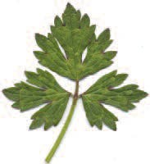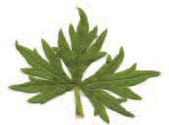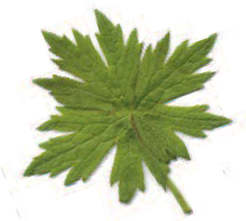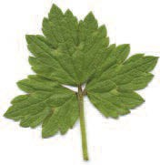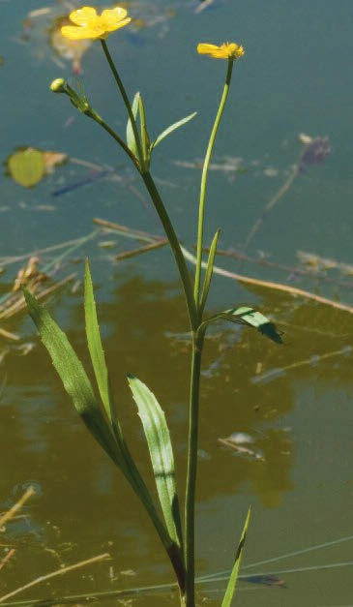

*Pupil Sheet*

**Bulbous buttercup** Found in dry, grassy areas. Flowers in May and June.

Flower showing upright sepals and a smooth stalk. The leaflets have no stalks.

no stalks

stalk

**Meadow buttercup** Common in grassy places. Flowers in June and July.

leaves are not lobed although some have a few teeth.

Flower showing upright sepals and a grooved stalk. The leaflets have stalks.

Bulbous buttercup showing its turned back sepals. Like the creeping buttercup (see below) the leaflets have stalks.

stalk

leaflet with stalks

**Creeping buttercup** Found in damp, grassy places and woodland. Also a common garden weed. Flowers from May to August.

