From the booklet: Grouping and Classification

*Teaching Notes*

**Using a key –** **Following the trail with buttercups**

This activity gives children an opportunity to use a key to identify (and name) certain buttercups. It is suitable for upper primary children, particularly as an extension activity.

The simple key provided includes seven members of the buttercup group (*Genus Ranunculus*). All have yellow flowers and are common and widespread. They include species known correctly as buttercups as well as some that closely resemble buttercups and are often mistaken for them. The buttercups included in the key flower from early spring to late summer. You only need one or two examples, so, wherever your school is, you should be able to find some buttercups in flower nearby. Usually the end of the summer term is the best time for this activity.

This activity provides a useful way of revising what the children know about the parts of a flower. Before using the key, let the children look closely at a buttercup flower and take it apart (see resource ‘Parts of a flower’). A drawing of a dissected buttercup flower can be seen below, together with notes that help to interpret its structure. Using the key then helps the children to reinforce what they have learnt and begin to understand how the flower parts, as well as characters of the leaf and stem, can be important when trying to identify the species.

**The activity**

Take the children out into the field where you know some buttercups are growing. Alternatively, do this as a classroom activity and bring some buttercup flowers into the room. It is very difficult to do this successfully from pictures of flowers, simply because the children cannot examine the flowers closely enough to see the necessary detail.

The children can work in groups. Ask the children, in their groups, to answer the questions on the Pupil Sheet ‘Buttercup fact file’. As they do this, they can make a drawing of the buttercup flower and leaf, showing the important features that they have observed. This completes their observations on the buttercup.

The children can then start to work through the pathway of the key, starting from ‘START HERE’ at the top. At each level, they decide which alternative is correct, then follow the pathway to the next pair of statements in the trail. They have already answered several of the ‘questions’ when building up their Buttercup fact file.

Pictures and some notes relating to the different kinds of buttercup are provided below. These can be used for confirmation after the children have worked through the key.

***A Meadow buttercup***

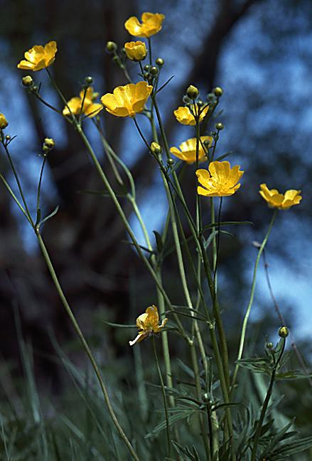

The Meadow Buttercup belongs to the buttercup family (*Ranunculaceae*). This family contains a large number of well-known attractive garden plants such as Clematis, Delphinium, Pasque Flower and Anemone. Many members of the family contain chemical substances called alkaloids. These make the plants very poisonous.

***A dissected buttercup***

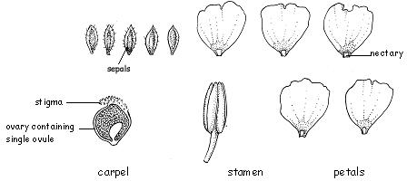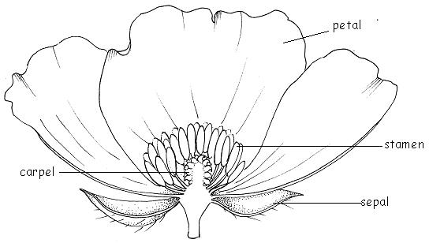These drawings of a dissected buttercup display the floral parts and provide additional information that should help you when doing floral dissections with the children. To revise how to dissect a flower, see booklet - Reproduction and life cycles Part 1: Parts of a flower.

*The structure of the flower*

**Sepals** (5) These are often yellow in the open flower.

**Petals** (5) Bright yellow with a small pocket-shaped nectary at the base

**Stamens (numerous)**

**Carpels (numerous)** The female part of the flower (the gynoecium) is made up of a large number of carpels which are not fused together. Each has its own stigma and ovary. The ovary contains a single ovule.