From the booklet: Reproduction and Life Cycles part 2
Teaching Notes
Pollination and fertilisation challenge
This activity presents the designing of a poster as a ‘challenge’, providing a way of helping children understand pollination and fertilisation. At the same time, skills being developed include collaborative working and presentation skills (oral and written) as well as opportunities for assessment.
Key question: How do plants reproduce themselves?

The setting
The local Botanic Gardens have decided to produce new materials for primary school children interested in learning about flowering plants. They have asked schools in the area to help design a poster to show how plants reproduce themselves.

The challenge
Divide the class into groups of three or four. Ask each group to design a poster that shows how plants reproduce themselves. To help your groups complete the task, first of all get them to think and talk about what they have already learned about pollination and fertilisation. You can encourage them to use books, leaflets and suitable websites as sources of information. Then ask them to design the poster.

Once the posters have been completed, display them in the classroom. Then ask each group in turn to explain their poster to the rest of the class. They should be prepared to answer questions about their work.

Criteria for a good poster which could be drawn up with the class:
- should convey information about pollination and fertilisation – in pictures, diagrams, words and phrases
- information should be well organised and neatly presented
- content of the poster should be appropriate for children of their own age.

See below for background information on pollination and fertilisation. Images of pollen and those relating to pollination can be found in the Pollen Image Collection and the SAPS Image Library found on the SAPS website.

Background information for teachers
Pollination and fertilisation
Pollination
Pollination is the transfer of pollen from the stamens to the stigma. The pollen is often carried by insects and other animals, but sometimes by wind or water.
Self-pollination occurs when pollen lands on the stigma of its own flower or another flower on the same plant. Cross pollination occurs when pollen is transferred to the stigma of a flower on another plant of the same species.
Because of the way that pollen grains are formed, within a single plant the pollen grains may be (genetically) slightly different from each other. Similarly the ovules within the same plant may be genetically slightly different from each other. Thus, even self-pollination can result in some variation in the offspring. Cross pollination, however, because the genetic material comes from two different parents, results in greater variation and is, therefore, considered to be advantageous to the plant. In many plants, the design and form of the flower promotes cross pollination.

Fertilisation
When the pollen grain lands on the stigma it receives a chemical signal from the stigma. A tube from the pollen grain grows down the style into the ovary and into one of the ovules. Here fusion takes place between genetic material in the male and female cells. After fertilisation, the ovule develops into a seed. When conditions are appropriate, the seed begins to grow into a new plant (germination).
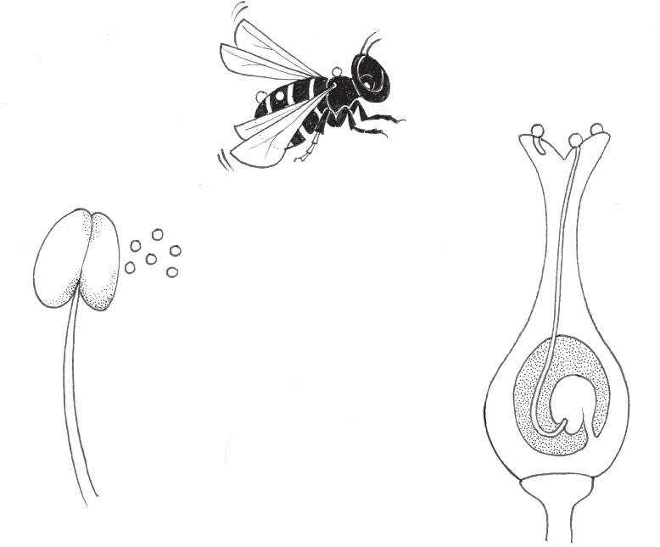
fertilisation
pollination
ovule
ovary
style
stigma
stamen

