2025 NSS, BGUSSS, and Graduate Outcome Survey Results Summary

The National Student Survey
- The survey ran from January to April 2025 for all undergraduate students in the final year of their degree, either Foundation Degree (Level 5) or Honours Degree (Level 6).
- In total, 78.44% or 291 out of the 371 eligible BGU students participated in the NSS 2025 compared to 74.19% or 296 of the 399 eligible students in the previous year. The final response rate of 78.44% was 4.24% points higher than NSS2024.

Institutional average
- Since NSS2023 the overall satisfaction (Q27) has been withdrawn for institutions based in England. Although not an official measure, an aggregated score of all the questions provides a comparable score to benchmark against other institutions.
- The aggregated score benchmark returns a score of 90.2% which ranks BGU as 1st in the sector, excluding small institutions and specialist providers.
- The aggregated score measure has increased from 88.6% in 2024, up by 1.6%. By comparison, the sector benchmark increased from 81.1% to 82.5%, up by 1.4%.
- For 6 out of 7 satisfaction scale themes, BGU maintained or improved its sector ranking, with only Academic Support dropping from 1st to 5th:
Theme | 2023 Rank | 2024 Rank | 2025 Rank | 2025 Score
Teaching on my course | 2nd | 3rd | 1st | 93.42%
Learning opportunities | 1st | 1st | 1st | 94.70%
Assessment and feedback | 3rd | 2nd | 1st | 92.16%
Academic support | 21st | 1st | 5th | 91.17%
Organisation & management | 49th | 27th | 16th | 89.62%
Learning resources | 16th | 2nd | 2nd | 91.58%
Student voice | 4th | 2nd | 1st | 92.53%

- Areas to improve across the institution:
- Targeted Subject Support: Conduct detailed programme reviews for Psychology, Sport, and Teacher Training to identify root causes of dissatisfaction.
- Celebrate and Share Best Practice: Leverage successful strategies from Business, English, and Education pathways across the wider academic community.
- Student Voice and Representation: Continue efforts to ensure student feedback mechanisms are not only heard but visibly acted upon.
- Learning Environment Monitoring: Investigate the reasons behind subject-level ranking fluctuations, particularly in practical-based disciplines such as Sport.
- Foundation Degree Success: Explore how the structured support in FdA pathways might inform enhancements to undergraduate programme design.

Subject variance
- 8 specific programmes (out of a possible 10) had at least 10 respondents, representing at least 50% of the cohort, and so achieved a specific set of NSS results.
- Clearly, there are considerable variations for these specific programmes and those programme leaders can use this information to inform their AMR action plan, especially for those programmes plotting to the lower left of the BGU average.
- The OfS also provide amalgamated subject cluster data at CAH3, CAH2 and CAH1 groupings to bring in student responses on programmes that do not gain a sufficient number of responses. The alignment of programmes to subject clusters is not as intuitive as one might expect, and for this reason, the BGUSSS results offer a more direct set of results for subject teams.
Guidance on the methodology used to derive the data cited above can be found at NSS Results: Intro & Guidance - Tableau Cloud or by contacting Andrew Wright (andrew.wright2@lincolnbishop.ac.uk) or Carolyn Dean (carolyn.dean@lincolnbishop.ac.uk) in the Planning Team.

The BGU Student Satisfaction Survey
- The BGUSSS ran in parallel with the NSS and surveyed all students across all levels of study, from foundation year to research degree students.
- The BGUSSS asks a greater number of questions across a broader range of academic courses and student experience themes. The questions include the equivalent NSS questions to enable BGU to understand how satisfaction might be progressing with undergraduate cohorts prior to their final year.
- The overall response rate rose from 37.7% in 2024 to 41.3% in 2025, with 722 of the 1,747 eligible students completing the BGUSSS.

Institutional level satisfaction
- A comprehensive data dashboard has been created by Andrew Wright, allowing detailed analysis of the responses and filtering by academic level and APP characteristics.
- In line with the changes to the NSS in 2023, the overall satisfaction questions have been withdrawn.
- Student satisfaction with their course organisation dropped slightly from 87.0% to 85.9% since 2024, although satisfaction with the timetable increased from 84.5% to 87.5% over the same period.
- More students stated that they would recommend BGU to a friend, colleague or relative now at
91.0% compared to 89.8% in 2024.

Teaching and Teaching Staff (Figure 1)
- Questions in the Teaching and Teaching Staff themes have among the highest levels of positive responses within the BGUSSS. The highest result is for how often staff are good at explaining things (94.5%) and how well staff have supported learning (94.4%).

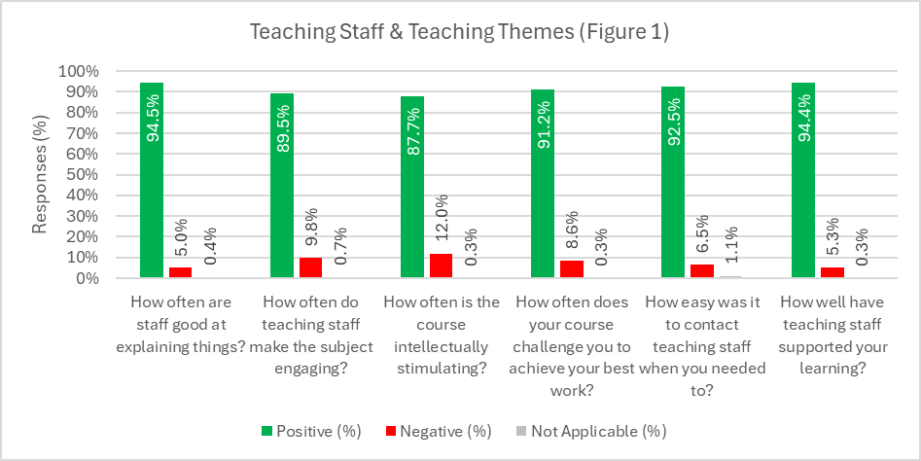

Learning Opportunities (Figure 2)
- Most respondents to the BGUSSS stated positive responses to the learning opportunities available to them, with five out of seven questions above 90% positive, and the other two between 83.5% and 87.1%. The lowest positive responses were regarding the balance of directed and independent study, albeit more than four out of every five respondents were positive.
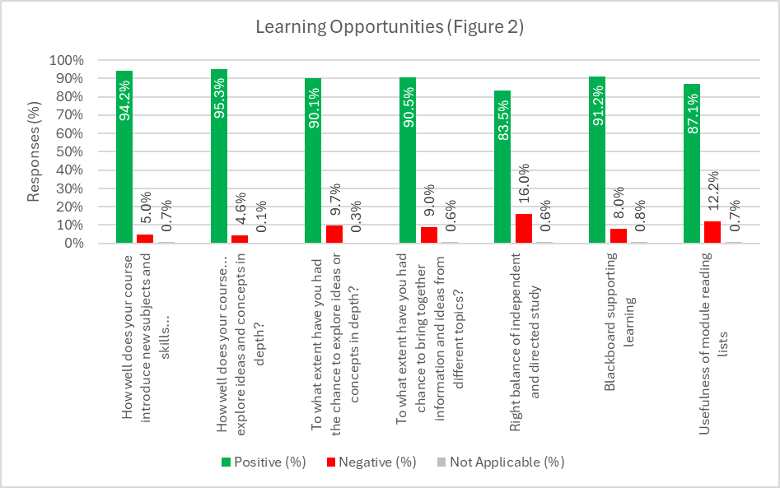

Student Support (Figure 3)
- Support provided to students covers areas such as Student Advice, Chaplaincy, personal tutoring, and mental health and wellbeing provisions.
- 88.9% of respondents gave positive responses regarding the availability of library services and other resources.
- However, 12.2% of respondents gave negative responses regarding personal tutoring, and 7.3% gave negative responses regarding the careers and employability service.
- The results for Chaplaincy, accessibility, counselling, and mental health support show a high level of ‘not applicable’ responses. Whilst it is important to note this high level of ‘non applicable’ responses, if these are put aside the results for these services are overwhelmingly positive, with very low levels of negative responses.
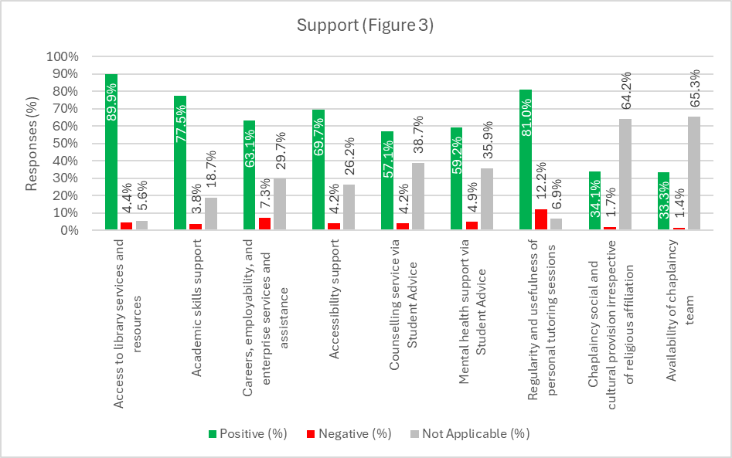

Campus & Community (Figure 4)
- 82.2% of respondents stated that they believe that they feel part of a community of staff and students at BGU, and that 91% of respondents would recommend BGU to a colleague, friend, or family member.
- 97.0% of respondents stated that the BGU campus is a safe and secure environment, with only 3.0% of respondents disagreeing.
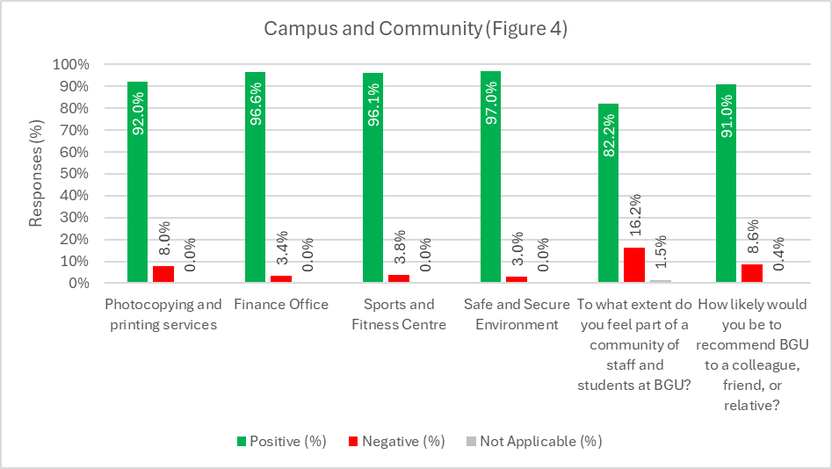

Access and Participation (Figure 5)
- Mature students report the highest overall satisfaction (3.42), exceeding the institution's average by 0.06. Younger students are the lowest-scoring group (3.31), 0.05 below the institution's average.
- BAME respondents are marginally above the institutional average, while white students align with the average. This is likely due to the high proportion of students who are classified as white.
- Male respondents (3.40) rate their experience slightly higher than female respondents (3.34).
- Students from the most deprived quintile (3.41) scored above the institutional average by 0.05, whilst those from less-deprived areas matched it (3.36). Equally, those from the lowest participation areas (POLAR Q1) scored slightly higher (3.38) than those from higher participation areas (3.37).
- The aggregated survey data indicate a stable and inclusive student experience across all APP groups, with only minor variation. Age appears to be the most differentiating factor, potentially warranting further exploration into how the learning environment, teaching style, or transition support could be enhanced for younger students. All other measures demonstrate broad equity of experience across the student population.
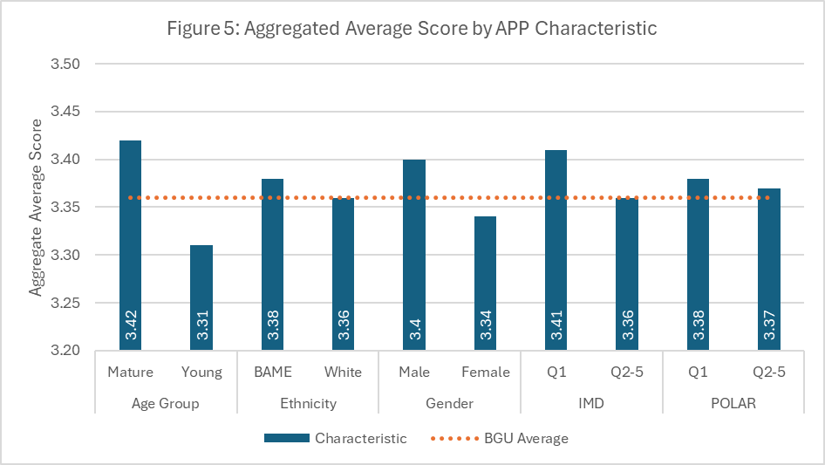

Access and Participation – by Key Themes (Figure 6a & 6b)
- Campus environment and Teaching Staff emerge as the most positively rated themes across the APP demographics. These results suggest effective teaching quality and a supportive learning environment.
- Course satisfaction and Student Voice consistently fall below the institutional average, which implies that there is scope for improvement in communication, curriculum coherence, and representation.
- BAME students show higher than average satisfaction across several themes (Disability, Campus, Resources, Teaching Staff), suggesting positive inclusion outcomes.
- IMD Q1 students generally score equal to, or above average, which suggests stronger levels of satisfaction for socio-economically disadvantaged students.
- Mature students consistently score above average, reinforcing the earlier findings (Figure 5) that they are the most positive cohort overall.
- Across all domains, the data portray a consistently equitable and positive student experience with limited variation between demographic characteristics. Institutional support appears particularly effective for mature, BAME, and IMD Q1 students, while Student Voice and Course satisfaction warrant targeted enhancement.
- Overall, the dataset suggests BGU’s inclusive practices are working well, maintaining parity in perceptions of quality and support among traditionally under-represented groups.
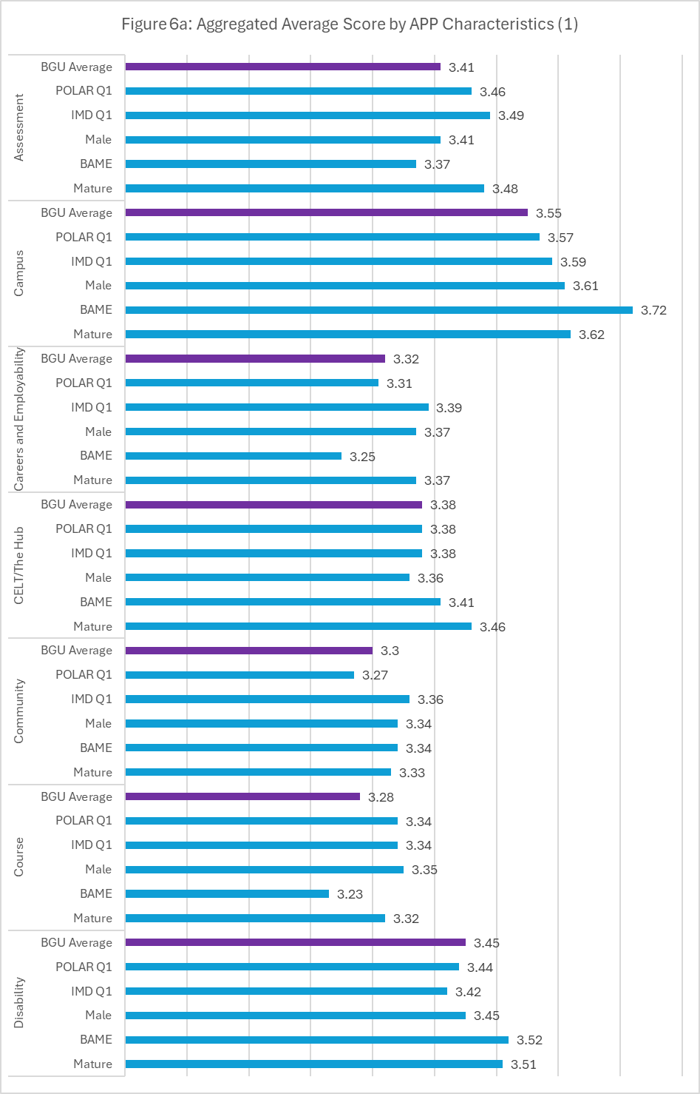
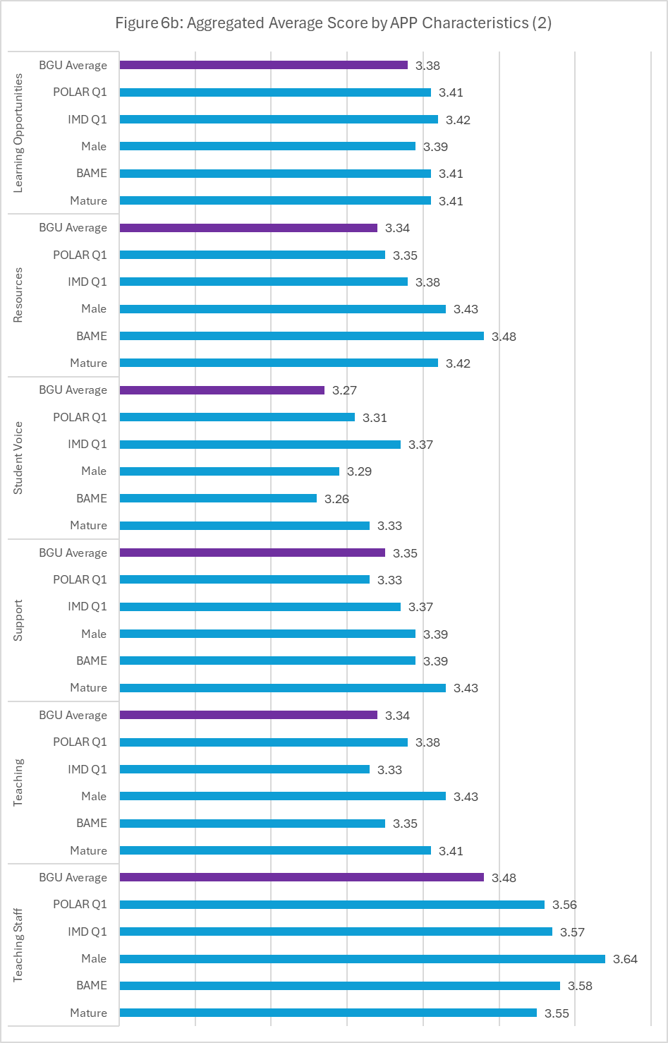

Graduate Outcome Survey
- The 2025 graduate outcomes survey tracks UK-domiciled students 15 months after they completed their awards. Outcomes recognise graduates as being in High-Skilled employment, further study, employed, unemployed, or other (travel, caring for someone or retired).

Institution overall
- For the 2022/23 graduating cohort, a total of 92% of respondents stated that they are either in employment or further study. This is the same as it was last year, and higher than the sector average (87%).
- Of these graduates entering employment, more than three-quarters of them are entering high- skilled employment (78.9%), which has moved above the sector average (76.8%) for the 2022/23 cohort.
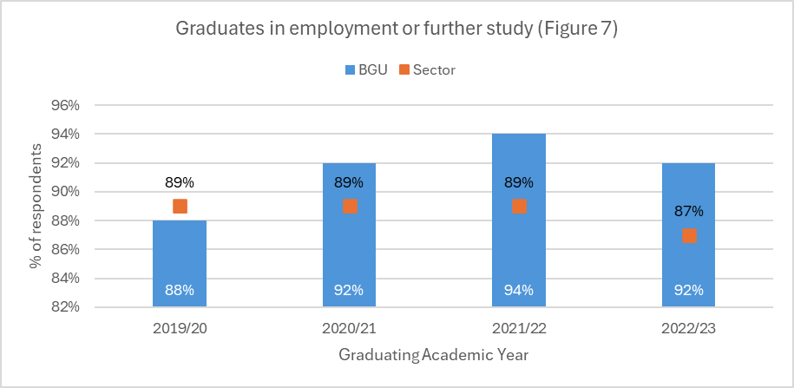
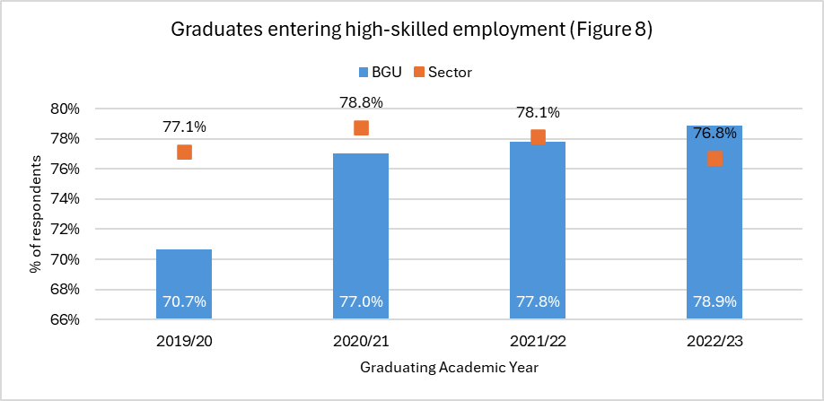
- The Graduate Outcomes Survey asks respondents to reflect on their work and study activity at the time of the census based on the utilisation of learnt skills, how their current activities fits in with their future plans, and whether they consider their current activities to be meaningful.
- For the 2022/23 graduating cohort 77% of respondents stated that they are currently utilising the skills they learnt during their course in their current activity, and this is higher than the sector average (67%).
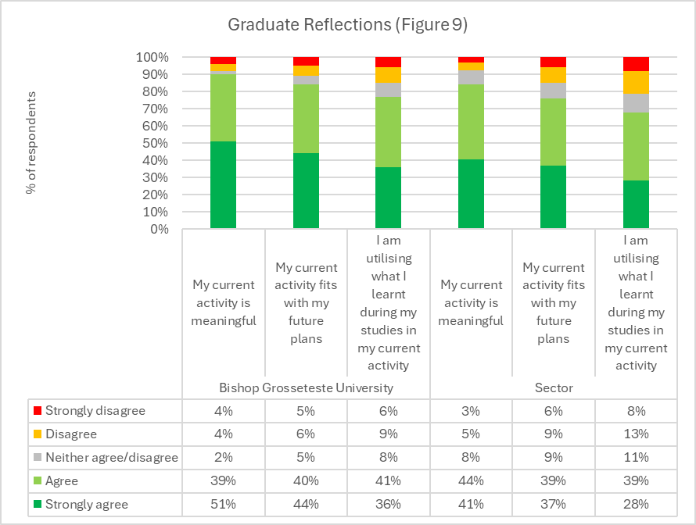
- Whether their current activity fits in with their future plans is indicative of whether the current activity fits in with the overall future plans of the individual, and this remains higher at 84% than the sector average (76%).
- The self-assessed meaningfulness of the current activity reflects the results of the previous two questions, again being above the sector average, with 90% of the 2022/23 cohort respondents stating their current activity is meaningful (sector: 85%).
- BGU continues to focus on programmes that lead into the education sector, with 60.9% of employed respondents stating that they are employed in sectors related to education compared to the sector average of 16.9%. The other sectors with higher than sector levels are “Administrative and support service activities” (+1.3%) and “Real estate activities” (+0.1%).
Graduates with a Known Disability
- Figures 10 to 12 show the Graduate Outcomes data for BGU graduates who declared a disability at the point of study. The data track outcomes over the past four years (2019/20–2022/23) and highlight the balance between those entering employment or further study and those not engaged in either activity.
- As shown in Figure 10, the proportion of disabled graduates in further study or employment has remained broadly stable, averaging 53.4% across the period. The highest outcome was recorded in 2021/22 (60%), followed by a return to 50% in 2022/23, mirroring post-pandemic labour market fluctuations. Although this represents a marginal decrease over time, the overall position remains comparable with national trends for disabled graduates.
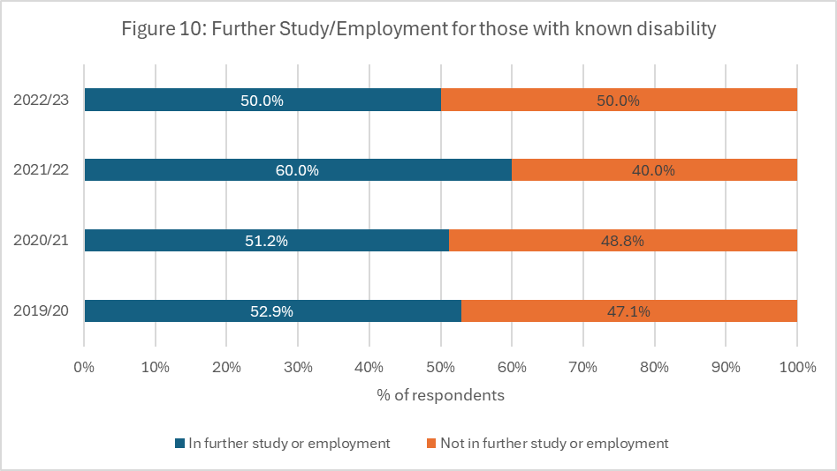
- Figure 11 illustrates the breakdown of primary activities for those in further study or employment. The largest destination continues to be full-time employment, although this has declined from 35.3% in 2019/20 to 28.9% in 2022/23. Smaller but stable proportions are engaged in part-time employment (around 6–8%), full-time further study (approximately 5–6%), and employment combined with further study (around 5%). This pattern suggests that disabled graduates are successfully transitioning into work or study, with some evidence of a shift towards flexible or blended arrangements that may better suit accessibility and wellbeing needs.
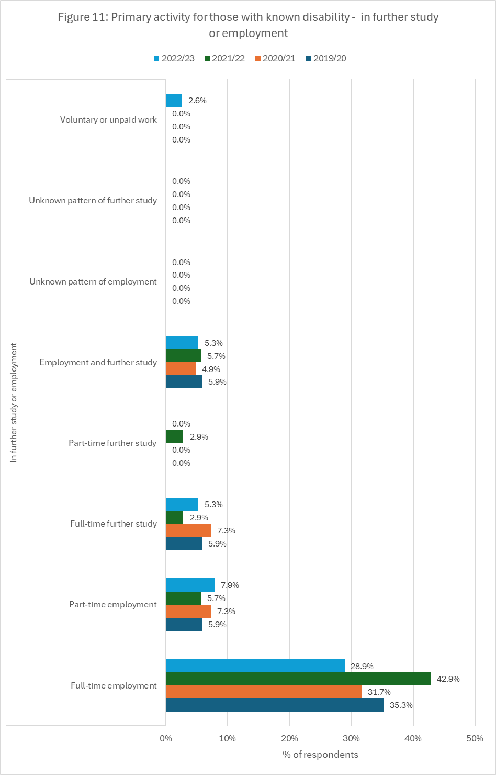
- For those not in further study or employment, Figure 12 shows that non-response rates have steadily increased from 32.4% in 2019/20 to 42.1% in 2022/23, limiting the reliability of longitudinal comparison. Within the reported group, unemployment has declined from 5.9% to 2.6%, while other activities such as travel, caring, or retirement have reduced from 8.8% to 5.3%. This suggests that most graduates not captured in employment or study outcomes are untracked rather than unemployed.
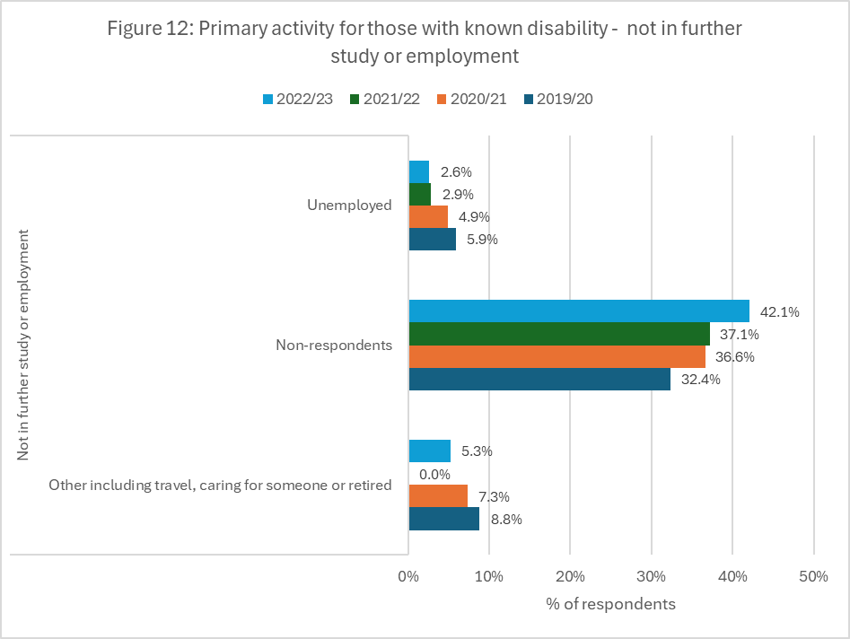
- Overall, the outcomes for graduates with a known disability demonstrate broad parity with the wider graduate population. Around half of respondents are in work or further study within 15 months, and the proportion entering high-skilled or meaningful employment aligns closely with institutional averages. Nevertheless, the decline in full-time employment and rising non-response rate highlight the need to continue strengthening employability support and follow-up engagement for disabled graduates, particularly in ensuring that flexible, accessible career pathways remain visible and well supported.
Table 1a: Standard Industrial Classification (SIC) - BGU vs. Sector Average
 | Accommodation and food service activities | Activities of extraterritorial organisations and bodies | Activities of households as employers; undifferentiated goods-and services-producing activities of households for own use | Administrative and support service activities | Agriculture, forestry and fishing | Arts, entertainment and recreation | Construction | Education | Electricity, gas, steam and air conditioning supply | Financial and insurance activities | Human health and social work activities
BGU | 2.8% | 0.0% | 0.0% | 5.6% | 0.0% | 2.8% | 0.0% | 71.8% | 0.0% | 0.0% | 5.6%
Sector | 4.1% | 0.0% | 0.1% | 3.4% | 0.3% | 3.5% | 2.3% | 16.4% | 0.6% | 4.0% | 22.3%
Difference | -1.3% | 0.0% | -0.1% | +2.2% | -0.3% | -0.7% | -2.3% | +55.4% | -0.6% | -4.0% | -16.7%

Table 1b: Standard Industrial Classification (SIC) - BGU vs. Sector Average (Continued)
 | Information and communication | Manufacturing | Mining and quarrying | Other service activities | Professional, scientific and technical activities | Public administration and defence; compulsory social security | Real estate activities | Transportation and storage | Unknown | Water supply; sewerage, waste management and remediation activities | Wholesale and retail trade; repair of motor vehicles and motorcycles
BGU | 0.0% | 1.4% | 0.0% | 0.0% | 1.4% | 2.8% | 0.0% | 0.0% | 0.0% | 0.0% | 4.2%
Sector | 5.4% | 5.2% | 0.3% | 1.5% | 12.1% | 7.6% | 1.2% | 1.5% | 0.7% | 0.4% | 7.2%
Difference | -5.4% | -3.8% | -0.3% | -1.5% | -10.7% | -4.8% | -1.2% | -1.5% | -0.7% | -0.4% | -2.9%

