Introduction
This report provides an overview of equality information for our staff and students. These data have been produced using Lincoln Bishop’s HESA returns, extracted from the HEIDI plus system. All numbers show full person equivalent (FPE) and have been rounded to the nearest five in line with HEIDI rounding methodology to ensure data protection particularly for those cohorts with small numbers.
As a widening-participation HEI (see Lincoln Bishop’s Access and Participation Plan Policies and Procedures | Lincoln Bishop University)) access and participation at Lincoln Bishop is not ‘a project with a minority of our learners’. Rather, it underpins and informs all that we do across the whole University.

Student profile
In 23/24 Lincoln Bishop had 2,375 students, of which:
- 47.2% of Lincoln Bishop students were young and 52.8% were mature (this is a 6-percentage point increase on 2022/23 mature student proportion which was 45.6%).
- 72% have no known disability and 28% have at least one disability. This is a decline in terms of the number and proportion of disabled students enrolled at Lincoln Bishop.
- In 23/24 71.3% of Lincoln Bishop students were white, this is a significant change to previous cycles, however the change is mainly due to an increase in the number of students whose ethnicity is classed as unknown or not applicable (22.5% in 23/24 compared to 5.6% in 22/23). The number of students classed as BAME rose 23/24 (from 3.7% to 6.1%)
- The largest change in terms of IMD quintile was in quintile 1 (most deprived) which rose from 325 (16%) in 22/23 to 625 in 23/24 (26.3%)
- Almost one third of enrolled students in 23/24 were from POLAR4 quintile 2, this is consistent with 22/23.

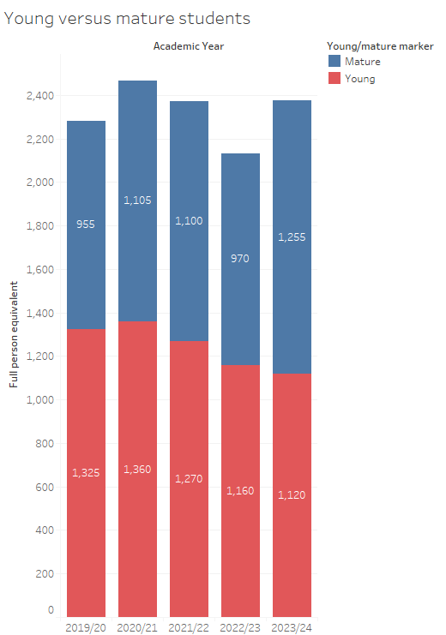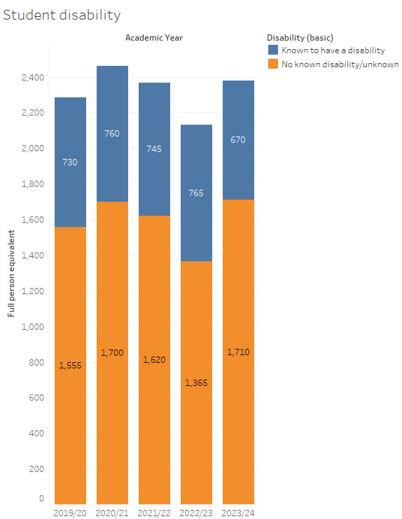
Graph 1: Young versus mature student breakdown (Source HEIDI Plus) Graph 2: Disability student breakdown (Source HEIDI Plus)
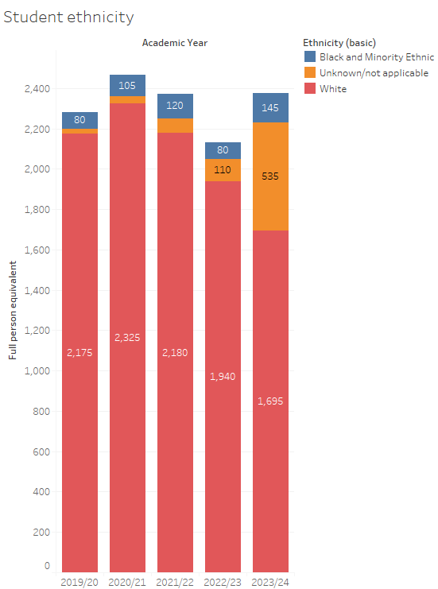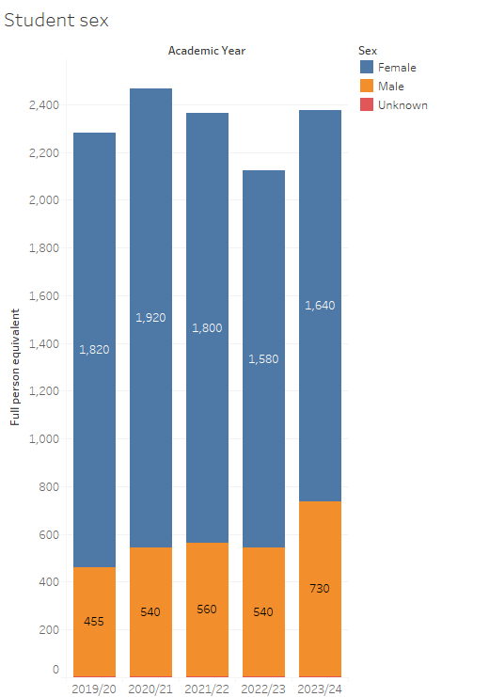
Graph 3 Student ethnicity (Source HEIDI plus) Graph 4: Student sex breakdown (source HEIDI plus)
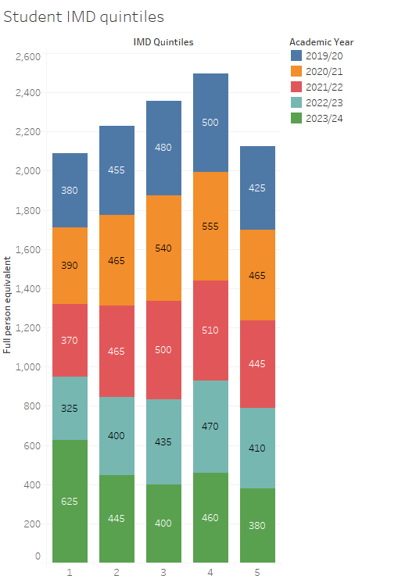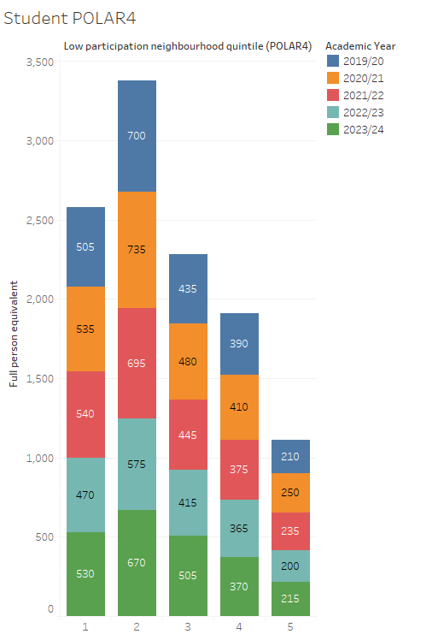

Graph 5: Student IMD quintile (source HEIDI plus) Graph 6: Student IMD quintile (source HEIDI plus)

Student Outcomes
In 23/24 405 students graduated from first degree programmes. Of this number 95 (23%) received first class honours, 185 (46%) received upper second-class honours, 110 (27%) received lower second- class honours and 15 (4%) received third-class honours. This means that 69% of Lincoln Bishop graduates received good degrees.

Looking at this data by characteristic:
- 26% of mature graduates received a first-class honours and 52% received upper second-class honours and 23% received lower second-class honours. This means that in 23/24 78% of mature graduates received a good degree compared to 66% of young graduates.
- 21% of graduates with a known disability received a first-class honours, 39% received an upper second-class honours, 32% received a lower second-class honours and 7% received third-class honours. This means that 60% of graduates with a known disability received a good degree compared to 73% of graduates with no known disability, a 13-percentage point gap.
- The data for BAME graduates is small in real terms (10 graduates of the 405 were from BAME backgrounds in 23/24, 2.5%). 50% of these graduates received an upper second-class degree and the other 50% received a lower second-class degree.
- 18% of male graduates received first-class honours, 35% received upper second-class honours, 41% received lower second-class honours and 6% received third-class honours. This means that 53% of male graduates received good degrees compared to 73% of female graduates in 23/24 a gap of 20-percentage points.
- 20% of graduates from IMD quintiles 1 and 2 areas received first-class honours, 43% received upper second-class honours, 30% received lower second-class honours and 7% received third-class honours. Overall, 63% of graduates from IMD quintiles 1 and 2 areas received good degrees compared to 72% of graduates from IMDQ 3 to 5, a gap of 11-percentage points.
- 25% of graduates from POLAR4 quintiles 1 and 2 areas received first-class honours, 40% received upper second-class honours, 30% received lower second-class honours and 5% received third-class honours. Overall, 65% of graduates from POLAR4 quintiles 1 and 2 areas received good degrees compared to 73% of graduates from POLAR4 quintiles 3 to 5, a gap of 8-percentage points.

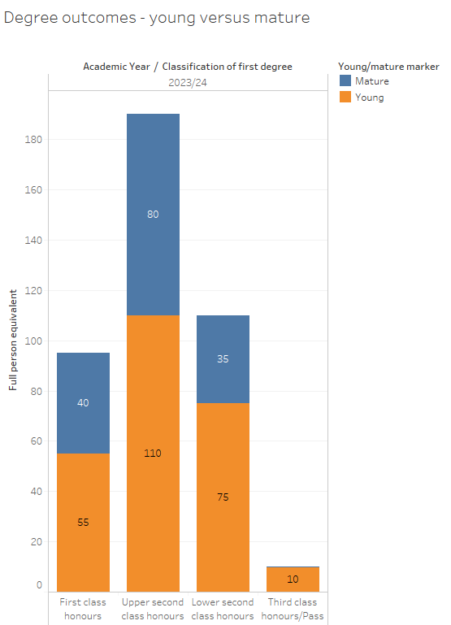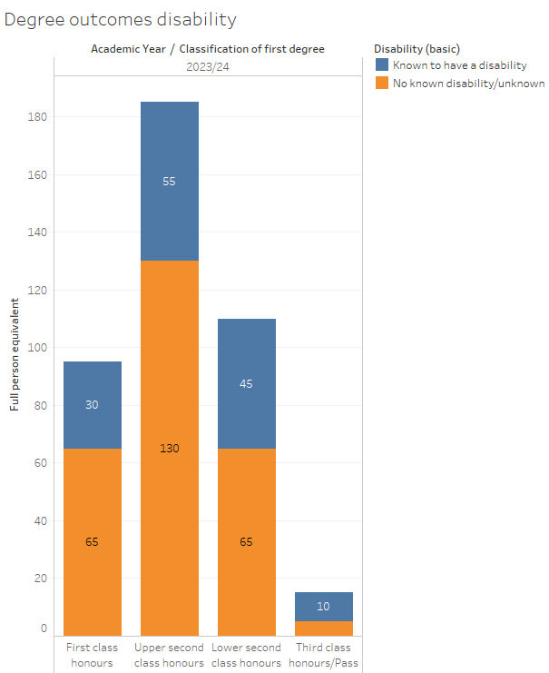
Graph 7: Young versus mature student outcomes (Source HEIDI Plus) Graph 8: Disability student outcomes (Source HEIDI Plus)

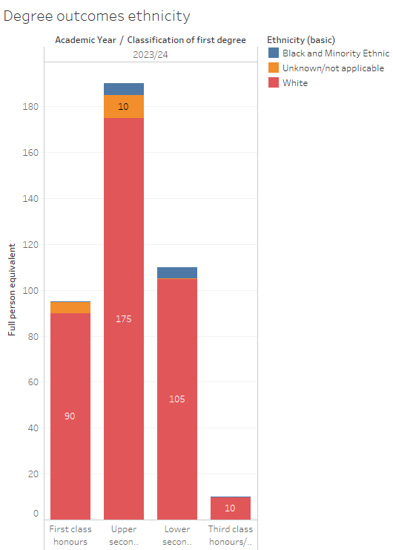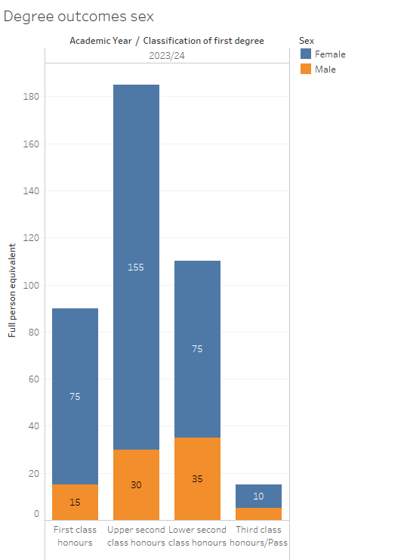
Graph 9 Ethnicity student outcomes (Source HEIDI plus) Graph 10: Sex student outcomes (source HEIDI plus)
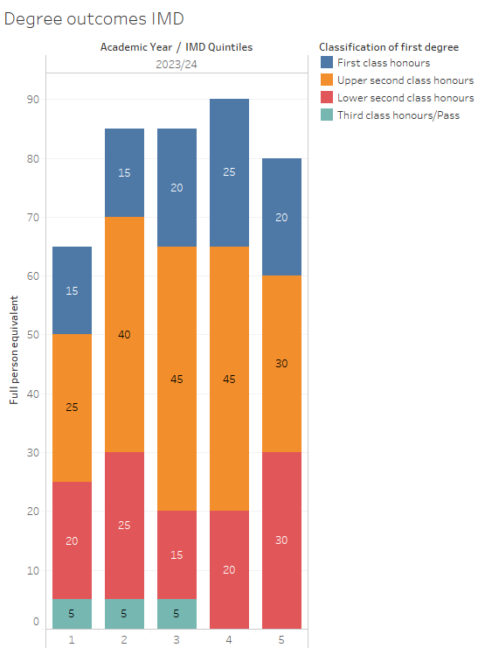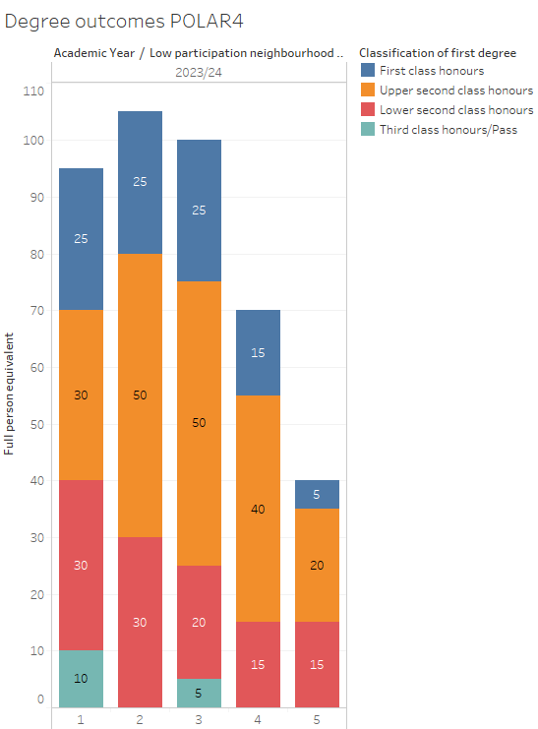

Graph 11: IMDQ student outcomes (Source HEIDI plus) Graph 12: POLAR4 student outcomes (source HEIDI plus)

Staff Profile
In 23/24 35% of all staff were male, this is in line with the previous year, despite a slight numerical increase. The proportion of male academic staff members decreased from 37% in 21/22, to 34% in 22/23 and 33% in 23/24.
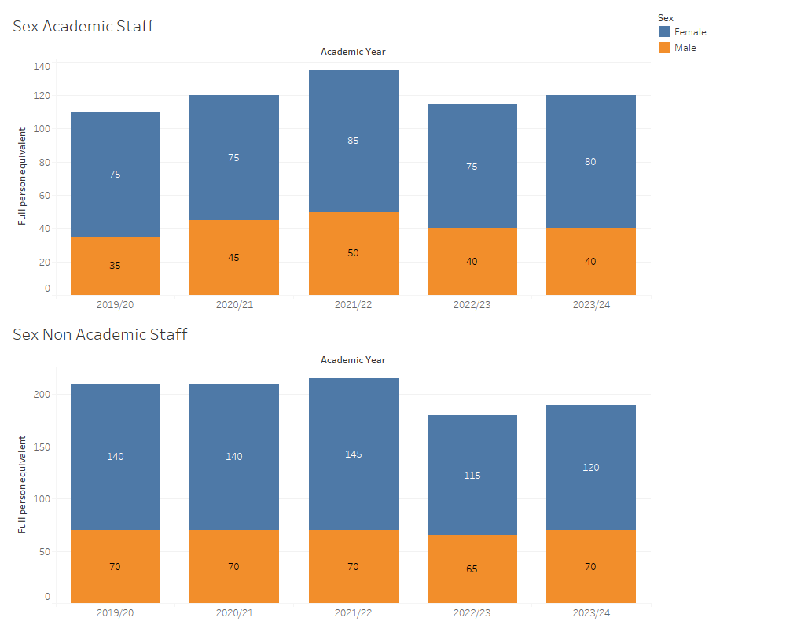
Graph 12 (Source HEIDI Plus via HESA data)
In 23/24 93.6% of all staff were white. The remaining 6.4% of staff were split evenly across Asian, Black, Mixed and Other. This is in line with 22/23 averages, but a decrease from 21/22 when 91.5% of all staff were white and 8.5% were from other BAME communities. The proportion of BAME academic staff was 11.5% in 23/24 whereas the proportion of BAME non-academic staff was 5.3% in the same year.
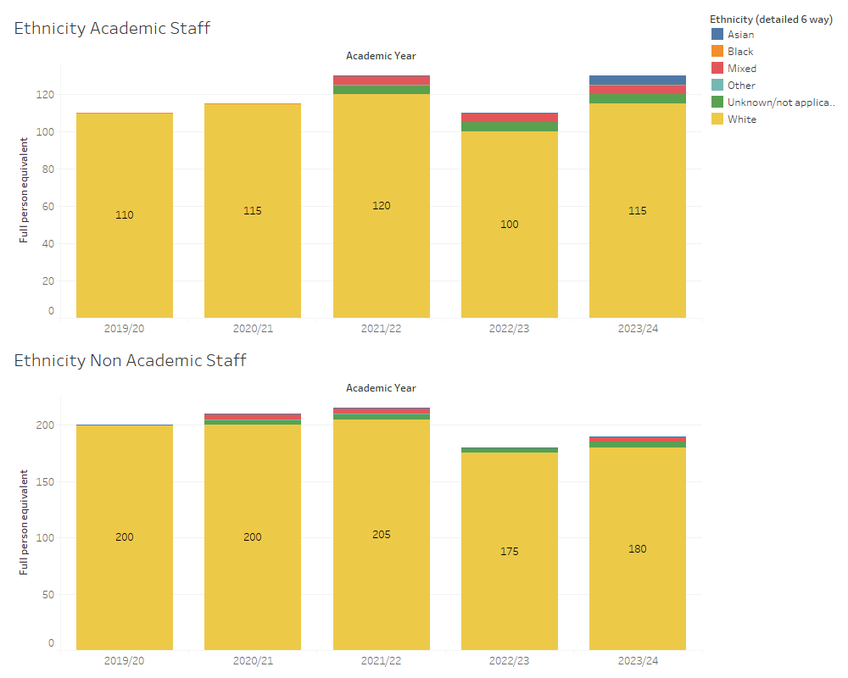
Graph 13 (Source HEIDI Plus via HESA data)

In 23/24 11% of all staff members were known to have a disability, this is in line with the previous year.
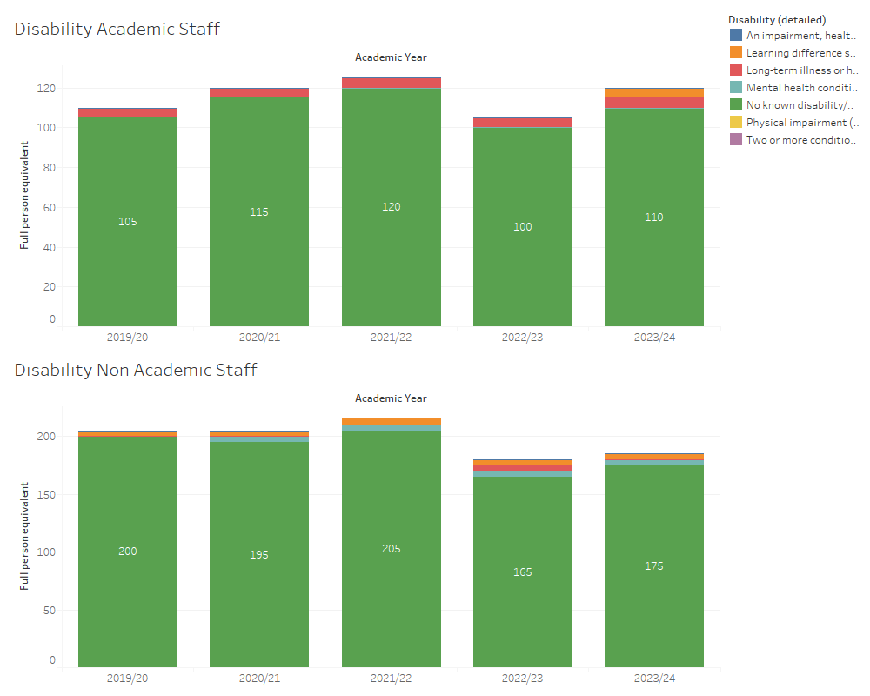
Graph 14 (Source HEIDI Plus via HESA data)

In 23/24 33% of all staff were aged between 36 to 50 years of age, 38.7% were between 51 and 65 years of age. These trends broadly reflect previous years, there are no obvious distinctions between academic and non-academic staff groups.
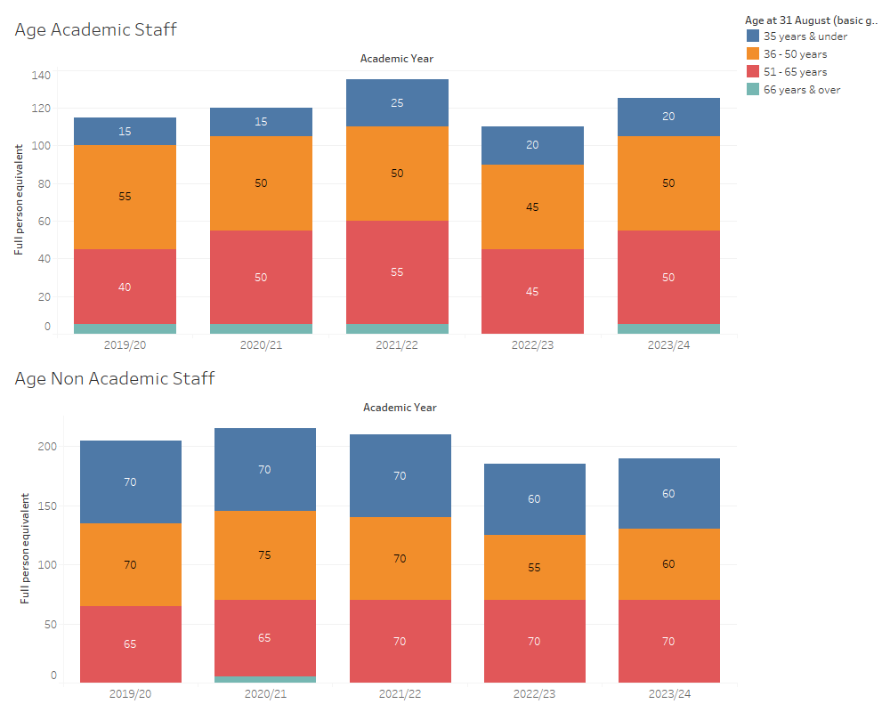

Graph 15 (Source HEIDI Plus via HESA data)
The table below shows the number of job applicants during the 2023/24 academic year by characteristic and stage of the job application process that they reached.

2023/24 Lincoln Bishop job applicants |  | Number of Applications | % Applied | Number of Applications Shortlisted | % Shortlisted from All Applications | Number of Offers | % Offered from All Applications
Sex | Male | 334 | 44% | 132 | 40% | 40 | 12%
Sex | Female | 409 | 54% | 159 | 39% | 56 | 14%
Sex | Other | 3 | 0% | 1 | 33%
Sex | Information Not Provided/Unknown | 13 | 2% | 3 | 23% | 1 | 8%
Ethnicity | Unknown | 759 | 100% | 295 | 39% | 97 | 13%
Disability | Disabled | 96 | 13% | 51 | 53% | 15 | 16%
Disability | Information Not Provided/Unknown | 17 | 2% | 7 | 41% | 4 | 24%
Disability | Not Disabled | 605 | 80% | 228 | 38% | 74 | 12%
Disability | Prefer not to say | 41 | 5% | 9 | 22% | 4 | 10%
Age | Under 21 years old | 59 | 8% | 18 | 31% | 7 | 12%
Age | 21 to 25 years old | 127 | 17% | 57 | 45% | 16 | 13%
Age | 26 to 30 years old | 106 | 14% | 42 | 40% | 13 | 12%
Age | 31 to 40 years old | 194 | 26% | 66 | 34% | 20 | 10%
Age | 41 to 50 years old | 139 | 18% | 50 | 36% | 22 | 16%
Age | Over 50 years old | 121 | 16% | 59 | 49% | 18 | 15%
Age | Age Unknown | 13 | 2% | 3 | 23% | 1 | 8%
Religion | Christian | 215 | 32% | 80 | 37% | 22 | 24%
Religion | No religion | 308 | 46% | 134 | 44% | 48 | 52%
Religion | Other | 100 | 15% | 31 | 31% | 14 | 15%
Religion | Unknown | 42 | 6% | 22 | 52% | 8 | 9%
Gender identity | Prefer not to say | 21 | 3% | 5 | 24% | 2 | 10%
Gender identity | Same sex as at birth | 708 | 93% | 283 | 40% | 92 | 13%
Gender identity | Same sex as at birth - no | 17 | 2% | 4 | 24% | 2 | 12%
Gender identity | Same sex as at birth - Unknown | 13 | 2% | 3 | 23% | 1 | 8%
Sexual Orientation | Bisexual | 60 | 7.91% | 20 | 33.33% | 5 | 8.33%
Sexual Orientation | Gay Woman | 11 | 1.45% | 4 | 36.36% | 2 | 18.18%
Sexual Orientation | Heterosexual or straight | 574 | 75.63% | 234 | 40.77% | 78 | 13.59%
Sexual Orientation | Information Not Provided/Unknown | 13 | 1.71% | 3 | 23.08% | 1 | 7.69%
Sexual Orientation | Not available | 20 | 2.64% | 9 | 45.00% | 1 | 5.00%
Sexual Orientation | Other sexual orientation | 20 | 2.64% | 9 | 45.00% | 2 | 10.00%
Sexual Orientation | Prefer not to say | 61 | 8.04% | 16 | 26.23% | 8 | 13.11%
Fig. 1 (Source – Stonefish data)

