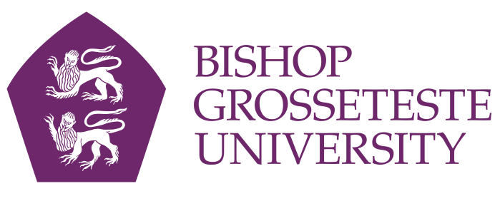

Erasmus+ Contact and Information Sheet 2020-2021
Full Name of Institution: | Bishop Grosseteste University (BGU)
ERASMUS+ I.D CODE: | UK LINCOLN 01
Institution Website: | www.bishopg.ac.uk  www.bishopg.ac.uk/international
Head of Institution: | Reverend Canon Professor Peter S. Neil, Vice-Chancellor
Address: | Bishop Grosseteste University  Longdales Road  Lincoln  LN1 3DY
Telephone: | + 44 (0) 1522 527347
ERASMUS+ Contacts: | Mr Wayne Dyble  International Manager  Tel: + 44 (0) 1522 563806  Email: wayne.dyble@bishopg.ac.uk / international@bishopg.ac.uk  Ms Sophie Saunders  Executive Assistant to the Pro Vice-Chancellor (supporting the Erasmus+ Programme as Erasmus+ Administrator)  Tel: + 44 (0) 1522 583632  Email: international@bishopg.ac.uk
Semester Dates: | Semester 1 - Autumn 2020  Monday 28 September 2020 – Friday 29 January 2021  Recommended arrival dates: Saturday 19 September 2020 - Sunday 27 September 2020  Christmas holiday: Saturday 19 December 2020 – Sunday 3 January 2021  Exam Week: Monday 25 January 2021 – Friday 29 January 2021
Semester 2 - Summer 2021
Monday 1 February 2021 – Friday 21 May 2021

Recommended arrival dates: Wednesday 27 January 2021 – Sunday 31 January 2021
Easter holiday: Saturday 27 March 2021 – Sunday 11 April 2021
Exam Week: Monday 17 May 2021 – Friday 21 May 2021

ERASMUS+ Application Deadlines: | Semester 1: Friday 29 May 2020  Semester 2: Friday 27 November 2020  Nominations for participation in the ERASMUS+ mobility programme must be sent by home institutions to international@bishopg.ac.uk by the deadline dates stated above.
Programmes of study available to incoming ERASMUS+ students: | Most live undergraduate courses (with the exception of programmes featuring a Foundation Year, programmes featuring Qualified Teacher Status [QTS], and Apprenticeships)
ERASMUS+ Accommodation: | Students usually have access to on-campus accommodation in either Constance Stewart Hall or Wickham Hall. BGU’s Accommodation team contact Erasmus students directly ahead of their mobility programme to make accommodation arrangements.

About BGU
Bishop Grosseteste University (BGU) has been educating students in the historic heart of the City of Lincoln for over 150 years, located on a beautifully green and pleasant campus just a few minutes’ walk from Lincoln Cathedral, Castle and the old Roman city. We’re set on a single-site campus, so just about everything you need is close by.
We began life in 1862 as an Anglican teacher training college for women. In 2012 we achieved full university status. In recent years we’ve undergone an explosion of growth in many areas, remaining a small and friendly university whilst expanding and developing our portfolio of courses into more exciting new areas than ever before. We still consider ourselves experts in education but our teaching courses now sit alongside an exciting range of other disciplines. We currently educate over 2,000 students in a wide range of subjects – within our expanding undergraduate portfolio, our traditional PGCE teacher training routes, work-based Foundation Degrees, Masters courses and even Doctoral study (and much more in between). We pride ourselves on being a supportive community, always striving to improve the lives of our students.
We’re exceptionally proud of the fact that, over the past 150 years, our commitment to first-class education has remained consistent. Our students are some of the happiest in the UK, which is incredibly important to us. We really care about our students and aim to support them all of the way through their studies, from application to graduation.

