Certificate in Education, Training and Skills (Cert ETS)

Professional Graduate Diploma in Education, Training & Skills (pGD ETS)

Handbook 2021-22

Welcome to Bishop Grosseteste University
We hope you will enjoy this programme and that it will provide you with an opportunity to deepen your knowledge and develop your teaching practice, so that you become an inspirational educator who leaves a positive impact on all those who you teach.

A little bit about the Cert ETS and pGD ETS:
This programme offers education and development to aspiring teachers and trainers in the education, training and skills sector such as further education (FE) colleges, private sector training providers and the criminal justice system (offender learning/prison education). This is a pre-service qualification therefore you, and everyone else enrolling on it, are likely to be new to the teaching profession. You will spend one day a week (Fridays) attending sessions at the University; the rest of the week you will be in placement, undertaking a variety of activities to provide you with the opportunity to further develop knowledge and skills, to gain vital experience of working as a teaching practitioner within the Further Education sector.

What does this course offer you?
The programme will develop your knowledge and understanding of the principles and practice of teaching, assessment and learning, and wider professional engagement in the sector. It will offer a challenging, supportive and rewarding experience to promote informed, reflective practice, which will support effective teaching and professional development. There are three tailored pathways for you to follow allowing you to specialise in areas relevant to your experience and career aspirations; these pathways are teaching a specialist subject in education and training, teaching English in education and training or teaching maths in education and training

Who is this qualification for?
You and your peers on this programme will be qualified professionals in your subject area, who are completing this programme full time. You will have been allocated to an appropriate placement in order that you have at least 100 hours of teaching practice available to you; this will be within your subject area and should be with post-14 year old learners.

You will be allocated an appropriate mentor within your placement. Your mentor will play a significant role in your professional development as they will work alongside you to support your development. Your mentor will ideally be a fully qualified teacher/trainer within your setting who has subject specific knowledge. Your mentor will be expected to meet with you regularly, attend mentor and triangulation meetings, undertake observations of your teaching practice, offer advice and support to you and fulfil all the other expectations as defined in the mentor agreement.

How is the programme assessed?

You will be assessed in a variety of ways to demonstrate you have both the
underpinning knowledge and the practical skills needed to be an effective, reflective
practitioner.

Academic work will be assessed using a range of assessment strategies; these may include presentations, analytical case studies, essays, academic posters etc.

There are typically three assessments per module and the module brief will clearly explain the learning objectives, the assessment strategy and criteria and task weighting within each module. All modules are graded as pass/fail only, however, you will be provided with a grading criteria matrix to show you how your tutor/assessor has arrived at their decision; you must achieve a minimum mark of 40 to gain a pass.

Observed teaching practice forms part of the assessment in three of the four modules
(ETS401/601, ETS502/602 & ETS504/505/506/604/605/606) you will cover the year. You will have a minimum of eight observations over the period of your programme. These will be conducted by your course tutor and your subject specialist mentor. You will be expected to engage in reflective practice and coaching dialogue before and after these developmental observations as well as providing other evidence of your planning (scheme of work, lesson plan etc.) and delivery (copy of resources). These observations will not be graded; however, you must demonstrate you have met the learning objectives set for each observation. Your course tutor will provide verbal feedback, which will follow a coaching model where you will engage in professional discussion with the aim of identifying your own areas for development. Following this discussion, you will receive written feedback from your course tutor where they will state the extent to which each outcome was met, i.e. not met, satisfactorily met, met well etc.

You will also build a professional development portfolio (PDP) throughout your programme. In this you will log your reflective accounts, peer observations, personal development plan and targets, you will store records of your engagement with the Education and Training Foundation (ETF) 2014 Professional Standards self-assessment tool at the start, mid-way and end of the year, as well as keeping evidence of your teaching practice (schemes of work, lesson plans, assessment plans, resources, learner feedback etc.) and your CV. This will be assessed throughout the course and submitted for final review at the end of the programme.

What after Cert ETS and pGD ETS?
On successful completion of this programme, both Cert ETS and pGD ETS graduates will be
eligible to apply for Qualified Teacher Learning and Skills (QTLS) via the Society for
Education and Training (SET). All graduates will be prepared to teach in the FE & Skills sector. They will be qualified to teach in FE colleges, secondary schools (although only pupils post-14 until QTLS attained), sixth form colleges, academies, training providers, offender learning/prison.

More information regarding QTLS may be found on the Society for Education and
Training website – see URL below;

https://set.et-foundation.co.uk/professionalism/qtls/

*** Free membership to the Society for Education and Training? ***

Whilst you are on your teacher training course you can benefit from free membership
to the Society for Education and Training. Apply for this using the URL below or scan the
QR code and you will be directed straight to the website.

https://set.et-foundation.co.uk/membership/free-student-membership-offer/#
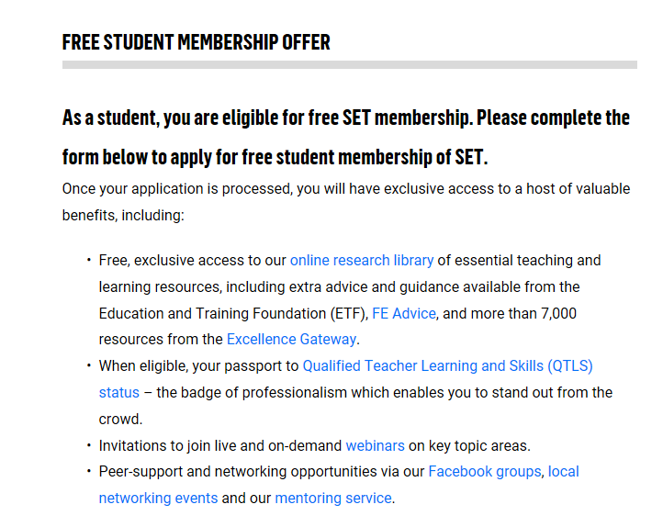

Assessment Policy

Quality Assurance
To ensure that you have access to fair and objective assessment throughout the programme, all assessments are subject to rigorous monitoring both within the University, within the collaborative partnership of BGU, Lincoln College and New College Stamford (via cross-moderation activities) and by the External Examiner.
Plagiarism
It is unacceptable to submit the work of others in assignments (either directly or by paraphrasing) without acknowledging it. Your tutor reserves the right to check your assignments electronically if plagiarism is suspected. Plagiarism is considered as academic misconduct, and will be subject to Student Disciplinary Procedures. On submission of your assignment you will be required to declare that the work is your own and all sources have been properly acknowledged (APA 7th referencing).
Assignment Submission
Assignments should normally be submitted according to the Schedule issued at the beginning of your course/module. Academic assignments will normally be submitted via Turnitin.

Special Circumstances
If the need arises, you may negotiate an extension to the hand-in date of an assignment with your tutor. All requests for extensions must be submitted for approval at least one working day before the published deadline. Such claims must be on the standard extension form and must be accompanied by corroborating evidence. Penalties will be applied in accordance with the BGU Code of Practice for the assessment of students if work is submitted late and work submitted more than 24 hours after the deadline will receive a mark of zero.

Return Date

Your work will be returned with personalised written feedback 20 working days from the date of submission.

Assignment Submission Guidance

Presenting your work is a very important academic skill. It is also a practical necessity for a tutor, who receives large numbers of assignments, to be able to see whose is whose! Please follow these guidelines:
- Use a header with your Student Number and the module number.
- Start with the title of the piece.
- Use minimum 12 font and 1.5 line spacing, except for leaflets/ posters (for these, use your best judgement).
- Use page numbers as footer.
- Follow the library advice / guidance on referencing; you need to show your wider reading and research. APA 7th referencing style is required.
- Save the document as follows: your student number, the module number, the task/assessment number e.g. B1234567602Task1.doc. If you have to resubmit, make that clear e.g. B1234567602Task1resub.doc
- Check your work against the required criteria, and proofread carefully.
Completed academic assignments should be submitted electronically via Turnitin where appropriate.

Course structure
The Cert ETS and pGD ETS, is an integrated programme for teachers and trainers within the diverse sector that is post-14 education and training. This integrated programme has a shared delivery model with differentiated outcomes for trainees on Level 5 Cert ETS and Level 6 pGD ETS.

In each semester you will complete two modules. The first two modules (Semester 1) will introduce you to the learning and skills sector, associated policies and professional expectations. These modules will also ensure you have all the ‘tools’ required to engage effectively with teaching practice and, for those who already have teaching experience, will enhance your ‘tool kit’ by providing you with greater understanding of the underpinning theories and introduce you to innovative and evidence base practice.

In Semester 2, you will have the opportunity to explore more deeply the philosophies of the role of a teaching professional, curriculum design and the subject-specific characteristics of teaching and learning in your chosen subject area, whether vocational, academic, maths or English.
All modules carry a value of 30 credits. Modules 1 to 3 are core modules; module 4 is a pathway module where you choose one from the 3 options.
 | September | January
Semester 1 | ETS401/601: Learning, Teaching and Assessment in the Education and Training Sector | ETS502/602: Responsive Teaching in the Education and Training Sector
Semester 2 | ETS503/60303: Professional Engagement in the Education and Training Sector | ETS 504/505/506 or ETS 604/605/606: Teaching a Specialist Subject or English or Maths in the Education and Training Sector

Each module will be assessed through a combination of assignments, which will be used to demonstrate your academic understanding, alongside practical observations of your teaching/training so you are able to demonstrate that you can apply theory to your practice. There are clear learning outcomes for each module and each assessment within it; these will be included on your assignment brief so you are able to ensure you cover the criteria sufficiently.
Key programme dates:

- Programme start 3 September 2021.
- Half-term: (Independent Study) 25-29 October 2021.
- Christmas: 20 December – 3 January 2020; last University day of attendance is Friday 17 December 2021; first University day is Friday 7 January 2022, though the placement will probably recommence on 3/4 January 2021.
- Half-term: (Independent Study) 14 – 18 February 2022.
- Easter: April 4 – 18 April 2022.
- Public Holiday 2 May 2022.
- Half-term (Independent Study) 30 May – 3 June 2022.
- Programme ends 24 June 2022.
- Graduation July 2022.

Microsoft Teams

Microsoft Teams is a chat-based collaboration tool that gives large, dispersed and remote teams the ability to work together and share information in a collaborative and common space.
We would like to encourage you to engage with Microsoft Teams throughout your programme. It allows you to extend your studies outside of the learning environment and create your own community of practice. These are vital elements in any education and training programmes.
All of the teaching staff will be active participants in Microsoft Teams. You will have access to a chat feature to raise questions and share resources with your staff and peers.
As a student of BGU you will have free access to Outlook 365. Therefore, you will all be able to be added to the pGD ETS 2020-21 Microsoft Team and use this at home. You can download the app for your mobile devices for free.
A full induction to Microsoft Teams will be provided.

Scan this code to learn more about Microsoft Teams

https://docs.microsoft.com/en-us/microsoftteams/teams-overview

Good luck in your studies

We hope you enjoy the programme

