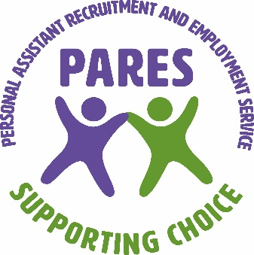
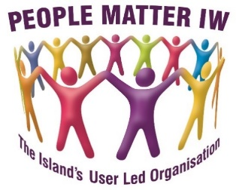

PARES (Personal Assistant and Recruitment Employment Service)

INFECTION CONTROL ANNUAL STATEMENT 2023

PURPOSE
This annual statement will be generated each year in January. It will summarise:
- Any infection transmission incidents and any action taken (these will have been reported in accordance with PARES Infection Prevention and Control Policy.
- Details of any infection control audits undertaken, and any actions taken.
- Details of any infection control risk assessments undertaken.
- Details of staff training
- Any review and update of policies, procedures and guidelines

BACKGROUND
Terri Baker – Registered Manager and Carla Evemy PARES Officer/ Nominated Person are responsible for ensuring PARES staff have the appropriate infection control training. They also share any information with the staff via supervision meetings or emails.

SIGNIFICANT EVENTS
Between 1st January 2021 – December 31st, 2021. The Coronavirus (COVID-19) pandemic is currently an ongoing local, national and international event. PARES and People Matter IW regularly review and update policies and procedures to ensure the safety of staff and service users.

AUDITS
An Infection Control Audit was carried out on 23.01.2023 with the next advised for January 2024. This can be carried out at any time due to ongoing changes.
To ensure our clients are fully informed of our Infection Control audit outcomes a copy of this annual statement will be placed on our website. We will also notify staff of any information they may need to be aware of when supporting our clients This will be communicated via information emails, telephone calls, texts and WhatsApp.

PARES Infection Control Summary
Any cases of Covid-19 have been reported to PARES in the required timescale and acted upon to ensure the clients and staff have been advised on the appropriate course of action.
An infection control audit was undertaken on 23.01.2023 No actions were required as policies and risk assessment s are regularly reviewed and updated to ensure the safety of staff and service users.
Infection Control Risk Assessments are undertaken as a part of the initial PARES Risk and Positive Outcomes Assessment. Covid-19 has been incorporated in to the main risk assessment under No 3 Infection Prevention and Control. Advice for when Covid -19 is reported is updated in line with GOV.UK and NHS advice. Last updates were:
23.12.2022 GOV.UK advice on use of Facemasks/PPE
24.08.2022 GOV.UK Advice on Covid-19
01.07.2022 NHS Advice on reports of a positive Covid Test result.
All staff have mandatory online Infection Control training via Care Skills Academy. Due to the pandemic all PA training has been reviewed and updated to include Hand Hygiene and Personal Care(if the PA provides Personal Care support). We have introduced using a UV light box as part of the training to demonstrate effective handwashing procedures.
To ensure the health and safety of staff and service users some staff have been asked not to work if they have come into contact with a person who has Covid-19. This is assessed on an individual basis especially if the client is assessed as being highly vulnerable.
PPE (Personal Protective Equipment) disposable masks, gloves, aprons, face shields, antibacterial wipes and disposal bags have been readily available.
Lateral Flow and PCR tests were routinely carried out until GOV.UK and Department of Health advice informed us we could pause it. LFT tests are still available for staff if they are symptomatic.
All staff have been encouraged to take up the Covid-19 boosters and seasonal flu vaccinations.
PARES is recording and reporting information to the relevant organisations including Local Authority and the national Capacity Tracker(daily).
The PARES Infection Prevention and Control Policy is in place with additional policies to support it:-
Hand Hygiene
Service User Placement Assessments
Personal Protective Equipment
Respiratory and Cough Hygiene
Safe Disposal of Waste
Safe Management of Blood and Body fluids
Safe Management of Care Equipment
Safe Management of Sharps and inoculation injuries
Safe Management of the Care Environment
COVID-19 Compliance and Pandemic

Statement written by Carla Evemy – PARES Officer/Nominated Person
Statement approved by Terri Baker – Registered Manager

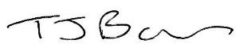
Signed: CARLA EVEMY Dated: 23.01.2023
Signed: TERRI BAKER Dated: 23.01.2023

