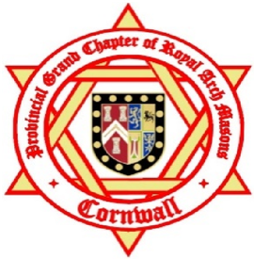
Royal Arch Chapter of Cornwall
Exit Form - Confidential
Please complete this form whenever a Companion leaves a Cornwall Royal Arch Chapter.
Chapter Name and No._________________________________________________________________
Surname ________________________________ Forenames ________________________________
Address _______________________________________________________________________________________
______________________________________________________________________________________________
Telephone No. ___________________________ Date of Birth_________/__________/__________
Date Exalted or Joined __________/__________/__________
Date of leaving __________/__________/__________
Reason. Please tick alongside
Resigned Ceased Membership Excluded Deceased Honorary
Reasons for leaving. Please tick alongside any that apply and underline the main reason
Health Personal Moved
Finance Work Disputes
Not for me Meetings Disillusioned
Family Travel Ritual
Not reported Other
Would he consider joining another Chapter? (Please tick)
Yes, in this Province Yes in another Province No

Signed ______________________________ Scribe E Signed ______________________________MEZ
Date __________/__________/__________
Any further comments may be written on the reverse.
Please return to, Trevor Conroy, Trehane, Church Lane, Helston, Cornwall, TR13 8PF
Or Email to cornwallsce@btinternet.com

