

PRESS KIT

**September 2018**

Holt Energy Advisors Ltd

Holt Energy Advisors Ltd (“HEA”) is a boutique energy advisory company delivering expert commercial consulting and transaction advisory solutions to the oil and gas and renewables sectors. HEA was formed in 2018 and provides the following services covering the oil and gas upstream production and renewables sectors.

* Acquisition and Due Diligence Services
* Divestments
* Commercial Advisory
* Economic Analysis
* Hydrocarbon Marketing
* Strategy Consulting
* Training

Based from its Canary Wharf office the HEA team provides services to listed and unlisted corporate clients, national governments, joint venture groups, banks and other advisors as well as industry trade groups globally.  
  
The HEA team have collective experience of over 40 completed transactions in the energy sector valued at over $5.5 billion covering 16 countries globally with due diligence projects completed in a further 21 countries.

Our Address: **5 Harbour Exchange Square, Canary Wharf, London, E14 9GE**

Telephone: **+ 44 (0) 203 916 0101** Email: [enquiries@holtenergyadvisors.com](mailto:enquiries@holtenergyadvisors.com)

Media Enquiries: [media@holtenergyadvisors.com](mailto:media@holtenergyadvisors.com)

Logo and Colour Palette

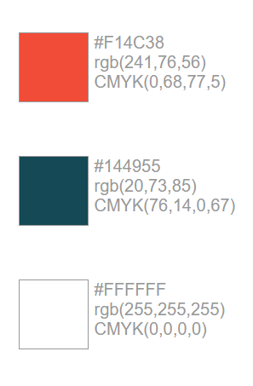

Logo with Border (Small)

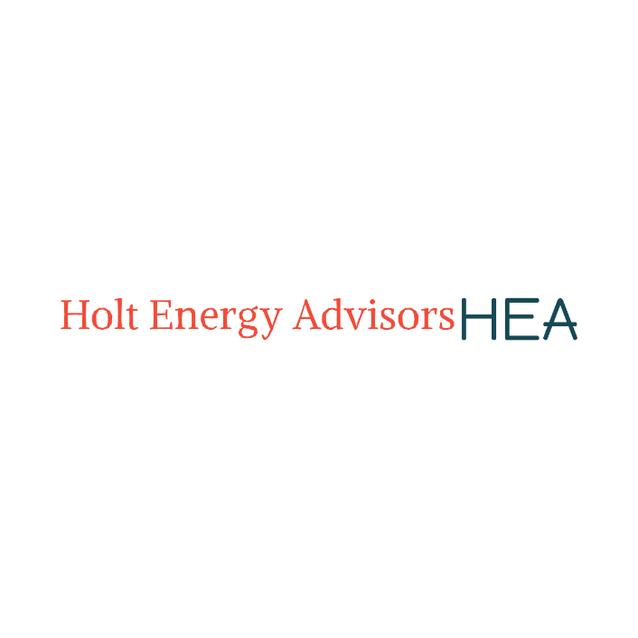

Cropped Logo (Medium)



Cropped Logo (Large)



Stacked

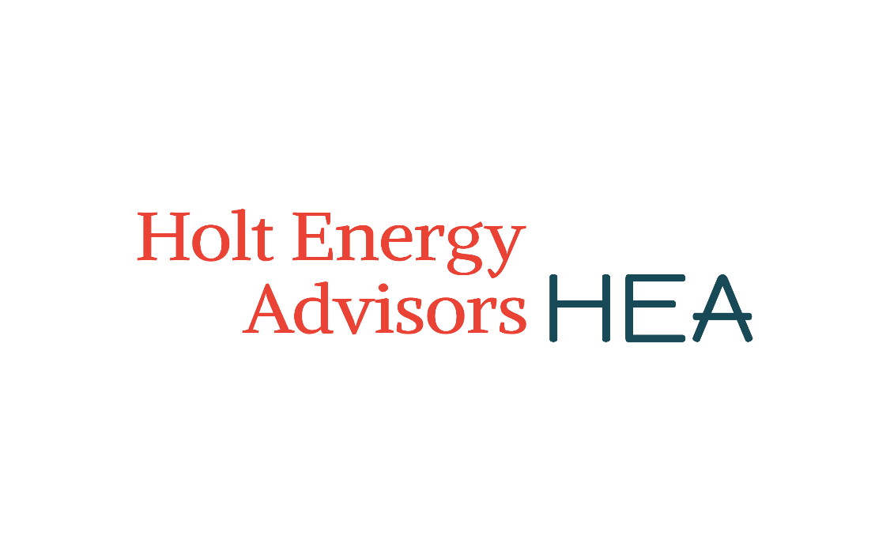

Abbreviation

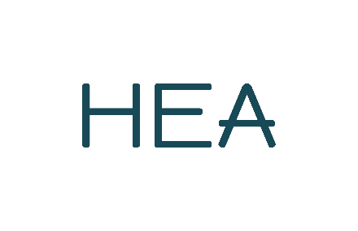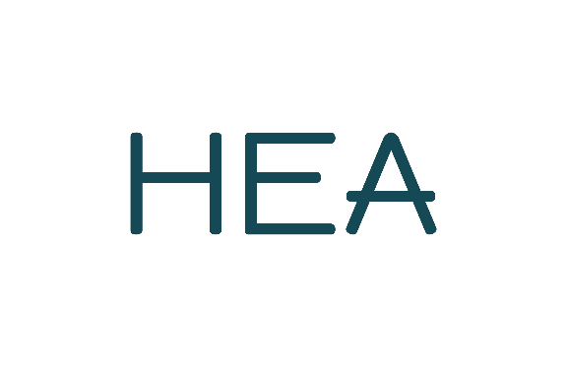

Inverted Images

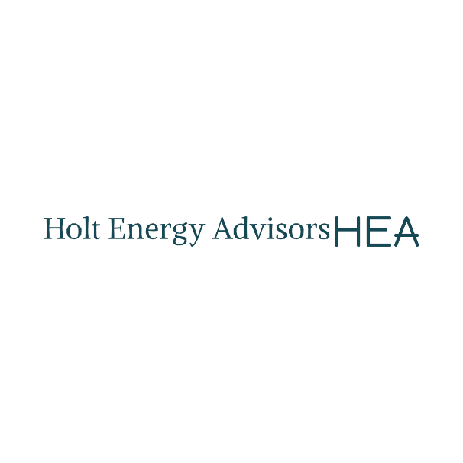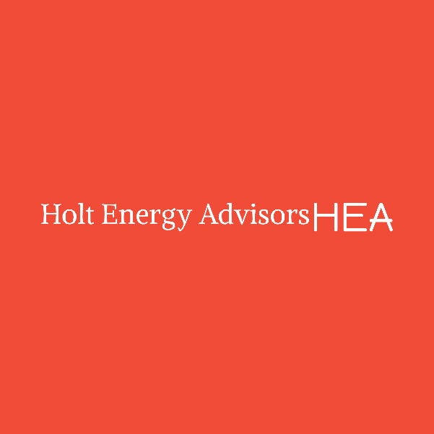

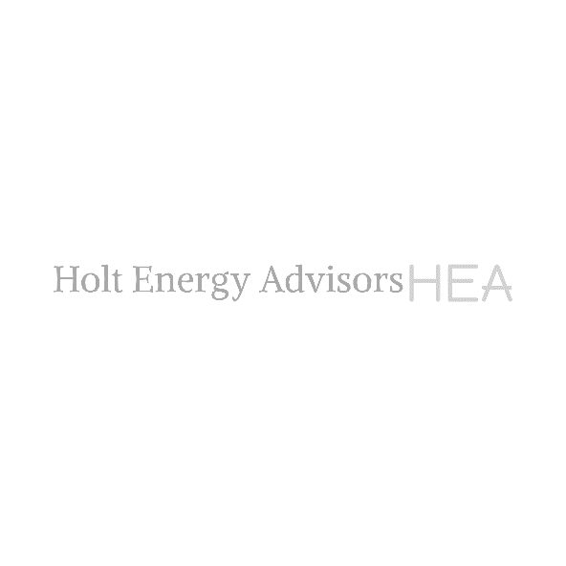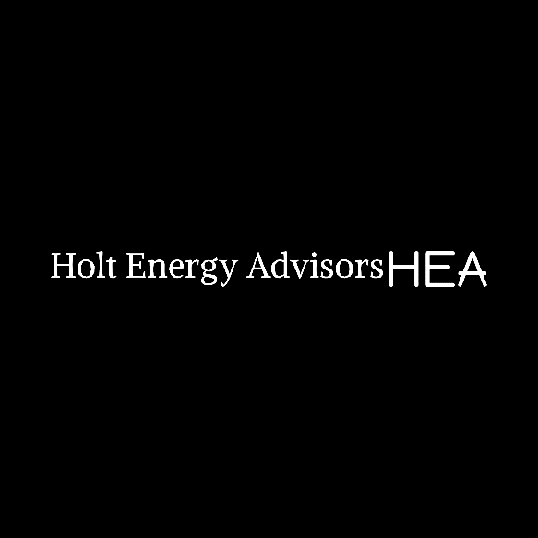

Transparent Image



Office Images

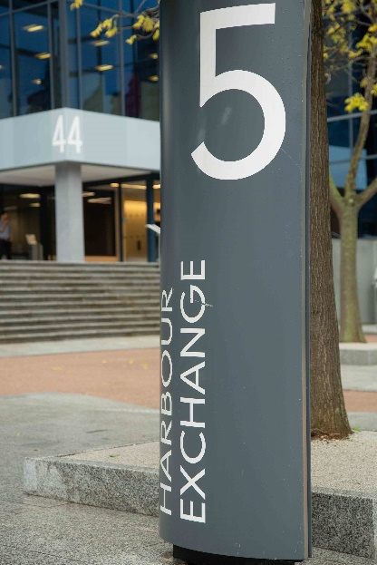



Managing Director Images

 