Answer sheet

Suggest a common agenda for the Fidelio scope and for its 2-team system
You could propose the following common agenda:
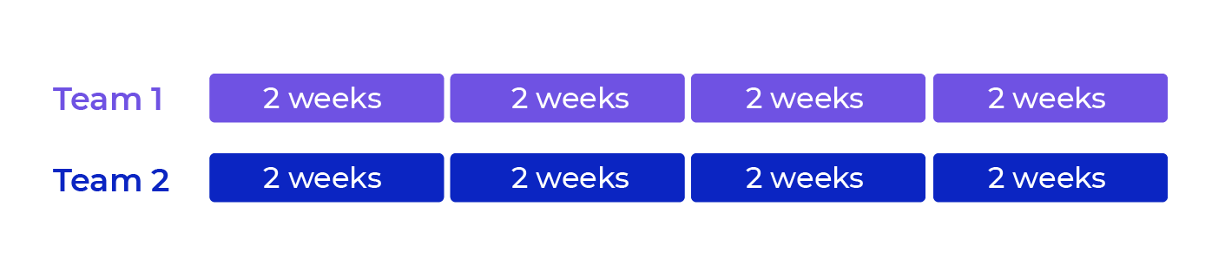
Working at a common pace is ensured in that all of the iterations for all of the teams last two weeks.
Synchronization is ensured in that all of the iterations for all of the teams start and end at the same time.

Select an organizational strategy for your roles and events
Here are the recommendations you could make:
- Don't change anything! Your teams are just getting started with agility⁠—it's probably best not to disrupt them. Make one of the Product Owners and one of the Scrum Masters leads.
- For your agile events at scale, invite the Lead Product Owner, the Lead Scrum Master and a developer from each team.
NB: If you have only a small number of developers, you could invite them all!

