Answer sheet

Connect three devices to each other

This is how your network should look in Packet Tracer:

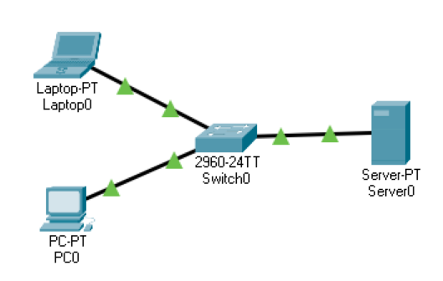

To keep the number of cables to a minimum, you should add a switch to the network and connect all the end nodes to it with straight-through cables.

Well done, you have a coherent network! Now the client knows that they’ll have to invest in equipment to keep the network secure.

