Answer sheet

Connect two networks to each other

This is the architecture you should have created in Packet Tracer:

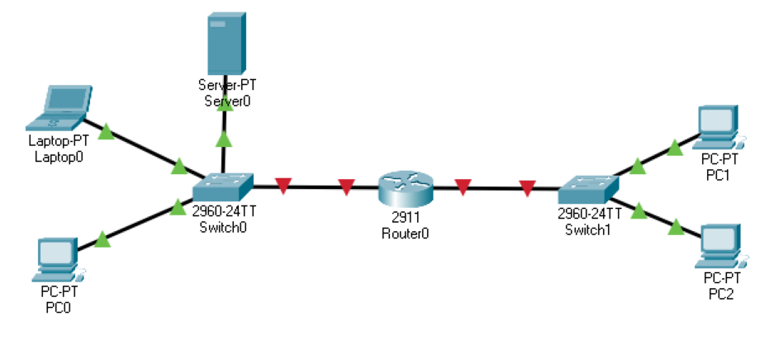

Our two networks are on the left and right, both made up of PCs/servers and a switch. A router acts as a gateway between the two networks, connecting the different components.

You provide the client with a full quote, made up of this diagram, as well as a breakdown of the costs, and delivery and installation times. All the client has to do now is sign the quote if he wants you to implement this architecture.

