Answer sheet

Configure the addresses for Cyclade’s two computers

Once all the devices have an address, this is what your network should look like:

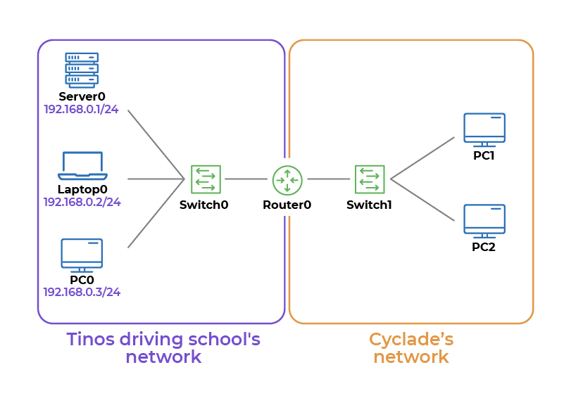
You can send a message from 192.168.100.1 to 192.168.100.2.

However, when you try to send a message between 192.168.100.1 and 192.168.0.1, it doesn’t work! Don’t worry, this is normal. These are two different networks, and we haven’t configured the router yet.

