Answer sheet

Task

Enable the routers’ network interfaces.

Assign them an IP address.

Specify the default gateway for all your end nodes.

Test communication between Cyclade’s two devices and Tinos’ server. You can use the ping or packet simulation method.

This is what your complete diagram should look like:
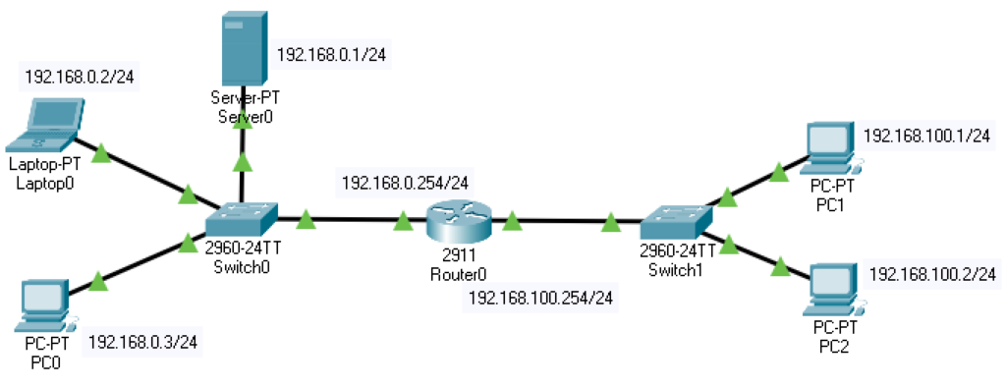

Each of the triangles representing connectivity should be green. This means that all interfaces are correctly configured.

